Approximating a Function with Linear Functions
Sheldon P. Gordon and Yajun Yang
Farmingdale State University of New York
gordonsp@farmingdale.edu yangy@farmingdale.edu

When most mathematicians think about the concept of approximating a function, they invariably think of it either in terms of local linearity or its natural extension, the Taylor polynomial approximations to the function. In this article, we will consider some different ways to think about approximating a function.
To make things simple, it is standard procedure in numerical analysis to consider continuous functions that are monotonic with fixed concavity on an interval; any function that has turning points or inflection points can be broken down into a set of such functions and each portion is treated separately. Also, to make things concrete, we will consider the function on the interval [0, 1]. Most of the ideas and developments that follow can be applied to most other functions with similar behavior properties.
Let’s begin with the tangent line at x = 0 to the exponential function; this gives us the local linearization
≈ 1 + x.
How accurate is this approximation? Well, if we stay close to x = 0, it is very good. However, if our objective is to approximate the function across the entire interval, it is clearly not such a good approximation as we move farther away from x = 0, as shown in Figure 1.
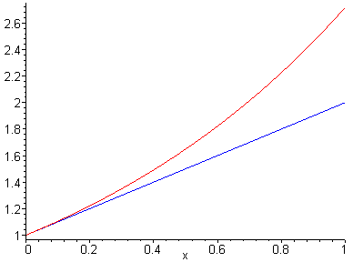
Figure 1

Before proceeding, though, we need a way to measure how well an approximating function P(x) fits a function f (x) on an interval [a, b]. There are actually several different ways that we can do so. The first, and perhaps the simplest, way to measure the error in the approximation is
Error₁ =
This is equivalent to finding the maximum deviation between the function and the approximating function on the entire interval. For our linear approximation to the exponential function on the interval [0, 1], this would obviously occur at the right endpoint of the interval and so the error would be e – 2 ≈ 0.718282. Essentially, then, this is the formalization of the kind of error measurement we make when we talk about an approximation being good to a certain number of decimal places.
The problem with such a point estimate is that it gives the worst case scenario, but does not necessarily provide a representative value to indicate how good, or poor, the fit is across the entire interval. Thus, if a line were actually a very good approximation to a curve across most of the interval in question, this criterion likely would not reflect that at all. As an alternative, we could define the error instead as the total error:
Error₂ = .
This represents the area bounded between the curve and the approximating function; the absolute values are used to avoid the cancellations that could occur if the two curves cross each other. For our tangent line approximation y = 1 + x to the exponential function, we use the fact that across the interval, so
Error₂ = .
If the approximating function is not always above or below the function, however, integrating the absolute value of the difference causes some significant problems. Also, note that this value for Error₂ is not in the least commensurate with Error₁, so we cannot compare the level of accuracy based on the two different measures.
A third measure of the error in the approximation is essentially based on the L² norm from topology,
Error₃ = .
Although it might seem somewhat unreasonable to use this, it is used quite frequently in numerical analysis because it is easier to program the square of the difference than the absolute value function and, more significantly, it is considerably faster to execute. Using this measure, we find that the error associated with the tangent line is
Error₃ =
after a reasonable amount of effort, including an integration by parts. Again, though, this value cannot be compared to either of the two preceding error estimates.

Improving on the Accuracy
We next consider several ways to obtain a more accurate linear approximation to the exponential function on this interval. Perhaps the most obvious alternative to the tangent line approximation at one of the endpoints is to use the tangent line at the center of the interval, as shown in Figure 2. The equation of that tangent line eventually reduces to . The corresponding three error values are Error₁ ≈ 0.245200 (which occurs at the endpoint x = 1 of the interval), Error₂ ≈ 0.069561 (after a simple integration), and Error₃ ≈ 0.094462 (again after an integration by parts). All three errors are reduced by the similar percentage compared to the errors at the left endpoint, so the tangent line at the midpoint of the interval is a clear improvement over the tangent line at one of the endpoints.
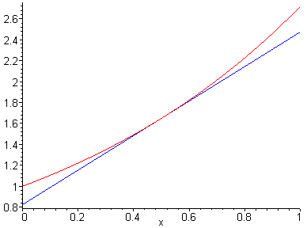
Figure 2

Another alternative to the tangent line approximations is to use the secant line that connects the two endpoints, as shown in Figure 3. The equation of this line is . After a very simple optimization calculation, we find that Error₁ ≈ 0.211867; after a straightforward integration, we have Error₂ ≈ 0.140859; and after using the numerical integration routine on a calculator, we obtain Error₃ ≈ 0.154424. Only with Error₁ do we have a smaller error than with the corresponding errors associated with the tangent lines, so the secant line is an improvement over the tangent lines. However, this is a clear demonstration of the fact that one cannot make a clear determination of which is the best fit based solely on a single criterion.
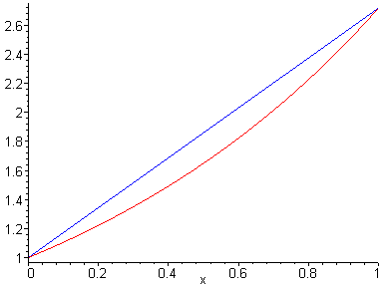
Figure 3

The above secant line approximation may be viewed as one example of polynomial interpolations. Interpolation theory reveals that taking the nodes of interpolation to be the zeroes of the Chebyshev polynomial of degree 2, , may reduce the Error₁ for a linear interpolation on the interval [0, 1]. To construct the Chebyshev node interpolation formula, we first find the two zeroes of . They are and . Then we use the point-slope form of a linear equation to find the interpolation formula: , whose graph is as shown in Figure 4. After a simple calculation, we find that Error₁ ≈ 0.123795; after a straightforward integration, we have Error₂ ≈ 0.063809; and after an integration by parts or using the numerical integration routine on a calculator, we obtain Error₃ ≈ 0.071686. These are the best results so far. One obvious reason for such an improvement is that the error of the approximation is somewhat evenly distributed across the entire interval.
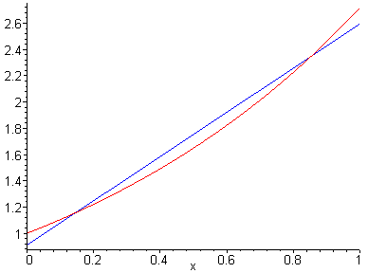
Figure 4

It is evident that we should be able to improve on the accuracy of the linear approximations by using a line that crosses the portion of the monotonic curve twice. Suppose that the line intersects the exponential curve at x = c and x = d. The slope of the line is then
and the corresponding equation of the line is y = e^{c} + m(x – c) or y = mx + b, where . Our problem is to find the values of c and d that produce the smallest possible errors for each of the three error criteria.
We begin with
Error₁ = .
This involves an optimization problem with three variables, x, c, and d; c and d determine the points of intersection and x determines the point between 0 and 1 where the vertical distance between the line and the curve is greatest. Among all the possible values of c and d between 0 and 1, inclusively, we want to find one pair of numbers for c and d such that the maximum error Error₁ resulting from this linear approximation is smallest. This optimization problem is different from those studied in Calculus. We deal with maximum and minimum in the same problem. Because of it, the best approximation is called the minimax approximation.
In general, the minimax approximation is difficult to calculate. For the exponential function, we will use some geometric insight to construct it. Consider the graph of with that of a best possible linear approximation . Clearly, and must be equal at two points c, d in [0, 1], where . Therefore,
.
Also, the maximum error must be attained at exactly three points 0, 1, and some point a in (0, 1), where , as in Figure 5. Otherwise, we could improve on the approximation by moving the line appropriately. We therefore have
, ,

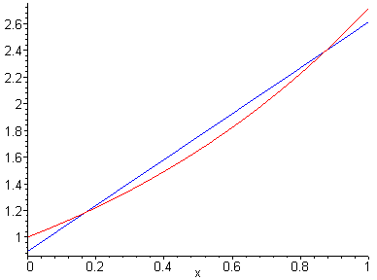
Figure 5

We need one more equation because there are four variables involved, i.e., m, b, a, and . Since has a local minimum at a, we have . Combining these four equations, we have
= Error₁,
and the linear approximation intersects the exponential function at c = 0.168371 and d = 0.873066. This is a significant improvement in the value of Error₁ compared to our four previous efforts. We also have Error₂ ≈ 0.064472 and Error₃ ≈ 0.072286; both are similar to the results from the Chebyshev node interpolation. In fact, the Chebyshev node interpolation is considered a near-minimax approximation. Because it is relatively easy to calculate, the Chebyshev node interpolation is used more often in numerical analysis to approximate a function.
Next, we consider Error₂, which is
Error₂ =
=.
The integration of the above three integrals yields a fairly complicated function of the two variables c and d. For instance, the first integral leads to the expression
It looks as if we could employ the techniques from multivariable calculus to find the minimum value of the Error₂. However, we must solve a nonlinear system of two highly nonlinear equations in two unknowns. Therefore, the best approximation by Error₂ is even more difficult to construct, compared to the minimax approximation. This is probably the reason that the Error₂ is rarely used for error analysis of the approximation of functions.
Using a search program to estimate the value of this integral using large numbers of combinations of the parameters c and d, we find that the error has a minimum value of approximately 0.053209, which occurs when c = 0.255 and d = 0.745. (Note that these values for c and d are accurate to within 0.005.) This is a reasonable improvement in the value of Error₂ compared to our five previous efforts, where our best value was 0.069561.
Incidentally, the fact that the solutions we obtained, c = 0.255 and d = 0.745, are symmetrically located on the interval from 0 to 1 suggests that this may always be the case. If that is so, then we can simplify the problem somewhat by introducing a single parameter c, with the associated point at 1 – c and reduce the minimization effort to one involving a single unknown. In that case, the equation we would obtain would be an expression in one variable and we could approximate the solution graphically using any available technology. In particular, using Derive, the above formula involving three integrals for Error₂ reduces to 2ce^{c-1}(e + 1) – e^{c-1}(5e + 1)/2 + 2e^{1-c} – e + 1. We show the graph of this error function in Figure … and, by zooming in and tracing, we find that the minimum error corresponds to c ≈ ….; that error is ….
The other two errors are Error₁ = ?, Error₃ =? (Do you have the results for these two errors?)

Now what? Can we do any of the integration in closed form using a CAS and then do a max-min analysis?? Or can we find the intersection of the two curves for f_{a} and f_{b} graphically???

Now, we search for a linear function that minimizes
Error₃ = .
This is equivalent to finding the minimum of the square of the term on the right, which means that this approximation is equivalent to the least squares notion used to define linear regression in statistics. This is also called the least squares approximation. The idea is similar to linear regression in statistics.
Define . To find a minimum of Error₃, we will find the minimum of . We set
which is a necessary condition at a minimum point. After integrating the second integral in each of the above equations, we get a simple linear system involving b₀ and b_{1:}
whose solution is b₀ = 4e − 10 and b₁= −6e + 18. The least squares linear approximation is . After a simple calculation, we find that Error₁ ≈ 0.154845; after a straightforward integration, we have Error₂ ≈ 0.053889; and after the integration by parts or using the numerical integration routine on a calculator, we obtain Error₃ ≈ 0.062771. Clearly, we get better results on Error₂ and Error₃. Error₁ is worse than the Chebyshev node interpolation, but still better than the tangent and secant approximations. This observation holds in general and makes the least squares approximation an intermediate approximation.
[Should we mention the following: Not a bad idea, if you add a reference.
There are at least two more intermediate approximations. One is an improvement on the least squares approximation (called Chebyshev least squares approximation), the other is the Chebyshev forced oscillation of the error, the error of the approximation is forced to be somewhat evenly distributed across the entire interval. ]

Here is the error summary of the approximations:
 | Error1 | Error2 | Error3
Taylor at 0 | 0.718282 | 0.218282 | 0.302155
Taylor at ½ | 0.245200 | 0.069561 | 0.094462
Secant joining 0 and 1 | 0.211867 | 0.140859 | 0.154424
Chebyshev node interpolation | 0.123795 | 0.063809 | 0.071686
Minimax approximation | 0.105933 | 0.064473 | 0.072286
Best approximation of Error₂ |  | 0.053209
Least squares approximation | 0.154845 | 0.053889 | 0.062771

Pedagogical Considerations
The authors believe that the investigations discussed in this article can serve as the basis for a wonderful computer lab project, if not a series of projects. For instance, early in Calculus II, many of the activities discussed would serve as an effective review of topics from Calculus I, including the behavior of functions, optimization, rules for differentiation, rules for integration, applications of the definite integral, and numerical integration. Simultaneously, such a project would set the stage for the eventual introduction to Taylor polynomial approximations, which many consider to be the culmination of the first year of calculus.
Furthermore, a continuation of this project could be a computer lab activity in Calculus III once students have been introduced to partial derivatives and optimization of functions of several variables.
Finally, it would also make an excellent project investigation in a course in numerical analysis to bring together so many ideas from calculus in the process of considering some extremely important concepts and methods from numerical analysis. At this level, the typical approach is to consider one method at a time to approximate functions in general. This project nicely cuts across all the different approximation methods applied to a single function to provide students with the ability to compare the effectiveness of the various approaches. …(I could not figure out what you wrote on the paper, sorry)

Acknowledgment The work described in this article was supported by the Division of Undergraduate Education of the National Science Foundation under grants DUE-0089400 and DUE-0310123. However, the views expressed are not necessarily those of either the Foundation or the projects.

References
Any needed??? May be one or two undergraduate level Numerical Analysis textbooks. YES – you referred to Atkinson several times. I think I have a book at home by Cheney called Approximating a Function or some such.

