The Average Distance in An Ellipse

One of Kepler’s greatest discoveries was the fact that the planets move in elliptic orbits with the sun at one focus [1, 2]. Astronomers characterize the orbits of particular planets by their minimum and maximum distances to the sun, known respectively as the perihelion and aphelion. Mathematically, for the ellipse
(1)
with foci at (±c, 0), where c² = a² – b², as shown in Figure 1, the perihelion is a – c and the aphelion is a + c. For the earth, the perihelion and aphelion distances are 93.1 and 94.4 million miles, respectively. Typically, the distance from the earth to the sun is taken as approximately 93.75 million miles, which is just the mean of the perihelion and aphelion values. Since the orbits of most planets (with the exception of Pluto, which is no longer officially classified as a planet), are quite circular, it seems reasonable to use this average.
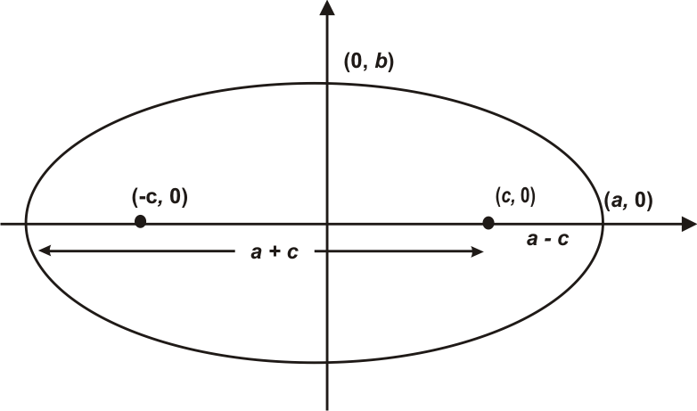
In the present article, we raise the more sophisticated mathematical question: What is the true average distance of a planet from the sun? More generally, we ask: For any ellipse, what is the true average distance from all points P(x, y) on the ellipse to a particular focus, F(c, 0)?
If P(x, y) is any point on the ellipse (1), then the distance D to the focus F(c, 0), as shown in Figure 2, is given by
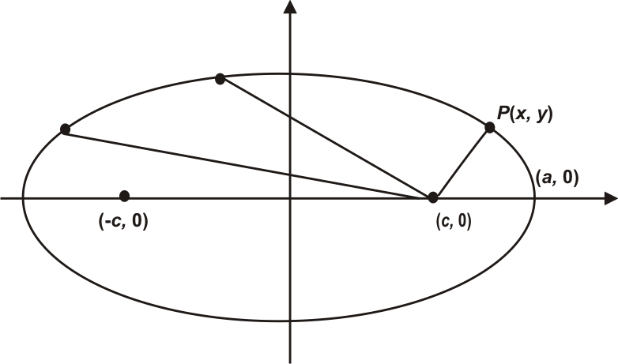After some routine algebraic manipulation, this expression reduces to the surprisingly simple
Furthermore, for any point on the ellipse, x < a and so, because c < a, we have cx < a². Therefore, when we take the positive square root (we are talking about the distance, which must be positive), we get
The average value for this distance over the entire upper half of the ellipse is then given by the definite integral
When we evaluate this integral using the Fundamental Theorem, we get

That is, the average distance from a focus to all points in the upper half of an ellipse is precisely equal to a, the length of the semi-major axis. The identical average will, of course, apply to all of the points in the lower half of the ellipse, and so the average distance to the focus for all the points on the ellipse will be a.
We note that this rather surprising and simple result is not particularly well known, at least in mathematics, in an era when there has been a diminished emphasis on analytic geometry in the curriculum. Moreover, since the perihelion distance is a – c while the aphelion distance is a + c, the standard usage in astronomy, which just averages these two values, produces a mean of a. Thus, the average distance is precisely the mean of the greatest and smallest distances from the sun and so the naïve usage is in perfect agreement with the mathematical formulation.
Flushed with success, let’s consider several related questions:
1. What is the average distance of points on the ellipse to the center?
2. What is the average distance of points on the ellipse to a vertex?
We begin with the average distance from the center. Using the definition of the ellipse, we find that
so that the average distance to the center is

(2)

After performing the integration using the substitution
and a considerable amount of simplification, we eventually finally obtain
Unfortunately, there does not appear to be a simple or meaningful geometric or physical interpretation of this expression.
Incidentally, in the limiting case of a circle where a = b and c = 0, Equation (2) reduces to
and this is equal to b = a, as we would expect.
Finally, we consider the average distance from points on the ellipse to the vertex at V(a, 0). We eventually obtain
However, for any point on the ellipse, we know that x < a and, because c < a, it follows that c² < a², and so c²x < a³. Equivalently,
and we therefore find that the average distance is
After using several successive substitutions followed by a considerable amount of algebraic simplification, this eventually reduces to
Again, this does not appear to be a particularly meaningful geometric or physical result.
We leave it to the interested reader to investigate the related questions of the average distances to vertices and foci of other conic sections.

References
1. Gordon, Sheldon P., Florence S. Gordon, et al., Functioning in the Real World: A Precalculus Experience, 2nd Ed., Addison-Wesley, 2004, ISBN: 0201383896. `

2. Lodge, Sir Oliver, Kepler And The Laws Of Planetary Motion in Pioneers of Science, Kessinger Publishing, LLC, 2010, ISBN 0766135004.

