On the Curvature Function:

Where does a curve bend the fastest?

Loucas Chrysafi

Department of Mathematics, Farmingdale State University of New York
e-mail: chrysala@farmingdale.edu

Sheldon Gordon
Department of Mathematics, Farmingdale State University of New York
e-mail: gordonsp@farmingdale.edu

Abstract

We examine the behavior of the curvature function associated with most common
families of functions and curves, with the focus on establishing where maximum
curvature occurs.

Introduction

The notion of the curvature of a function appears in all the traditional calculus texts. However, it is typically introduced primarily as a vehicle for providing additional manipulation practice. As a result, the books miss some lovely mathematical ideas. The curvature of a function is defined according to the formula

or some other form (see [3] or [7] ), but almost all examples and problems are basically algebraic exercises in which the term simplifies nicely. The two standard functions used are and . Few of the texts actually examine how the curvature function of a particular function is related to the behavior of the function, nor any of the other fascinating mathematical issues that can arise. As a result, many mathematicians themselves have never thought deeply about these issues, nor have they used them to unify some important ideas in calculus courses.

Curvature

Definition Let be a twice-differentiable function. The curvature of at is defined by
.
Another way of thinking about curvature is to use the fact that at any point on a curve, where the curvature is nonzero, we can construct a circle tangent to the curve having the same curvature at that point. This is called the osculating circle and its radius is called the radius of curvature. Thus,
Definition The radius of curvature at the point on the curve , is
.
For more details see [2].
We now examine what this means for some of the standard families of functions encountered in the first few years of the undergraduate mathematics curriculum. Many of the results are quite surprising and run counter to what we might intuitively expect.

Linear Functions

If , then clearly the curvature is zero everywhere.

Quadratic Functions

If , then

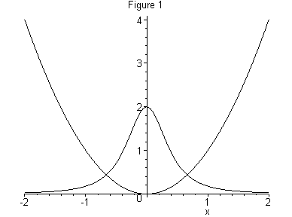
Figure 1 shows the parabola along with its associated curvature function . From the graphs, it is evident that the curvature function has a maximum at (or very near to) the vertex of the parabola. In particular, from the expression for , we see that the maximum curvature occurs at and has value 2. In fact, for an arbitrary quadratic function , we locate the maximum curvature by finding where the derivative , thus
.
Therefore when , so that . Thus, by the First Derivative Test, the curvature function has a local maximum at the vertex of the parabola as expected. The maximum value is
.

Therefore, the larger the leading coefficient the greater the maximum curvature. Interestingly, the other parameters have no effect on the curvature. Moreover, for any parabola we note that the curvature function as , as one might expect (a good student exercise). In turn, this means that the radius of curvature increases as increases. Figure 2 shows the parabola along with the osculating circles at and . The locus of centers of all the osculating circles is called the evolute to the curve. For more details, see [2].
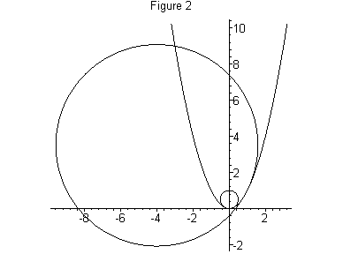

Power Functions
If , then
.
Example 1:
Figure 3 shows along with its associated curvature function. The curvature function has two maxima at a pair of symmetrically located points. It also has a minimum at . Let’s see why. Clearly as , the curve bends less and less and so
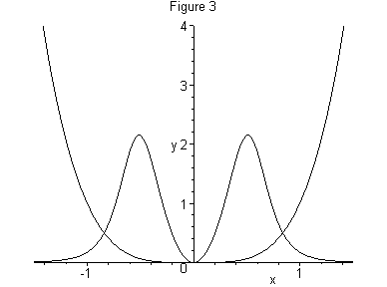
the curvature approaches zero (another good student exercise). Also, we know that higher even degree functions are increasingly flat near the origin. Consequently, it makes sense that the curvature becomes maximal at two points on either side of the origin. In particular, it turns out (we do the derivation in general later) that the abscissa of these points are .

Example 2:
Now let’s consider the cubic function . Its graph along with its associated curvature function are shown in Figure 4. Maximum curvature also seems to occur at two points that are symmetrically located about the origin, and minimum curvature seems to
occur at the origin. The latter makes sense because the curve has a point of inflection at the origin where . Thus is a minimum there.
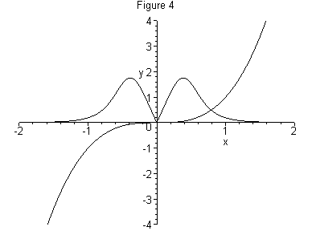

We next consider the general case,. We have
.
The critical points for occur where

so that
or or or .
The cases and are trivial- the curve is linear and so has zero curvature. If , then is the only critical point for the curvature function, which was proved
earlier. If , then clearly represents a point where the curvature is zero, so it is the minimum value. The maximum curvature therefore occurs at
(1)
provided that or , , and that or . Notice that, as we observed for and , this always happens at two points located symmetrically about the origin. In particular, for , the maximum curvature occurs at and for , the maximum curvature occurs at . As gets larger, the critical points get closer and closer to . Since the radicand in (1) is negative in the interval , the behavior of the critical points as a function of in that interval will be very interesting or not defined. We leave it to the reader for further investigation. Figure 5 shows graphically the behavior of these critical points as a function of .

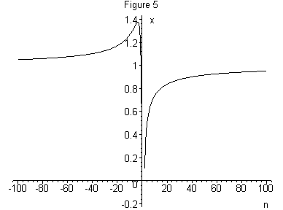

Exponential Functions

If , then we have
.
To find the critical points for , we compute
.

Since the denominator is positive, when , so that . Hence, the only zero of occurs at
.
In the special case of (see Figure 6), the maximum curvature occurs at and is equal to
.

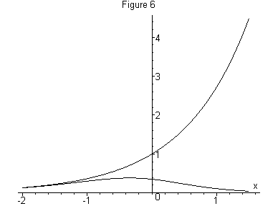
Thus, while we often tend to think of an exponential function as being “centered” at its vertical intercept, from the point of view of curvature, the function is centered at a point
to the left of the vertical axis. Figure 7 shows with the circle of curvature at .
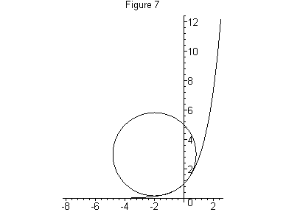

Problem 1: Show that the inflection points on the curvature function associated with the exponential function occur at
.

Natural Logarithmic Function

For , we have
so that
.

Since the denominator is never zero and for the logarithmic function, the only critical point occurs where
or or ,
as seen in Figure 8. Therefore, the maximum curvature is
,
which is the same value as the maximum curvature of . In retrospect, one might have expected this considering the fact that the two functions are inverses of one another.

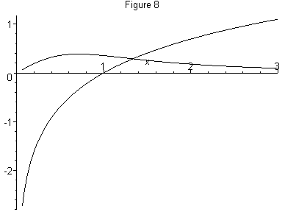
Problem 2: Show that the maximum curvature of occurs at.

Trigonometric Functions

Intuitively for the sine and cosine functions, we expect the maximum curvature to occur
at the turning points. Also, the minimum curvature should occur at the inflection points.

We will prove this for the sine function. (the comparable fact obviously holds for the cosine.) We have
so that
.
This expression is zero when (all the other terms are positive), so that
,
Incidentally, . Figure 9 shows the sine curve together with its associated curvature function from to .

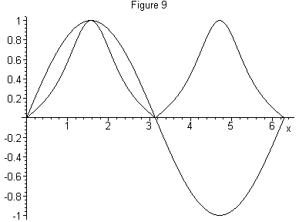

Since and , the circle of curvature at is centered at and has radius one. Figure 10 shows the circles of curvature of the sine function at and .
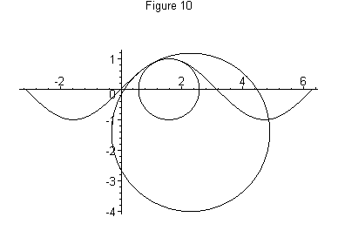
Normal Distributions

Let us consider the family of normal distributions with mean and standard deviation ,
.
The curvature of this family is given by
.

Figure 11 shows along with its associated curvature function. As expected, the maximum curvature occurs at the turning point , and is equal to
Therefore, as gets larger, the curvature at approaches zero, and as approaches zero, the curvature at goes to infinity. Even though the curvature of will always have three local maximum points, the global maximum curvature occurs at regardless of the value of . Proving it, however easy it may sound, is a rather messy proposition without the use of a computer algebra system (CAS) . We leave it for the curious and interested reader.
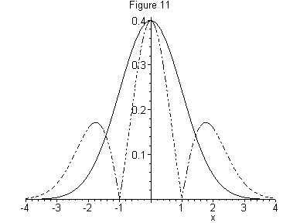
Note that . This implies that the circle of curvature at is centered at and has radius, a fact that is captured in Figure 12.

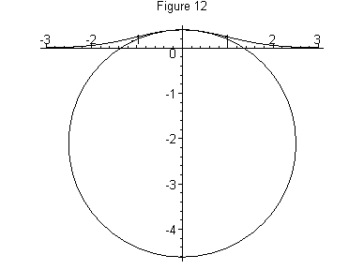
Problem 3: Locate the other two local maximum points of the curvature of the normal curve . Relate these two points to features of the normal distribution.

Logistic Functions

Consider the family of logistic curves given by
. (2)
Example 3: , ,
Figure 13 shows with its associated curvature function. We observe that the maximum curvature occurs at two points, which seem to be symmetrically located about the inflection point of the logistic curve. The minimum curvature occurs at the point of inflection at . We suggest that the reader investigate the effect of the parameters , , and on the curvature of (2). This might also make a very effective student research project.

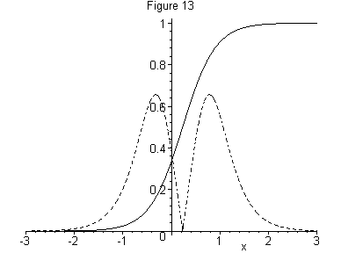

Example 4: Hyperbolic Cosine
First consider the hyperbolic cosine function. Interestingly enough, the curvature function associated with is sech, and the curvature achieves its maximum at , where (see Figure 14).

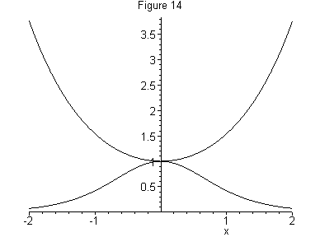
Problem 4: Show that the maximum curvature of the catenary occurs at the point , and that .
Example 5: Hyperbolic Sine
Consider the hyperbolic sine. Its associated curvature function is as shown in Figure 15.
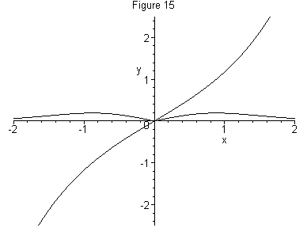

Notice that there are two symmetrically located points of maximum curvature.
Problem 5: Show that the maximum curvature of occurs at .

Another interesting observation, based on the symmetry of the hyperbolic sine is the fact that .
Problem 6: Find all for which
.

Curvature and Parametric Curves

For a parametric curve , , the curvature function is defined as
. (3)
Let’s see what happens with some common parametric curves.

Example 6: Circle
For simplicity we will consider a circle with radius centered at the origin, and therefore having parametric equations and . Then
,
Naturally, the curvature along any circle is constant and is the reciprocal of the radius which is consistent with the fact that the curvature and the radius of curvature are always reciprocals of each other. That will make any circle its own circle of curvature at any point on the circle.

Example 7: Ellipse
Consider the standard ellipse centered at the origin with equation
, ,
Using the parametric equations , , we find ,
so that

.

Therefore, the critical points occur at
.
If , the maximum curvature occurs at and , and . The minimum curvature occurs at and , and . Figure 16 shows the curvature function of the ellipse with and as a function of the parameter .

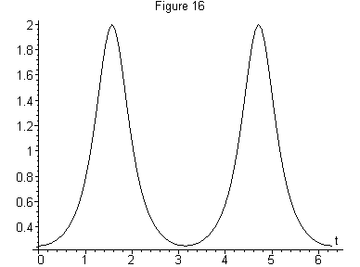

Clearly the curvature is maximum at the vertices on the major axis. However from the figure, there is a considerable amount of oscillation in the curvature.

Problem 6: Use Equation (3) to establish that curvature in polar coordinates is given by
.
In an attempt to entice the reader to further experiment with curvature, we finish with some graphs of curves with their associated curvature in polar coordinates. In Figure 17, we show the four-leaf rose (the inner curve) and the associated curvature function. Apparently the curvature is maximum at the angles corresponding to the maximum values of , and is a minimum at the angles where the rose passes through the pole.

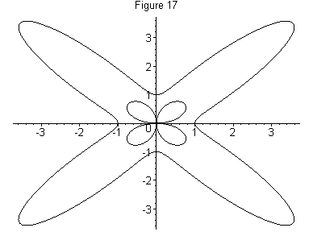

Figure 18 shows and the associated curvature function. We leave it for the reader to determine which is the function and which is the curvature.

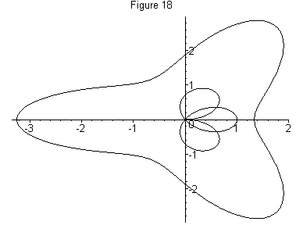

3 Pedagogical Considerations
Too often, the ideas and techniques of calculus I are lost to many students by the time they reach calculus III. An expanded treatment of curvature can provide a wonderful opportunity to jog students’ memories about these techniques. It also gives them the chance to practice some standard differentiation rules. But most importantly, it provides the opportunity to connect the ideas on curvature to the ideas on the behavior of functions and of limits. Another possibility is to assign this kind of study as a group project, particularly if students have access to a computer algebra system such as Derive,
Mathematica or Maple. Each group could be assigned a different family of functions to explore and report on.
Curvature seems to be an ideal topic for exploration and research for undergraduate mathematics, engineering, and computer science students in a calculus course. This is certainly preferable to “doing” curvature problems as little more than an algebraic exercise. For a brief history of curvature, see [1]. Some interesting applications of

curvature in physics and engineering dynamics can be found in [3]. For an application of curvature in designing the outer panel surface of an automobile, see [4]. An application of motion under curvature can be found in [6]. For an application of curvature in image processing, see [5].

References
[1] J. Coolidge, The Unsatisfactory Story of Curvature, Amer. Math. Monthly, 59
pp.375-379, “ ISSN: 0002-9890 ”, 1952.
[2] A. Gray, Modern Differential Geometry of Curves and Surfaces, “ ISBN: 0-849-3
7872-9 ”, 1993, CRC Press.
[3] R Larson, R. Hostetler, B. Edwards, Calculus, 7th ed., “ ISBN: 0-618-23972-3 ”,
2002, Houghton Mifflin, MA.
[4] M. Lial, T. Hungerford, C. Miller, Mathematics and Applications, sixth ed.,
“ ISBN: 0-673-46943-3 ”, 1995, HarperCollins, NY.
[5] Malladi, R., and Sethian, J.A., Image Processing via Level Set Curvature Flow,
Proceedings of the National Academy of Science, 92, pp. 7046-7050, 1995.
[6] Sethian, J.A., A Review of Recent Numerical Algorithms for Hypersurfaces Moving
with Curvature-Dependent Speed, Journal of Differential Geometry, 31, pp. 131-161,
“ ISSN: 0022-040X ”, 1989.
[7] J. Stewart, Calculus, fifth ed., “ ISBN: 0-534-39330-6 ”, 2003, Brooks/Cole, CA.

