Dynamic Visualizations of Taylor Approximations to Enhance Student Understanding

One of the guiding principles of the calculus reform movement over the past quarter century has been the notion of approaching every concept and technique from graphical and numerical as well as symbolic points of view. See, for example, (Hughes-Hallett, Gleason, et al., 1994), (Smith and Moore, 1996), and (Dick and Patten, 1994). In particular, (Hughes-Hallett, Gleason, et al., 1994) enunciated the so-called Rule of Three, stating that every topic and technique in calculus should be approached analytically, graphically, and numerically. Some have re-interpreted this principle by adding that one should also approach every topic verbally and/or dynamically as well.
In large measure, the impetus for emphasizing the graphical approach is based on the very strong case made by (Zimmerman and Cunningham, 1991) for the need to stress visualization in order for students to gain a solid understanding of the concepts and methods in all areas of mathematics. This theme was reinforced by all the included articles in the volume that cover the entire undergraduate mathematics curriculum, with special attention on calculus. In turn, this became the dominant theme in the calculus reform movement, as many mathematics educators accepted this principle or as many more came to the same conclusion independently from other perspectives.
However, the implementation of this principle invariably hits a brick wall when first year calculus courses reach certain topics and sets of problems that seemingly involve traditional symbolic manipulation and rote learning exclusively. Two such are techniques of integration and l’Hopital’s Rule; the present author has previously discussed approaching both from the perspective of using dynamic software to increase student understanding of the underlying ideas and their applications in (Author, 2017) and (Author, 2016). Another such topic in introductory calculus where the standard presentation all-too-often becomes bogged down in heavy algebra so that it reduces to mere symbolic manipulation is with the approximation of functions using Taylor polynomials, where the presentation too often devolves into a great many examples and problems that are primarily manipulative exercises – finding the successive derivatives of a function, evaluating those derivatives at a point, and performing related computations – that tend to distract students from the underlying conceptual understanding.
In this article, we look at the notion of Taylor polynomial approximations from a variety of different points of view. This includes approximating common transcendental functions, approximating an arbitrary differentiable function, investigating how the approximating polynomial depends on the “center” point where the derivatives are evaluated, approximating functions in polar coordinates, and approximating parametric curves. While many of these themes are often approached from the Rule of Three, conveying deep understanding to the students requires more than static images. Instead, the topic is much better served by introducing dynamic graphical perspectives that provide different and in some ways deeper insights into the methods and concepts.

Background The current author’s experience is that most of the critical topics in calculus can be dramatically presented using either graphing calculators or computer graphics software to allow students to visualize the underlying concepts and so enhance their understanding of the associated methods and their applications. Forty years ago, the present author as well as many other mathematicians addressed the challenge of making these notions evident to students by developing comprehensive packages of computer graphics programs using BASIC that addressed virtually every topic in introductory calculus. In virtually all of these packages, the key topics addressed were:
- The graph of a function
- The tangent line to a function at a point
- The graph of a function and its first and/or second derivatives
- Riemann sums and other numerical integration routines
- Taylor polynomial approximations
- Graphs in polar coordinates and parametric equations.
In addition to these core topics, a wide variety of other topics, all of which have strong visual dimensions that add to student understanding, were treated as well.
BASIC routines have become outmoded over the years. While many of these concepts and methods can be displayed on a graphing calculator, calculators are often too slow to provide essentially instantaneous displays as parameters change, which is a drawback when displaying the ideas and techniques in front of a class. Moreover, there are things that, unfortunately, cannot be well displayed on a calculator screen because of its rather low level of resolution compared to a computer screen.
The author has more recently returned to this challenge and has developed a much more extensive package of Dynamic Interactive Graphical displays of Mathematics (DIGMath) using Excel because it is available on almost all computers today. Moreover, Excel has the further advantages that it does not require any plug-ins or internet connections, as for example, using Flash, Java, or JavaScript, and it is the standard technology tool for virtually every discipline outside of mathematics. (The complete package of well over 100 programs are available gratis for use either by instructors for in-class demonstrations of these ideas or by students for individual or small-group investigations and/or projects.)
In the intervening years, many other mathematics educators have thought deeply about these issues and have developed specialized software tools to implement dynamic displays of many of the basic calculus ideas and techniques.
(Hong and Lee, 2013) provide an extensive collection of references of general discussions of using dynamic software, primarily GeoGebra, for teaching and learning mathematics. (Ochkov and Bogomolova, 2015) likewise provide some solid overviews of the rationales for using dynamic software to improve the teaching and learning of undergraduate mathematics. (Hohenwarter and Preiner, 2007) give an extensive overview of the capabilities of GeoGebra and the website (GeoGebra Simulations, 2019) provides a variety of simulations for calculus and other areas of mathematics. (Kidron and Zehavi, 2002) discuss the use of dynamic software – they term it animations – to teach the limit concept and related topics in calculus. (Habre, 2004) discusses the importance of multiple representations – symbolic, graphical, and numerical – to convey to students the underlying concepts on Taylor approximations. Similarly, (Simmons, 1991) discussed the importance of using numerical and graphical methods in teaching Taylor polynomials in calculus. (Lutzer, 2005) discussed some of the same ideas while emphasizing the role of proof throughout the teaching of calculus.
All of these efforts have had considerable impact on the teaching of calculus, though by no means can one say that they have been universally accepted, let alone implemented. In part, this may be due to the fact that many mathematics faculty are still uncomfortable with using technology in the classroom or feel that it takes too much time to implement; some feel it is not appropriate to require students to purchase specialized software in addition to an expensive textbook and calculator; still others feel that the one software tool that almost all of their students will someday use in other courses and on the job is Excel (and the majority of students today arrive on campus today apparently already knowing how to use it). Furthermore, most quantitatively-oriented people today are familiar with Excel and many are able to modify or create their own spreadsheets without having to learn a new computer language. As such, existing Excel spreadsheets provide templates that can be adapted to create comparable modules for other situations or to provide additional information and insights. As a consequence, there seem to be good reasons to have such dynamic programs available in Excel, so that both faculty and students can have easy access to their use without needing to expend money or time in learning/teaching new programs.
As part of the author’s package of Excel programs for calculus are a collection of dynamic modules that are intended to enhance student understanding of the fundamental concepts related to Taylor polynomial approximations. As will be illustrated later in the article, these spreadsheets all use sliders (a feature to input or change values by moving, using a mouse, say, a square in a horizontal bar) and other Excel controls to provide dynamic effects in which parameters and associated values can be changed and the resulting effects can be seen both graphically and numerically virtually instantaneously.
In this article, we will discuss the various aspects of creating and using Taylor approximations that can be enhanced using such software.

Building Taylor Approximations
We begin with a series of dynamic investigatory programs designed to allow students to construct successive polynomial approximations to the most common transcendental functions – the exponential function, the sine and cosine functions, and the natural logarithm function. In each case, the students are encouraged to begin with a linear approximation and challenged to vary the parameters using sliders until they create the linear function that best fits the function. The program indicates that the best linear fit is the one that agrees with the function at the “center” point and that has the same slope as the function at that point. The decision as to how well a line (or other polynomial) fits the function is based on the visual display, the size of the maximum deviation between the target and the approximating polynomial at 200 uniformly spaced points, and the sum of the squares of the deviations at those 200 points.
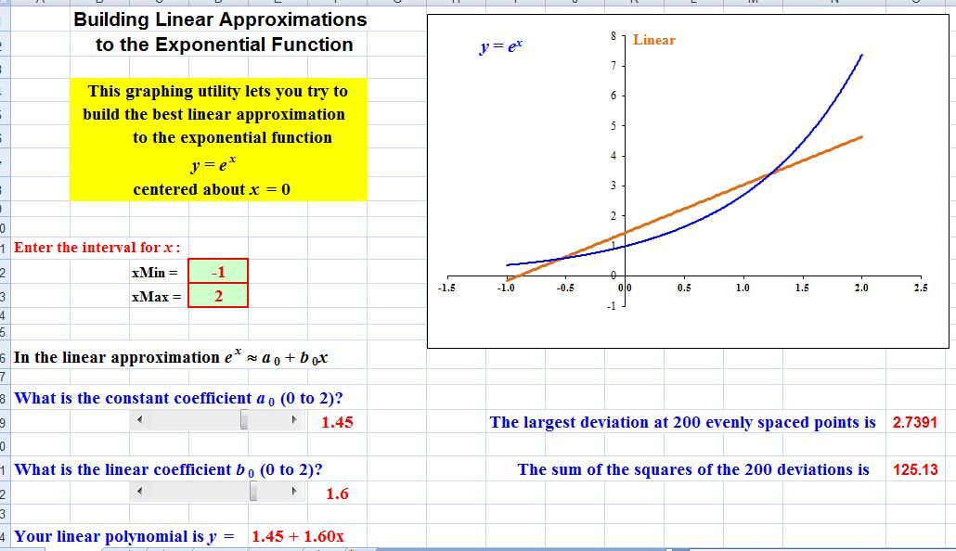
Figure 1

We begin with module #79, Taylor Approximations to the Exponential Function. In Figure 1, we show the first “page” for the linear approximations to the exponential function. Notice that this particular linear function (y = 1.45 + 1.60x) is a poor fit to the curve; the associated maximum deviation is 2.7391 and the corresponding sum of the squares of deviations is 126.13. Since the linear function is supposed to agree with the function when x = 0, where e⁰ = 1, one would naturally modify the value of the constant coefficient to produce the result shown in Figure 2, where y = 1 + 1.60x and the associated numerical measures are, respectively, 3.1891 and 183.58. Visually, this line is a better fit to the curve but, perhaps surprisingly, both numerical measures have increased somewhat. In retrospect, while the line is a better fit to the curve near the center point, it diverges more from the curve toward both ends and that accounts for the increase in the greatest deviation as well as the increase in the sum of the deviations. On the other hand, if one zooms in around the center point, both measures decrease significantly.
Also, since the linear function is supposed to have the same slope as the exponential function at x = 0, one would naturally alter the linear coefficient to get the line y = 1 + x, where the results are shown in Figure 3. The numerical measures are now 4.3891 and 405.73, respectively. This line is clearly a much better fit to the curve about the center. However, the numerical measures have increased even more, and this is attributable to the fact that the line diverges even more drastically from the curve toward the endpoints.

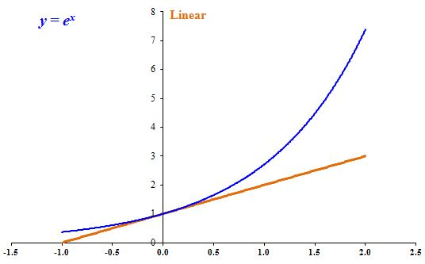
If we therefore zoom in slightly, say to the interval [-1, 1], then the largest deviation drops to 0.7183 and the sum of the squares of the deviations is 12.449. Both of these are considerably smaller than anything we had before.
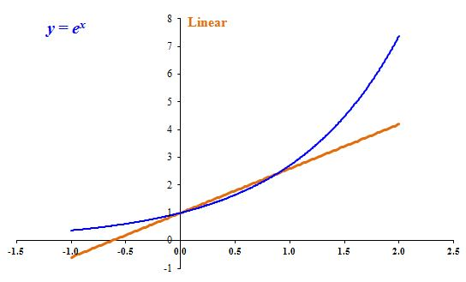
Figure 2 2
Figure 3 2

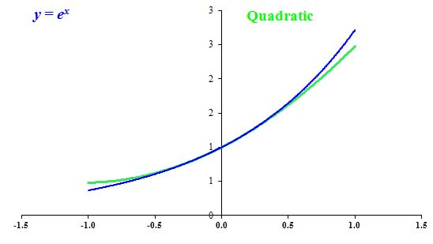
Students are then encouraged to go on to try to construct the best quadratic fit to the exponential function while keeping the same values for the constant and quadratic coefficients and the same values for the interval, in this case [-1, 1]. This necessitates their varying only the quadratic coefficient to obtain the parabola that seems to match the exponential curve most closely while reducing the two numerical values as much as possible. Very quickly, they observe that the best value for that coefficient seems to be 0.5, so that the resulting quadratic is y = 1 + x + 0.5x². The corresponding graph is shown in Figure 4 and the resulting numerical values are 0.2383 and 0.9986. The two curves clearly agree closely between x = -0.5 and 0.5 and the numerical values have decreased very substantially. (One could add the argument that since the sum of the 200 deviations is just under 1, the average deviation is approximately 0.005, which indicates very little separation between the two curves.)

Figure 4: A quadratic approximation to the exponential function

In the comparable way, students are encouraged to continue this process with trying to find the best cubic coefficient while maintaining the constant, linear and quadratic coefficients, and this leads to a value of 0.17. Eventually, by the time they reach the quintic level, they get y = 1 + x + 0.5x² + 0.17x³ + 0.04x⁴ + 0.0024x⁵, correct to the limits of accuracy used in the programs, for which the two numerical measures are 0.0001 and 0.0003. By eye, the two curves are then indistinguishable across the interval [-1, 1].
One could then ask the students to extend the interval somewhat, say to [-2, 2], and to repeat the above investigations.
We note that the author has three totally comparable spreadsheets available to perform the same investigations with the sine (#80), the cosine (#81), and the natural logarithm (#82). The one difference is that the program for the cosine extends up to a sixth degree approximation since otherwise only the quadratic and quartic terms would contribute to improving the approximation.
By the end of this investigation, the students have a firm understanding that as the degree of the approximating polynomial increases, the more accurate the approximation is, well before a formal introduction to the idea of a Taylor approximation.
To provide students with deeper insight into the comparison of the behavior of successive approximations to one of the four fundamental transcendental functions, as well as to the function itself, the author has developed a separate spreadsheet, #83 Taylor Polynomial Approximations. Each of the four functions is investigated on a separate page of the spreadsheet. For each function, the user can select which approximations – the linear, quadratic, cubic, quartic, …, fifth degree – would like to have displayed along with the target function. The entire screen is shown in Figure 5 for the exponential function. For those approximations selected, the program displays the corresponding polynomials as well as the exponential function on the interval chosen by the user.
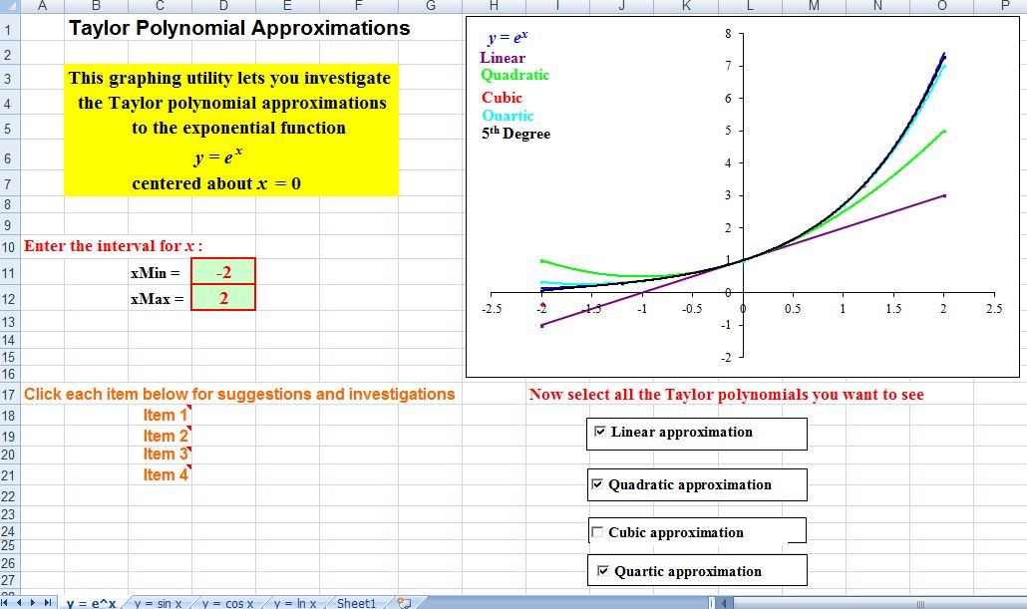

Figure 5: Various polynomial approximations to the exponential function

It quickly becomes evident to the students that each successive polynomial hugs the exponential curve more and more closely over longer intervals of x-values as the degree increases. Eventually, it is also apparent that as the degree increases, the function and the approximating polynomial are visually indistinguishable from one another.
A very different, yet extremely important, perspective on Taylor polynomial approximations can be introduced effectively to students using the logarithmic function option of this spreadsheet. We know that ln x is only defined for x > 0 and that the Taylor expansion for it converges only for 0 < x < 2, but the issue is how to bring these facts to life for the students while conveying critical and fundamental concepts. We demonstrate this using the natural logarithm sheet in the Taylor Polynomial Approximations spreadsheet used above.
We begin by considering all the various Taylor approximations of degrees 1 through 5 to the natural logarithm on the interval [0.5, 1.5], as shown in Figure 6. The heavy curve near the center is the natural logarithm. It is clear that the linear approximation is by far the least accurate. The quadratic approximation appears to agree with the function across much of the interval with only minimal divergence near the two ends. The higher degree approximations are essentially indistinguishable from the target function across the entire interval. We show the associated values for the maximum deviations and for the sum of the squares of the deviation in Table 1, where all results are reported to five significant decimal places. It is clear that each successive polynomial results in a smaller value for the maximum deviation and for the sum of the squares of the deviations, which reinforce this conclusion.
Table 1
n | Max Dev'n | SS
1 | 0.19315 | 0.84860
2 | 0.06815 | 0.07436
3 | 0.02648 | 0.00875
4 | 0.01086 | 0.00121
5 | 0.00461 | 0.00019

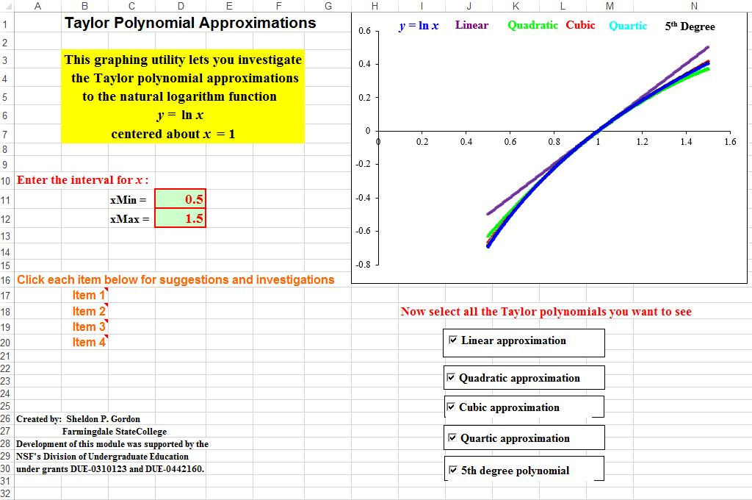
Figure 6
For comparison, we next consider the interval [0.1, 1.9], which extends fairly close to the boundaries of the interval of convergence. Near the left, it is very clear that as the degree of the polynomial increases, the better the polynomial tends to agree with the function. However, we know that the natural logarithm is asymptotic to the negative y-axis and so it must decrease faster and faster as x → 0⁺ and no polynomial of finite degree can match this behavior. This can be demonstrated effectively by taking an interval starting closer to 0, say [0.02, 1.9]. Toward the right of the interval, the linear function is by far the worst match, though the others all seem to be bunched fairly closely about the logarithmic function.

Table 2
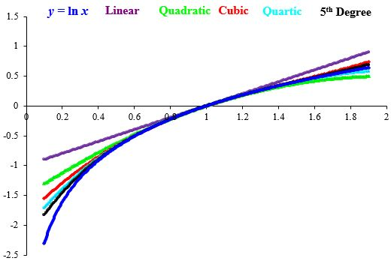
Figure 7
n | Max Dev'n | SS
1 | 1.40259 | 23.08571
2 | 0.99759 | 8.67813
3 | 0.75459 | 4.05667
4 | 0.59056 | 2.13098
5 | 0.47246 | 1.20483

In Table 2, we show the associated values for the two measures of goodness of fit. Again, each measure decreases significantly with an increase in the degree. In fact, the subsequent values for the sum of the squares drop by almost 50% (after the linear function) with each subsequent polynomial.
To emphasize the fact that the successive polynomials in fact diverge from the natural logarithm outside the interval of convergence, we extend the interval to [0.1, 3], as shown in Figure 8.
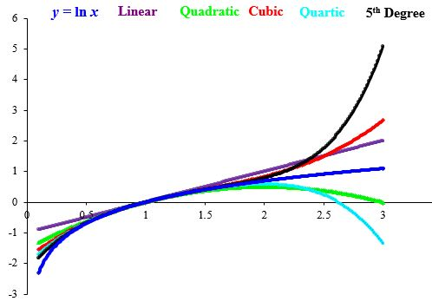
Figure 8
nMax Dev'nSS11.4025941.7519421.0986134.0403031.5680546.9389242.4319587.4274653.96805192.92642
Table 3

From the image, it is clear that all of the polynomials are reasonably good fits to the target function from about x = 0.7 to about x = 1.5. However, beyond x = 2, it becomes evident that the successive polynomials diverge more and more rapidly from the logarithmic function. In particular, the quadratic and the quartic both have negative leading coefficients and hence approach -∞ as x increases and the quartic decreases more rapidly. Similarly, the linear, the cubic and the fifth degree polynomials all have positive leading coefficients and so each of them approaches +∞ as x increases. Moreover, the higher the degree of the polynomial, the more rapidly it diverges away from the target function.
We also show the numerical measures associated with each of the polynomials in Table 3. These values clearly support the conclusions above.
Another of the modules is an investigation of approximating the sine (as well as the cosine) with polynomials. For either function, the approximating polynomial used is of the form
where the user selects the desired values for the seven parameters a, b, c, d, e, f, and g using sliders. As the user changes the value for any of the parameters with the slider, the corresponding graph changes instantaneously, thus providing the appearance of a smooth animation effect with no wait, let alone change of input values, between one value of a parameter and the next. The spreadsheet also has the provision for selecting any of the coefficients to be zero, so that the students are able to conduct the investigation in a systematic way by concentrating first on identifying the best fit among the possible polynomials of lower degree and then increasing the degree one step at a time.
Essentially, the exploration is a two-fold challenge. Graphically, the object is to create the polynomial that is the best fit, visually, to the target function, which usually means that the polynomial effectively is superimposed over the function. Numerically, the spreadsheet measures the goodness of the fit using the Sum of the Squares of the vertical distances between the target function and the approximating polynomial. The smaller the value is for the Sum of the Squares, the better the fit. The objective then is to find what appears to be the minimum value of the Sum of the Squares to achieve the optimal fit.
In the process of conducting these explorations, the students quickly come to realize that small changes in the values of the parameters often result in relatively small changes in the graph or in the value for the Sum of the Squares, but that can result in changes that are surprisingly large.
For many of the students, the ability to conduct this kind of experimental approach is much more convincing in a visceral way than any more mathematical approach that often comes across as too intellectual. Thus, this approach provides a way for these students to come to a deeper level of understanding of some extremely fundamental mathematical ideas, including the notion of approximating a function and assessing the level of accuracy in an approximation.
Still another module (#84: Taylor Polynomials for Any Function) allows the user to input any desired function y = f(x) on any desired interval [a, b] with any desired center point x = c. The program then approximates the values of the various derivatives and draws the graphs of the function f and the successive Taylor polynomials.

Taylor Approximations and the Center Point
Another spreadsheet (#85: Taylor Polynomials vs. the Center Point), which might be of more interest to faculty than to students, considers the issue of how a Taylor polynomial approximation to a function varies with the choice of the center point. The spreadsheet provides the capability of experimenting with a variety of cases, including quadratic and cubic approximations to the exponential function, linear and cubic approximations to the sine function, quadratic approximations to the cosine function, and quadratic approximations to the natural logarithmic function. For whichever case is chosen, the user can control the choice of the center point x = c via a slider. The program calculates the corresponding Taylor polynomial centered at c and draws the graph of the function and the polynomial. As c changes, the polynomial graph changes accordingly to show how the center determines the approximating polynomial. Also, if used with students, a useful challenge is to try to decide which choice of c appears to produce agreement over the widest possible interval.
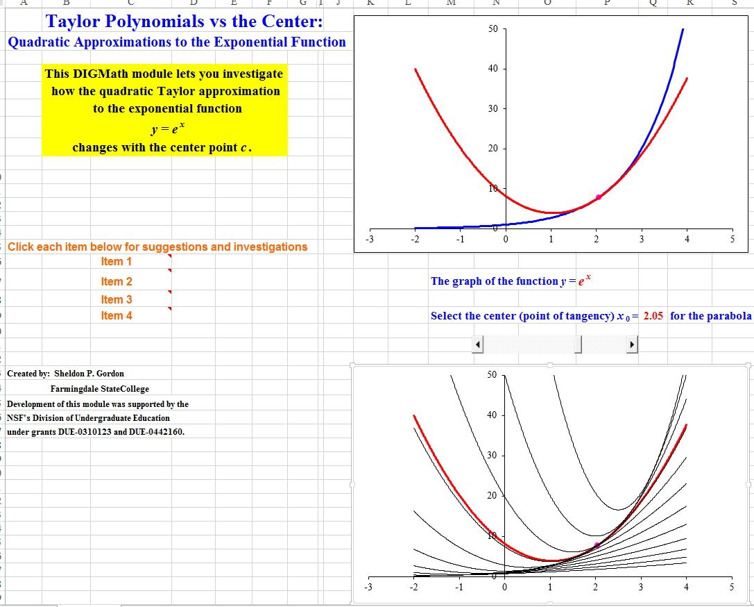
Figure 9

In addition, the program creates a second graph that simultaneously displays an array of a dozen different Taylor polynomials based on different values of c, plus one additional graph based on the current choice of c. It is very instructive to examine the different behavior patterns associated with different Taylor polynomials at different center points.

Taylor Approximations to Curves in Polar Coordinates
We next look at a different way to reinforce key ideas about Taylor polynomial approximations in a rather unexpected context – that of constructing and investigating Taylor polynomial approximations to functions in polar coordinates. Suppose we have the polar function r = f(θ) = sin θ. To do this, we use a different spreadsheet (#93: Taylor Approximations to Polar Curves). This requires that the user enter the function. To do this, we use the letter Q rather than θ, which would make things considerably more complicated for students. Unfortunately, the necessity of entering the expression for the function, as well as for any Taylor approximations, requires that students have some familiarity with “computerese” in the sense of using parentheses for function arguments and for order of operations, using * for products, and ^ for exponents. Thus, for this function, one would have to type: sin(Q) in the cell provided. Note that this is the polar equation of a unit circle tangent to the pole with center on the vertical axis.
The program also has to enter the desired Taylor approximation, also in terms of Q. Thus, for a linear approximation, the polynomial would be entered as Q – Q^3/6, since 3! is not available as such. Similarly, for a cubic approximation, the polynomial would be Q – Q^3/6 + Q^5/120. Finally, the user has to enter any desired interval; while one might be tempted to use an interval such as [0, 2π], we have found that a better choice might be an interval centered about 0. Thus, we might use the interval [-θ, θ], which would have to be entered as [-3.28, 3.28] since, again, it is more complicated to enter π.
In Figure 10, we show the full display screen for the cubic approximation to the polar function on the interval [-2, 2]. Notice that the target function is circular and the approximating polynomial function is a very good fit over most of the circle. The slider below the graph provides a tracing point along both curves. Throughout most of the circle, the two points are indistinguishable from one another; however, you can see the separation, where the approximation breaks down, for Q from -2 to -1.

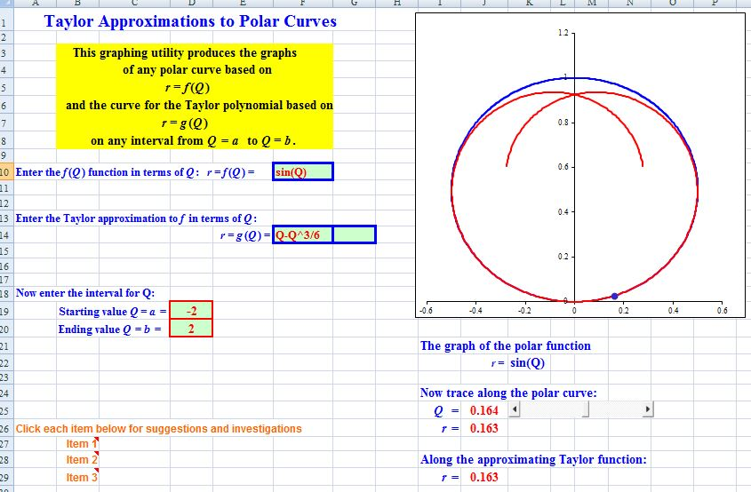
Figure 10
In Figure 11, we show this cubic approximation on the interval [-4, 4], where it is much clearer how the cubic polynomial diverges from the circle. Notice that the scales on the vertical and horizontal axes are quite different; this accounts for the considerable distortion seen in the figure, so that the circle does not appear to be at all circular.
In Figure 12, we show the quintic approximation r = f(Q) = Q – Q^3/6 + Q^5/120 over same interval [-4, 4]. It is clear that the quintic polynomial agrees closely with the circle over a considerably larger interval, as one should expect. And, obviously, this improves with still higher degree polynomial approximations.
We note that this investigation has the potential to provide some very solid insights to students, particularly when the target function is a very recognizable shape, so that it is easy to see where the approximations agree and where they don’t. However, the fact that using this program requires some familiarity with mathematical expressions in computing does make it somewhat inadvisable to assign such investigations to all calculus students unless one knows that they have the prerequisite, non-mathematical background. Despite this, it would make a nice 15 or 20 minute excursion in the classroom. Alternatively, this and the following topic might make a very nice presentation at a math club, for instance, where students who are likely beyond calculus could still derive a lot of benefit from being reminded of some fundamental facts and formulas while showing them some applications that are likely outside of their experience in calculus classes.
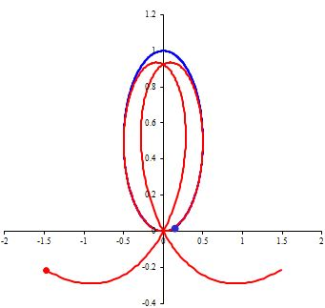
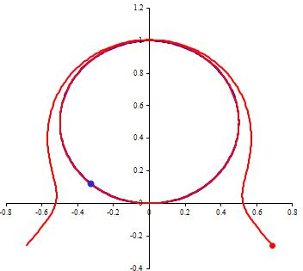
Figure 11
Figure 12

Taylor Approximations to Parametric Functions
Our final investigation involving Taylor polynomials has to do with using such polynomials to approximate parametric functions of the form
x = f(t), y = g(t),
where t is a parameter, often time. This investigation utilizes still another Excel program (#98: Taylor Polynomial Approximations to Parametric Functions). With this, the user must supply expressions for each of the two functions (this again requires knowledge of the rules for mathematical expressions in most computer languages). The user also has to enter the desired interval of t values and expressions for the desired Taylor polynomials x = F(t) and y = G(t) for each function. For instance, we consider the parametric functions x = sin t and y = cos t on the interval [-π, π]. This is a parametric representation for the unit circle centered at the origin.
We begin with the cubic Taylor polynomial for x
x = f(t) = sin t ≈ t – t³/6
and the quartic Taylor polynomial for y
y = g(t) = cos t ≈ 1 – t²/2 + t⁴/24.
As seen in Figure 13, this pair of approximations fit the function quite well across perhaps half of the interval, but clearly diverge dramatically from the “circle” toward either endpoint.

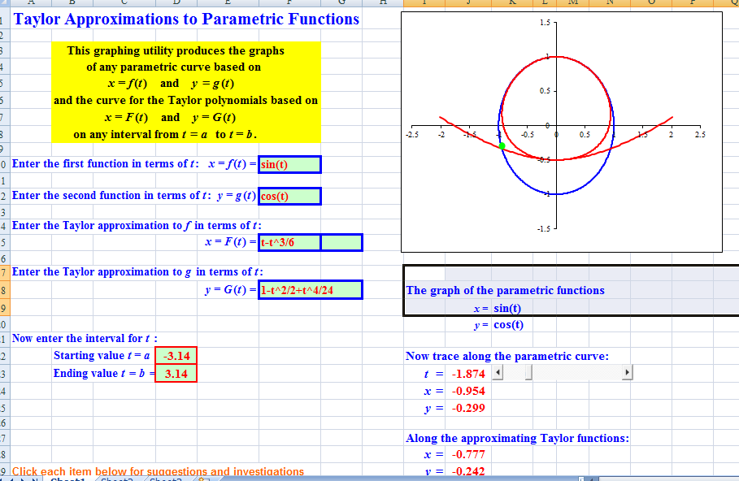
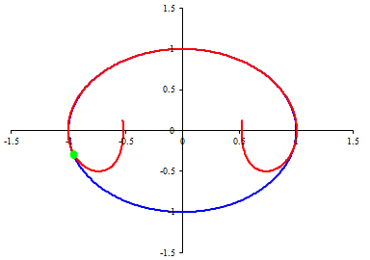
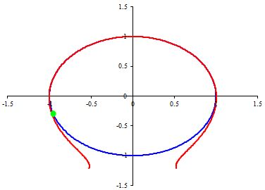
To improve the approximation, we can increase the degree of the Taylor polynomial for either x or y (or both). Suppose we first improve the approximation for the x function, going to the quartic polynomial. This produces the image shown in Figure 14.
Figure 13
Figure 14
Figure 15

We observe that the resulting approximation agrees very well with the target circle over a far longer portion of the interval. Also, note that the approximation in Figure 13 appears to diverge from the circle outside of the circle while this improved approximation diverges, at least for a relatively small interval, inside the circle.
We next improve on the approximation by extending the Taylor polynomial for y to the 6th degree to obtain the image in Figure 15. The approximation extends the interval, albeit not by much, over which the two are indistinguishable. Note, though, that the polynomial now diverges from the circle exterior to the circle. This “alternating” behavior can likely be attributed to the fact that the subsequent terms in both approximations have alternating signs, which would tend to pull the polynomial in the opposite direction.
The above discussion can certainly be used to stimulate discussion with students and to present them with the challenge of continuing the process of extending the approximations one term at a time to see what happens. They can also be challenged to investigate what happens if the approximations are extended sequentially on only one of the variables, but not the other.
As with the investigation of Taylor approximations for polar functions, this topic also requires that students have some comfort with computer notation for functions. As such, this might not be reasonable to assign to all students, so again this might be a good topic to include in a presentation to a math club.

Summary
If instructors do not emphasize the conceptual understanding behind fundamental ideas and techniques in calculus, many students (particularly those with relatively weak mathematical backgrounds) will likely not develop that understanding on their own, but will rather merely apply computational methods by rote. They will almost certainly carry little of value on to subsequent math courses or to courses in other fields.
Dynamic software that brings the concepts to life with visual images can go a long way toward significantly enhancing student understanding of the fundamental ideas and techniques of calculus and, in turn, may help in keeping those ideas alive after the course is over.

References
Attorps, Iiris, Kjell Björk and Mirko Radic, (2015), Generating the Patterns of Variation with GeoGebra: The Case of Polynomial Approximations, Int’l J of Math Ed in Science and Tech, 47:1, 45-57, DOI: 10.1080/0020739X.2015.1046961.

Author, (August, 2019), Dynamic Investigatory Graphics for Mathematics (DIGMath) Spreadsheets for Calculus, URL: to be supplied.
Author, (2017), Visualizing and Understanding l’Hopital’s Rule, Int’l J of Math Education in Science & Tech, 48.
Author, (2016), Visualizing Techniques of Integration, Mathematics and Computer Education, 47.
Dick, Thomas P. and Charles M. Patton, (1994), Calculus of a Single Variable, PWS Publ., Boston, MA.
GeoGebra Simulations, (May, 2019), Optimization Simulations using GeoGebra,
URL: https://math.libretexts.org/Visualizations_and_Simulations/GeoGebra_Simulations
Habre, Samer, (2009), Multiple Representations and the Understanding of Taylor Polynomials, PRIMUS, 19.
Hohenwarter, Markus, Judith Hohenwarter, et al., (2008), Teaching and Learning Calculus with Free Dynamic Mathematics Software GeoGebra, Proc., Int’l Conference on Math Ed 11, Monterey, Mexico.
Hohenwarter, Markus and Judith Preiner (2007), GeoGebra, J. of Online Mathematics and its Applications, 7.
Hong, Dae S. and Jae Ki Lee, (2013), Synthesising Algebraic and Graphical Represen-tations of the Maximum and Minimum Problems, Int’l J of Tech in Math Ed, 20.
Hughes-Hallett, Deborah, Andrew Gleason, et al., (1994), Calculus, 1st Ed., John Wiley & Sons, NY.
Kidron, Ivy and Narit Zehavi, (2002), The Role of Animation in Teaching the Limit Concept, Int’l J of Computer Algebra in Mathematics Education, 9.
Lutzer, Carl, (2005), The Role of Proof in Mathematics and Mathematics Education, PRIMUS, 15.
Ochkov, Valery F. and Elena P. Bogomolova, (2015), Teaching Mathematics with Mathematical Software, J. of Humanistic Mathematics, 5.
Simmons, Todd, (1991), A Numerical and Graphical Approach to Taylor Polynomials Using an Electronic “Spreadsheet, PRIMUS, 1.
Smith, David A. and L. C. Moore, (1996), Calculus: Modeling and Application, Houghton Mifflin Co., NY.
Zimmerman, Walter and Stephen Cunningham, (1991), Visualization in Teaching and Learning Mathematics, MAA Notes #19, Mathematical Association of America, Washington, DC.

