Fitting a Tangent Function to Data

One of the most powerful new ideas that has had an impact on the mathematics curriculum, especially at the high school level, is the notion of fitting a function to data. Every graphing calculator comes with the capability of fitting linear, exponential, power, logarithmic, and polynomial (up to fourth degree) functions to a set of data; most models also provide the ability to fit a sinusoidal function to data and some also have curve-fitting routines for logistic and other functions. Excel has the same capabilities, though it can fit polynomials up to 6th degree to a set of data. The ability to create functions at the push of a button is an incredibly powerful tool that most students quickly learn to appreciate and enjoy applying.
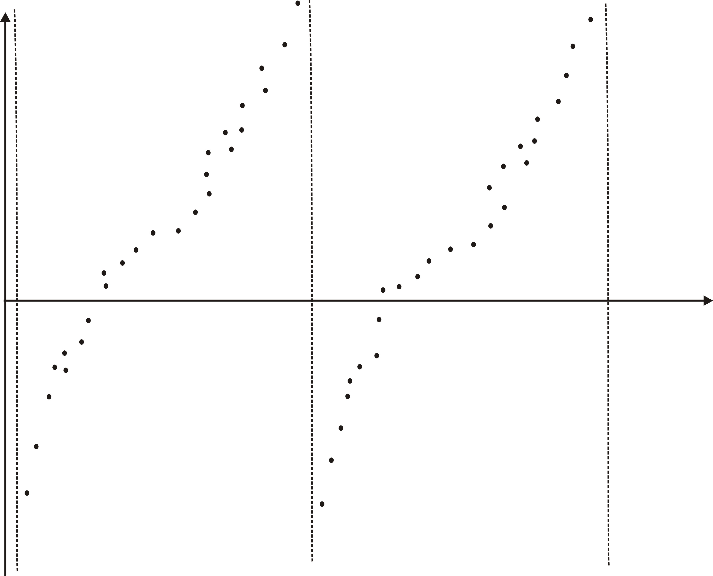
But, what happens if you face a set of data that clearly does not fall into one of the standard behavioral patterns built into a calculator, so the technology is of little, or no, value and you are reduced to a more basic tool, the human mind? For instance, consider the set of data shown in Figure 1, which suggests a tangent function. How do you create a tangent function that is a reasonable fit to the data when calculators and widely available software packages don’t provide the “right” button? In this article, we attempt to answer this question by creating an algorithm to estimate the four parameters in a general tangent function
Figure 1
(something we shall call a tangentoidal function) that can be done as a classroom exercise at the precalculus level. Doing so has multiple advantages:
1. It reinforces some of the fundamental mathematical ideas that students have seen previously,
2. It extends some of these mathematical ideas in a natural direction,
3. It reinforces some of the fundamental principles of data analysis.
4. It drives home the point that while one can use technology, the power of human insight and understanding is an even more powerful tool.

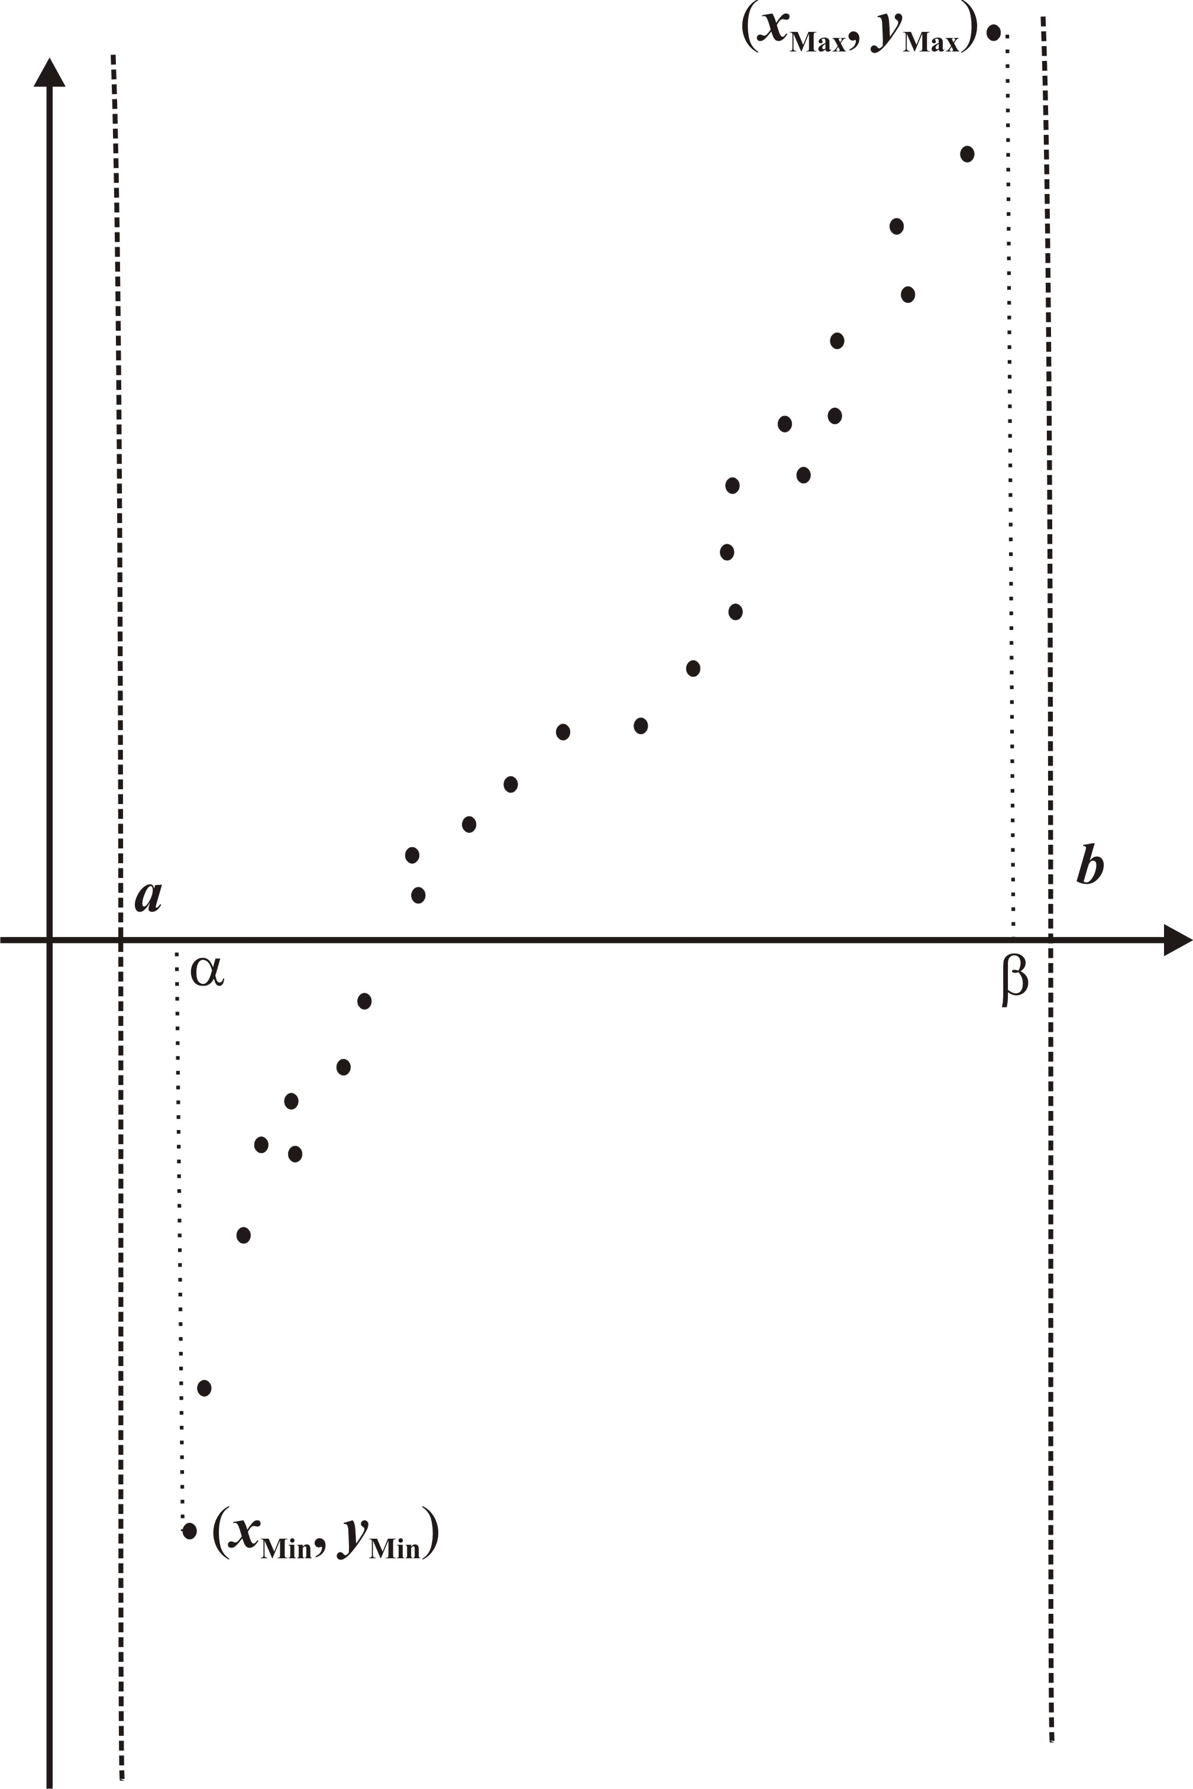
Suppose that a set of data points fall into a pattern that appears, roughly, to be one branch of a tangent curve, as shown in Figure 2. We assume, for now, that the pattern is an increasing one. If there are multiple branches evident in a set of data, we suggest that one should focus on just one branch and then repeat the comparable analyses for each of the other branches separately and eventually average the resulting parameters for each branch. We note that each of the four parameters, A, B, C, and D, in the general tangentoidal function plays essentially the same role that it does in the general sinusoidal function. A represents the midline level, B is the amplitude, C is the frequency, and D is the phase shift. Admittedly there may be some need to interpret just what several of these ideas mean in terms of a tangent function and we do so below.
Figure 2
x | y
1.30 | -840
1.35 | -280
1.50 | -150
1.80 | -131
2.00 | -110
2.30 | -91
2.70 | -70
3.00 | -42
3.20 | -20
3.60 | 8
3.90 | 16
4.11 | 28
4.42 | 50
4.70 | 65
4.90 | 95
5.10 | 120
5.40 | 155
5.80 | 180
6.00 | 200
6.30 | 215
6.40 | 235
6.50 | 260
6.65 | 400
6.70 | 960
Estimating the Parameters We begin by trying to estimate the period of the tangentoidal function that fits the set of data in Table 1. Suppose that the point that is furthest to the right has the greatest height and we denote it by. Similarly, suppose that the point that is furthest to the left has the most negative value for y and we write . The “catch” is that we don’t know precisely where the vertical asymptotes and will fall, so we can’t identify the period directly. Instead, we proceed as follows to estimate its value. Suppose that = (6.7, 960) and that = (1.3, -840). This branch of a tangent function then extends from slightly less than 1.3 to slightly more than 6.7 and so the period b - a will be somewhat more than 6.7 – 1.3 = 5.4.
For simplicity, we work in degrees. As displayed in Figure 2, we find that the interval of x-values from 1.3 to 6.7 corresponds to an interval of angles, from
to
rounded to three decimal places. Therefore, of the 180° over which one branch of a tangent function extends, we have accounted for 89.932° + 89.940° = 179.872°. We now have to apportion the remaining 0.128°. While this may not seem to be a lot, remember how quickly a tangent function rises and falls towards its vertical asymptotes in both directions. Clearly, the vertical asymptote at the left corresponds to -90°, so we need to extend the interval by 0.068° at the left and, similarly, by 0.060° to the right. On a percentage basis, we extend the interval [-89. 932°, 89. 940°] by
Table 1
to the left,
to the right.
It is reasonable to extend the equivalent interval of x-values from to by the same amounts. Thus, since the length of the interval is 5.4, we extend it by 0.038% of 5.4 = 0.002052 to the left and by 0.03336% of 5.4 = 0.001814 to the right. Thus, and , so that the period of our tangentoidal function is .
When working with the sine and cosine, the base period is 2π since it takes 2π radians for either function to complete a full cycle, so that
However, for a tangent, the base period is π and so the corresponding frequency is
Therefore, the associated frequency for the tangentoidal function we are creating is
and the phase shift is
Next, to estimate the midline A, we can proceed in several ways:
1. We could find the point in the data that is closest to and use its height as the estimate of the midline.
2. We could use the fact that the slope of an increasing tangentoidal function is smallest at the “center point” that defines both the midline and the phase shift (as is comparably the case with a sine function where the largest slope occurs at the center point). Thus, if the data values are arranged in increasing order based on the values of x, we can calculate the slopes of the lines through successive pairs of points and select the pair having the least slope. (This is very simple to do using a spreadsheet or a graphing calculator in data or table mode.) We might then use the initial point of the line with the least slope, the end point of that line, or perhaps best, the midpoint of that line segment as our center point and so we have an estimate for the height of the midline. A simple modification would apply if the pattern is a decreasing one.
We note that one could choose either of these strategies and compare how well the resulting tangentoidal functions fit the data, as we discuss below, or perhaps it makes sense to average the different estimates for the midline.
x | y | Slope
1.30 | -840 | 11200.00
1.35 | -280 | 331.11
1.50 | -150 | 63.33
1.80 | -131 | 105.00
2.00 | -110 | 63.33
2.30 | -91 | 52.50
2.70 | -70 | 93.33
3.00 | -42 | 110.00
3.20 | -20 | 70.00
3.60 | 8 | 26.67
3.90 | 16 | 57.14
4.11 | 28 | 70.97
4.42 | 50 | 53.57
4.70 | 65 | 150.00
4.90 | 95 | 125.00
5.10 | 120 | 116.67
5.40 | 155 | 62.50
5.80 | 180 | 100.00
6.00 | 200 | 50.00
6.30 | 215 | 200.00
6.40 | 235 | 250.00
6.50 | 260 | 3500.00
6.65 | 400 | 11200.00
6.70 | 960
Table 2
Finally, we need to estimate the amplitude B of the tangentoidal function. We know that the slope of the basic tangent curve x is 1 at the origin and, in fact, that this is the minimum slope at any point on the curve. The curve rises and falls twice as fast and, for any multiple m, rises and falls m times as fast as does. Therefore, it makes sense to use an estimate for the slope of the tangent line at the center point as our estimate of the amplitude. But, this is precisely what was calculated above in the process of applying the second strategy for estimating the midline. When presenting these ideas in a precalculus course, it is necessary to finesse the mathematics a bit to avoid mention of slopes of tangent lines and hence the derivative.
The algorithm developed above certainly does not cover every possible case. To do that requires a level of sophistication that goes well beyond a classroom exercise at the precalculus level (there is a reason that calculators and standard software packages do not include a tangent-fitting routine).

A Set of Data Let’s now see what happens when we apply the above analysis to the set of data in Table 2, which extends Table 1 by including a column for the slope of the line segments connecting successive points. The corresponding scatterplot is in Figure 3, where we see that the points fall into an increasing pattern that suggests a tangentoidal function. Notice that the data contain our “end” points (-1.30, -840) and (6.70, 960). Moreover, we have highlighted the entries where the slope is smallest, so that the above approach based on the initial point gives us a center point at (3.60, 8) and thus a midline level of . Furthermore, the smallest slope value is 26.67, so this would be our estimate for the amplitude of the tangentoidal function. The period, as we estimated previously, is 5.403866, so that the frequency is 0.581360 and the phase shift is 3.999881. We therefore have the tangentoidal function
Figure 3
.
We show the graph of this tangentoidal function superimposed over the data points in Figure 4 and see that, though it has the desired shape, it is actually a rather poor fit to the data. Let’s see why.
One of the guiding principles when fitting a line to a set of data by hand is not to force the line to pass through any of the data points; doing so gives special attention to those points at the cost of all the other points. The regression line, by definition, is the line that comes closest to all the data points in the least squares sense. In retrospect, the above analysis focused on using the two end points (to estimate the vertical asymptotes and hence the period and the phase shift) and the center point to estimate the midline and the amplitude. In the process, all the other data points were totally ignored. The resulting curve, thus, does a fairly good job of matching these three points, but fails miserably at coming close to most of the other points.
Figure 4

Using the Sum of the Squares We note that one of the fundamental principles of data analysis is that all points must be given equal weight. While this principle is usually stressed in conjunction with linear regression, it often gets lost as one proceeds on to other families of functions and, as a consequence, many students tend to forget about the principle. This activity therefore is a great opportunity to stress that point again.
With linear and non-linear curve fitting, the standard measure of how well a function fits a set of data is the least squares criterion that be a minimum. We now apply the same criterion to fitting a tangentoidal function to data. The corresponding calculations are shown in Table 3, where we see that the sum of the squares based on our initial estimates is a whopping 1,055,614,011.09. If you examine the entries in the last column closely, you will notice that the tangentoidal function reaches a height of 25,297.5016 at the right endpoint (compared to the data value there of 960) as the curve rises rapidly toward its vertical asymptote; the corresponding contribution to the sum of the squares is 592,313,984.36. This one point accounts for well over half of the total of the sum of the squares. Similarly, the tangentoidal function reaches a height of -22,348.3115 at the left endpoint (compared to the data value there of -840) as the curve climbs rapidly from its vertical asymptote at the left. The corresponding contribution to the sum of the squares is 462,607,462.69, which accounts for almost 44% of the total. Thus, these two points alone account for about 99.93% of the total sum of the squares!
We note that these calculations can be performed very easily with either a spreadsheet or a graphing calculator. For instance, on the TI-84 family, suppose that the data values are entered in L₁ and L₂, and the formula for the tangentoidal function is entered in L₃. Then, the squares of the deviations can be calculated in L₄ by typing the function with the estimated values for the four parameters and using L₁ as the independent variable rather than x. If you then exit the STAT menu and go back into it and request STAT CALC and select 1-Var Stats applied to L₄, you will get the sum of the squares, along with all the other statistical results.

x |  | y |  | tan function
1.30 | -840 |  | -22348.31148 |  | 462,607,462.69
1.35 | -280 |  | -873.0644939 |  | 351,725.49
1.50 | -150 |  | -218.0011432 |  | 4,624.16
1.80 | -131 |  | -80.76573295 |  | 2,523.48
2.00 | -110 |  | -53.67505354 |  | 3,172.50
2.30 | -91 |  | -32.48124194 |  | 3,424.45
2.70 | -70 |  | -17.13110259 |  | 2,795.12
3.00 | -42 |  | -9.52259547 |  | 1,054.78
3.20 | -20 |  | -5.38074959 |  | 213.72
3.60 | 8 |  | 1.685731779 |  | 39.87
3.90 | 16 |  | 6.44961451 |  | 91.21
4.11 | 28 |  | 9.709717863 |  | 334.53
4.42 | 50 |  | 14.64658573 |  | 1,249.86
4.70 | 65 |  | 19.49728805 |  | 2,070.50
4.90 | 95 |  | 23.38707329 |  | 5,128.41
5.10 | 120 |  | 27.83897386 |  | 8,493.65
5.40 | 155 |  | 36.23948256 |  | 14,104.06
5.80 | 180 |  | 54.12133822 |  | 15,845.44
6.00 | 200 |  | 69.69848534 |  | 16,978.48
6.30 | 215 |  | 120.0858841 |  | 9,008.69
6.40 | 235 |  | 158.4350869 |  | 5,862.19
6.50 | 260 |  | 234.2701333 |  | 662.03
6.65 | 400 |  | 893.1140003 |  | 243,161.42
6.70 | 960 |  | 25297.5016 |  | 592,313,984.36
 |  |  |  |  |  | 1,055,614,011.09
1.80 |  | -131 |  | -79.87831739 |  | 2613.426433
2.00 |  | -110 |  | -53.23924437 |  | 3221.78338
2.30 |  | -91 |  | -32.27898439 |  | 3448.157675
2.70 |  | -70 |  | -17.03451619 |  | 2805.342475
3.00 |  | -42 |  | -9.460215723 |  | 1058.837561
3.20 |  | -20 |  | -5.332557698 |  | 215.1338637
3.60 |  | 8 |  | 1.71566246 |  | 39.49289831
3.90 |  | 16 |  | 6.470398229 |  | 90.81330992
4.11 |  | 28 |  | 9.725152109 |  | 333.9700654
4.42 |  | 50 |  | 14.65453248 |  | 1249.302074
4.70 |  | 65 |  | 19.49771022 |  | 2070.458375
4.90 |  | 95 |  | 23.38076462 |  | 5129.314877
5.10 |  | 120 |  | 27.82371908 |  | 8496.466764
5.40 |  | 155 |  | 36.2024774 |  | 14112.85137
5.80 |  | 180 |  | 54.01124683 |  | 15873.16592
6.00 |  | 200 |  | 69.49119838 |  | 17032.5473
6.30 |  | 215 |  | 119.3373956 |  | 9151.333876
6.40 |  | 235 |  | 157.0397198 |  | 6077.805283
6.50 |  | 260 |  | 231.0004209 |  | 840.9755882
6.70 |  | 340 |  | 9049.806143 |  | 75,860,723.04
 |  |  |  | -5984.473747 |  | 109,129,990.52

Table 3

We now use the values we estimated above as initial estimates of the parameters and attempt to modify them to produce a more accurate tangentoidal function to fit the data (and, simultaneously, a smaller value for the sum of the squares). If you look carefully at Figure 4 above, you might decide that the reason the curve misses so many of the points is that the slope at the center point, which is equal to the amplitude, is too small. If we change that value to 100, say, instead of 26.67, we get a value of 15,651,847,851.171 for the sum of the squares instead of 1,055,614,011.09; it is roughly 15 times as large and the resulting tangentoidal function is actually a much worse fit, even though the function comes much closer to the points near the center! (See Figure 5.) The reason is that the curve is rising far more rapidly toward the vertical asymptotes at either end and so the contributions to the sum of the squares there are considerably larger (6,899,208,498.19 and 8,733,929,981.08, respectively, instead of 592,313,984.36 and 462,607,462.69 we had previously.)
This might suggest that we try reducing the value for the amplitude. If we try , say, instead of , then the sum of the squares drops to 128,096,675.11, which is a huge improvement compared to over 15 billion. The corresponding function is shown in Figure 6, where we see that it does a very good job of coming close to both endpoints (which is certainly good), but the cost of doing so is that it is much further from most of the other intermediate points (which is definitely bad).

Figure 5
Figure 6

The main problem has to do with the speed with which the tangentoidal function approaches its vertical asymptotes. It therefore might be a good idea to try to increase the period slightly while keeping all the other parameters the same as for Figure 6. Instead of a period of 5.40387, then, let’s try 5.5. The resulting sum of squares is 986,841.18, which is a considerable improvement over our previous tries. The corresponding function is shown in Figure 7 and we see that it now appears to be a very poor fit to almost all of the points, though it misses the two end points most especially. In large part, the problem is that the slope, 10, at the center point appears to be much too small. If we try 100 instead, we get a much larger value for the sum of the squares (about 17,721,000), but the function seems to be a considerably better fit to the intermediate points (see Figure 8).
Figure 8

Figure 7

We leave it to the interested reader to continue the search to see how small a value can be obtained for the sum of the squares and how closely one can find a tangentoidal curve to fit the data. The two goals appear to be contradictory, though; reducing the sum of the squares comes at the cost of a poorer fit to most of the data points and a good fit to most of the points seems to miss the two extreme points quite badly, resulting in a very large value for the sum of the squares. However, this can lead to a very instructive and spirited class discussion, because a final determination is more of a judgment call than anything else. Moreover, we also note that the values obtained for the sum of the squares are extremely sensitive to slight changes in any of the four parameters.
We note that this kind of investigatory challenge of finding parameters to produce the best possible fit, both graphically and numerically in terms of the sum of the squares, is something that students really get excited about. The present author has found that, at one level, this becomes a highly competitive game as each student tries to get the best results, assuming that all have access to some kind of technology to produce the graphs and the calculations in the classroom. On another level, it provides repeated reinforcement for the meaning of the parameters – it is no longer a matter of memorizing (hopefully) a few words that have little meaning to them and which they all too often use interchangeably.
Moreover, it is also fairly easy to generate comparable sets of data to assign projects to individual students or small groups of students to perform similar analyses and subsequent investigations. Unfortunately, there seem to be few, if any, realistic situations in which real-world data fall into tangentoidal patterns, unlike the case with sinusoidal behavior. Consequently, this exploration is more in the nature of a mathematical exercise than a practical one.

