Finding The Best Quadratic Approximation of a Function
Yajun Yang and Sheldon P. Gordon
Farmingdale State College of New York
yangy@farmingdale.edu gordonsp@farmingdale.edu

Abstract This article examines the question of finding the best quadratic function to approximate a given function on an interval. The prototypical function considered is f(x) = e^{x}. Two approaches are considered, one based on Taylor polynomial approximations at various points in the interval under consideration, the other based on the fact that three non-collinear points determine a unique quadratic function. Three different techniques for measuring the error in the approximations are considered.

Keywords quadratic approximation, Taylor polynomial, error in the approximation, total error, root-square error, maximum error

When most mathematicians think about the concept of approximating a function, they invariably think of it either in terms of local linearity or its natural extension, the Taylor polynomial approximations to the function. In a previous article [5], the authors investigated a variety of ways that a function can be approximated by a linear function. In this article, we extend some of those ideas to consider a variety of different ways to think about approximating a function using a quadratic function.
To make things simple, it is standard procedure in numerical analysis to consider continuous functions that are monotonic with fixed concavity on an interval [a, b]; any function that has turning points or inflection points can be broken down into a set of such functions and each portion is treated separately. To make things concrete, we will consider the function on the interval . Most of the ideas and developments that follow can be applied to most other functions with similar behavior properties – namely, they are either increasing or decreasing with fixed concavity on an interval. However, the conclusions regarding which approximation is best will depend both on the function and on the interval selected.
Let’s begin with the Taylor polynomial approximation of degree 2 at :
.
How accurate is this approximation? Well, it is a perfect fit at and, if we stay close to , it is extremely good. However, if our objective is to approximate the function across the entire interval, it is clearly not as good an approximation the farther we move away from , as seen in Figure 1.

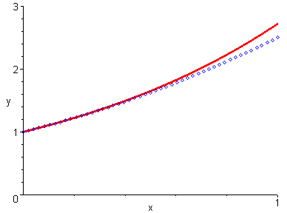
Figure 1 Taylor polynomial approximation of degree 2 at ;
the solid curve is , the dotted curve is the

Before proceeding, though, we need a way to measure how well an approximating function fits a function on an interval . There are actually several different ways for doing this. Two of the simplest ways to measure the error in the approximation over the entire interval involve the vertical differences between the function f and the approximating polynomial P at a fixed number of points x₁, x₂, …, x_{n}, for some positive integer n. One approach is to calculate the sum of the absolute values of these vertical differences and the other is to use the sum of the squares of the vertical differences. Both methods are used to avoid the cancellations that could occur if the two curves cross each other. Notice that both sums and increase as n increases. An easy way to eliminate the effect of n from the error calculations is to divide either sum by n. We then have the following error formulas:
and .
Both of these expressions can be thought of as finding the average of the vertical discrepancies between the original function and the approximating function at the n points.
One main drawback of using either formula is that in most cases the values of are difficult to compute. However, both formulas lead to somewhat more sophisticated and more useful approaches, as we discuss. For instance, with the absolute value formulation,
, as .
Suppose we partition the interval into n uniformly spaced subintervals, so that the width of an individual subinterval is , and so . Define by

i = 1, 2, …, n.
These are the midpoints of n evenly spaced subintervals of . Then
.
The quantity is a Riemann Sum associated with the definite integral .
We define
.
This error represents the area bounded between the curve and the approximating function. It measures the total error of the approximation over the interval. For our quadratic approximation , we use the fact that across the interval , so
.
If the approximating function is not always above or below the function f, however, integrating the absolute value of the difference can cause some significant computational problems.
Alternatively, if we use the squares of the vertical differences instead of the absolute value of the vertical differences in the above approach, we have for the error of the approximation. As the number of subdivisions increases, we have
, as .
We can think of this integral as representing the average value of the function over the entire interval. This formula leads to a second measure of the error in the approximation:
.
This is essentially the L² norm from topology. Although it might seem somewhat unreasonable to do this, the root-square error is used quite frequently in numerical analysis because it is easier to program the square of the differences than the absolute value function and, more significantly, it is considerably faster to execute. Using this measure, we find that the error associated with the quadratic approximation on the interval is
,
using Derive to evaluate the definite integral.
The problem with the above two error estimates is that they provide a representative value to indicate how good, or poor, the fit is across the entire interval, but does not provide information on the worst case scenario. Thus, if a quadratic function was actually a very good approximation to a curve across most of the interval, but peaked at some point in question, neither criterion would likely reveal that. So, a third measure of the error in the approximation is to use the maximum difference between the function and the polynomial. We define
.
This is equivalent to finding the maximum deviation between the function and the approximating function on the entire interval. It is known variously as the maximum norm, the uniform norm, the infinity norm, and the Chebyshev norm in numerical analysis. For our Taylor quadratic approximation to the exponential function on the interval , Figure 1 obviously suggests that the maximum deviation occurs at the right endpoint of the interval and so this error, correct to six decimal places, would be . We show the difference function in Figure 2, which provides somewhat better insight into the behavior of the error than Figure 1 does. More generally, one would typically have to apply calculus to determine this maximum if it were not visually evident. Essentially, then, this error estimate is the formalization of the kind of error measurement we make when we talk about an approximation being good to a certain number of decimal places.
It is important to note that these three error estimates are not in the least commensurate in the sense that we cannot compare the level of accuracy based on the three different measures.

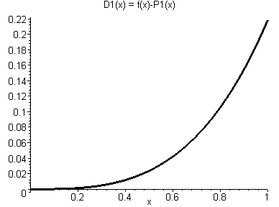
Figure 2 Difference function

Improving on the Accuracy
We next consider several ways to obtain a more accurate quadratic approximation to the exponential function on this interval. Perhaps the most obvious alternative to the quadratic Taylor polynomial approximation at the left endpoint is to use the quadratic Taylor polynomial at some point within the interval. In particular, we consider the point at the center of the interval, as shown in Figure 3. The corresponding quadratic function, , is
.
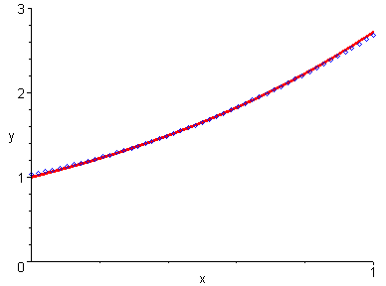
Figure 3 Taylor polynomial approximation of degree 2 at ;
the solid curve is , the dotted curve is the

This parabola appears to be an almost perfect match to the exponential function across the entire interval. If you zoom in on different portions of this graph, you will observe that the quadratic polynomial crosses the exponential curve at on this interval. The corresponding three error values are then
Error_{Total} ≈ 0.008659 (after a simple integration),
Error_{Root-Square} ≈ 0.013188 (using Derive),
Error_{Max} ≈ 0.039110 (using Derive)

Table 1
Error_{Total} | 0.051615 | 0.008659 | 0.093906
Error_{Root-Square} | 0.079682 | 0.013188 | 0.139598
Error_{Max} | 0.218282 | 0.039110 | 0.359141

To help in comparing the different error values, we tabulate the results in Table 1, and also add the corresponding results based on the quadratic Taylor polynomial based on the right hand endpoint . From the table, we see that all three errors with the quadratic Taylor polynomial at the midpoint of the interval are significantly smaller than the corresponding values based on the quadratic approximations at the left endpoint, let alone those based on . Therefore, among the three possibilities, is by far the best approximation to , no matter which error measurement we use.
The significant improvement in the accuracy for compared to the other two choices suggests that we might gain even greater accuracy by choosing a suitable point somewhere other than at one of the endpoints or the midpoint of the interval as the point where we construct the quadratic Taylor approximation. However, there is no reason to expect that the same choice for will necessarily minimize all three of the error estimates; in fact, we should expect that each of the three will likely be smallest at a different point in the interval.
For example, if we conduct a simple computer search routine, we find that the Error_{Max} achieves a minimal value of 0.034961, which corresponds to the point (correct to four decimal places). This is somewhat better than what we obtained above by using the Taylor polynomial at . For the function f(x) = e^{x}, it is possible to optimize the error analytically, but the ability to do this is a rarity and so we focus only on results from search routines, which apply to any function.
Using a different search routine, we find that the Error_{Total} achieves a minimal value of 0.008659, which corresponds to the point . Finally, a search approach yields a minimal value for Error_{Root-Square} of 0.013145, which occurs when , and this is significantly smaller than the other values displayed in Table 1. We display all of these results, in addition to the ones we obtained above, in Table 2. Interestingly, all three of these improved error estimates occur relatively close to the midpoint .

Table 2
 |  |  |  |  | Error at
Error_{Total} | 0.051615 | 0.008659 | 0.093906 | 0.5 | 0.008659
Error_{Root-Square} | 0.079682 | 0.013188 | 0.139598 | 0.5089 | 0.013145
Error_{Max} | 0.218282 | 0.039110 | 0.359141 | 0.5208 | 0.034961

Using Parabolas through Three Points
Instead of using a tangent parabola as our approximating quadratic, we next use the fact that a quadratic function is uniquely determined by any three non-collinear points. Suppose, for instance, that we take the two endpoints, and , along with the midpoint of the interval. The parabola that passes through these three points , , and is, correct to six decimal places,
,
so that
.
(We can find such a polynomial very simply using the quadratic regression routine in any graphing calculator or in Excel, for instance.) We show this quadratic approximation in Figure 4 and observe that the parabola appears to be an excellent match to the exponential function across the entire interval. We also show the difference between and the approximating quadratic in Figure 5 and observe how small the difference remains across the entire interval. We should therefore expect that all three of the error estimates will likely be considerably smaller than the

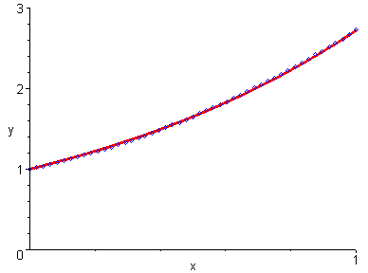
Figure 4 Parabola approximation ;
the solid curve is , the dotted curve is the

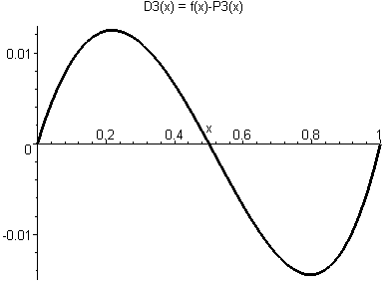

Figure 5 Difference function

preceding values based on the Taylor approximations. In particular, we obtain
Error_{Total} ≈ 0.008731
Error_{Root-Square} ≈ 0.009665,
Error_{Max} ≈ 0.014421
To help compare the different quadratics and how well they fit the exponential function, we extend Table 1 to include these values as well in Table 3.

Table 3
Error_{Total} | 0.051615 | 0.008659 | 0.093906 | 0.008731
Error_{Root-Square} | 0.079682 | 0.013188 | 0.139598 | 0.009665
Error_{Max} | 0.218282 | 0.039110 | 0.359141 | 0.014421

We therefore see that Error_{Max} and Error_{Root-Square} are both significantly smaller for this quadratic than with any of the three Taylor approximations. The value for Error_{Total} is 0.008731, and it is very close to the smallest value of Error_{Total} associated with the Taylor approximations.
Can we improve on this quadratic approximation? The parabola through three points is a perfect fit to the function at each of those three points and is extremely close to the function for values of x close to those three points. Therefore, using the two endpoints of the interval actually results in our losing some of the advantages of such an approximation – the nearby points outside the interval are not “counted”. It therefore makes sense to select three points that are all inside the interval. For instance, suppose we take the uniformly spaced points x = 0.25, 0.50, and 0.75. The resulting quadratic function is and the corresponding approximation is
.
Note that the coefficients of this parabola haven’t changed much compared to the preceding approximation.
Now let’s see what happens to the values of the error estimates. We extend the above table to include these results in Table 4.

Table 4
Error_{Total} | 0.051615 | 0.008659 | 0.093906 | 0.008731 | 0.005430
Error_{Root-Square} | 0.079682 | 0.013188 | 0.139598 | 0.009665 | 0.008840
Error_{Max} | 0.218282 | 0.039110 | 0.359141 | 0.014421 | 0.029420

We therefore see that most of the error estimates have been reduced, other than Error_{Max}, which is roughly twice as large for than for . Thus, in two of the three cases, we have achieved a greater degree of accuracy by using the parabola through these three points rather than the one through the endpoints and the midpoint of the interval.
This suggests that we can likely improve on the error estimates still further by examining other sets of three points to determine a parabolic approximation. For instance, interested readers might want to explore what happens if the three points are 1/6, 1/2, and 5/6. The idea here is to choose one point from each equally divided subintervals [0, 1/3], [1/3, 2/3], and [2/3, 1] of [0, 1]. And by selecting three midpoints, one from each subinterval, we likely maximize the potential benefit of the approximating function being a perfect fit at the midpoints.
Naturally, the above improvements lead to a search for a quadratic approximation that could minimize each of the three errors by finding, in some sense, the “best” three points in the interval, though what that “best” is will depend on the choice of the error estimate selected. For example, if we want the smallest approximation error by Error_{Max}, we will look for three points in the interval such that the parabola through these three points minimizes the maximum deviation from the exponential function on . We use a computer search routine and find that the “best” three points are , , and with a minimum value for Error_{Max} of 0.008760. The corresponding quadratic function, , is
.
This approximating function is known as the minimax approximation. Since it is the best approximation by the error estimate Error_{Max}, we expect to have a very close fit to. Therefore we will only show the difference between and in Figure 6; visually, we see that the greatest difference is roughly 0.008, which is in line with the computed value of 0.008760.

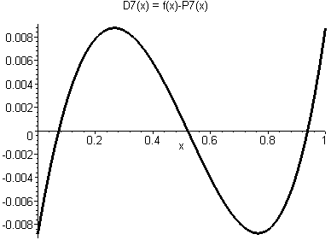

Figure 6 Difference function

When we consider the smallest approximation error by Error_{Total}, we will search for three points in the interval such that the parabola through these three points minimizes the total area bounded between the parabola and the exponential function on . Using a different computer search routine, we find the “best” three points are , , and . As you can see, these three points are very different from the minimax approximation solution. The Error_{Total} achieves a minimum value of 0.004347 with its corresponding quadratic function
.
Figure 7 shows the difference between and .
Finally, finding a quadratic function that minimizes the Error_{Root-Square} is a special case of the well-known least squares approximation. Using a computer search routine, we find a minimum value for Error_{Root-Square} of 0.005276 with the “best” three points being , , and . Again, these three points are different from those by the other two optimal error estimates. As we mentioned earlier, the “best” three points depend on the choice of the error estimate selected. The least-squares quadratic function, , is
.
The difference between and is shown in Figure 8. We summarize all of these results including the values of all three errors for each quadratic function , , in Table 5.

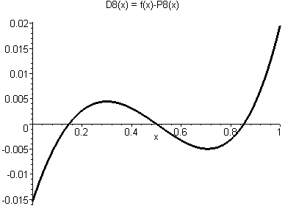 | 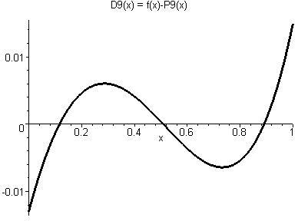
Figure 7 Difference function | Figure 8 Difference function

Table 5
Error_{Total} | 0.008731 | 0.005430 | 0.005472 | 0.004347 | 0.004530
Error_{Root-Square} | 0.009665 | 0.008840 | 0.006102 | 0.005672 | 0.005276
Error_{Max} | 0.014421 | 0.029420 | 0.008760 | 0.019672 | 0.014981

Even though the best quadratic approximations by Error_{Total} and by Error_{Root-Square} produce different results for each of the three errors, their values for Error_{Total}, Error_{Root-Square}, and Error_{Max} are somewhat close, respectively. Notice that the graphs of the difference functions and resemble each other. These observations may be explained by the ways these two errors Error_{Total} and Error_{Root-Square} are defined. The best quadratic approximation by Error_{Root-Square} is easiest to compute among the three best quadratic approximations.
While we don’t go into this here, it is certainly worth mentioning that there is a well-established theory in numerical analysis [1, 2] for finding the “best” possible points. For any given continuous function including on the interval , the quadratic interpolation at the so-called Chebyshev nodes, , , and , will yield a good estimate of the quadratic minimax approximation. Interested readers might want to see how small the various errors are corresponding to these choices.

Pedagogical Considerations
The authors believe that the investigations discussed in this article can serve as the basis for a computer lab project, if not a series of projects. For instance, in Calculus II, many of the activities discussed would serve as an effective review of topics from Calculus I, including the behavior of functions, optimization, rules for differentiation, rules for integration, applications of the definite integral, and numerical integration. Simultaneously, such a project would provide a very practical application of Taylor polynomial approximations, which many consider to be the culmination of the first year of calculus.
Furthermore, a continuation of this project could be a computer lab activity in Calculus III once students have been introduced to partial derivatives and optimization of functions of several variables.
Finally, it would also make an excellent project investigation in a course in numerical analysis to bring together so many ideas from calculus in the process of considering some extremely important concepts and methods from numerical analysis. The typical approach in numerical analysis is to consider one method at a time to approximate functions in general. This project nicely cuts across all the different approximation methods applied to a single function to provide students with the ability to compare the effectiveness of the various approaches.

Acknowledgment The work described in this article was supported by the Division of Undergraduate Education of the National Science Foundation under grants DUE-0089400 and DUE-0310123. However, the views expressed are not necessarily those of the Foundation.

References
- K. E. Atkinson, Elementary Numerical Analysis, 2nd Edition, John Wiley & Sons, New York, NY, ISBN: 0-471-50999-X (1993).
- K. E. Atkinson, An Introduction to Numerical Analysis, 2nd Edition, John Wiley & Sons, New York, NY, ISBN: 0-471-62489-6 (1988).
- E. W. Cheney, Introduction to Approximation Theory, McGraw-Hill, New York, NY, ISBN: 0-070-10757-2 (1966).
- D. Hughes-Hallett, A. M. Gleason, et al., Calculus – Single Variable, 3rd Edition, John Wiley & Sons, New York, NY, ISBN: 0-471-40826-3 (2003).
- Yang, Yajun and Sheldon P. Gordon, Finding the Best Linear Approximation to a Function, Mathematics and Computer Education, Vol. 42, No. 2 (2008).

