Taking Your Chances on Excel

In a pair of previous articles [1, 2], Gordon discussed some simple to use, yet not very well known, sophisticated capabilities of Excel to illustrate how to develop an easy-to-use spreadsheet that produces the graph of an arbitrary function y = f(x) on any desired interval [a, b]. This includes a dynamic dimension via the use of sliders and other special features of Excel that allow the user to change parameters instantly and to make choices in ways that are effectively instantaneous. In the present article, we extend some of these ideas to introduce ways to create dynamic visual simulations of probabilistic events to provide students with far greater insights into random processes such as coin flipping.
Excel allows us to do many of the things that mathematicians use graphing calculators for in their classrooms, in the assignments they give to students, and in their own work. Moreover, there are significant advantages to using Excel instead of, or in addition to, a graphing calculator—much higher levels of resolution, virtually instantaneous responses, dynamic features that we address in this article, and an ease of printing out results that cannot be achieved with calculators.
As discussed in the previous articles, the author believes that any software for use on an in-class demonstration basis or by students on an individual basis should reflect several basic principles:
(1) Any program must be very simple to use in case the user is not particularly computer savvy or not overly self-confident.
(2) The program must be very easy to use in the sense of involving as little “button-pushing” as possible; otherwise, it is too easy to lose the attention of the class during a live demonstration or even to divert attention away from the mathematical concept or method being illustrated.
(3) The program must be as fool-proof as possible so that naïve users don’t inadvertently screw it up by deleting something important or entering the wrong information in the wrong place and hence changing the “logic” of the program.
(4) The display screen should be as uncluttered as possible, so that the important graphs and numerical displays do not get lost.

Creating a Dynamic Probability Simulation
The author has written an extensive number of programs in Excel covering virtually every concept and technique in calculus, precalculus/college algebra, differential equations, probability and statistics, numerical analysis, and other courses. These programs are intended either for classroom demonstrations or for independent student use. They can be downloaded free from the author’s website [3]. Most of the modules for probability and statistics are based on drawing large numbers of random samples from some underlying population and displaying the results both graphically and numerically to dramatically improve student understanding of what are all too often very sophisticated and non-intuitive ideas.
To illustrate how such a simulation can be created, we will focus on a relatively simple coin-flipping routine involving a choice of between 1 and 3 fair coins (you might want to think of them as a penny, a nickel, and a dime). The simulation allows the user to select the number of coins and a reasonable number of times that those simulated coins are flipped; say between 100 and 1000 times. The simulation should display the outcomes of those simulated flips graphically as a histogram and also print out the number of times each possible outcome actually occurred among the simulated results. The simulation should also display the theoretical predicted values for comparison. Finally, it should provide a simple way to generate another set of random samples using the same values for the parameters. Our goal is to produce an interactive program that produces the kind of graphical and numerical displays shown in Figure 1, where the user’s input is controlled by a pair of sliders.
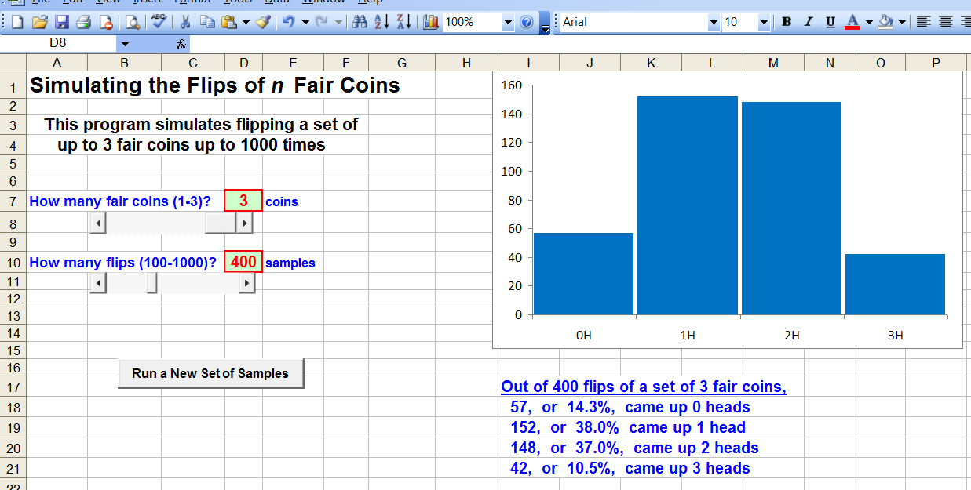

Figure 1

Organizing the Spreadsheet
We begin by introducing the dynamic elements mentioned above by using Excel’s controls. As discussed in [2], the controls are found as part of the Developer tab in the Excel ribbon, as shown in Figure 2. When you click on the down arrow under Insert, two collections of buttons appear, as shown in Figure 3; the upper collection consists of the Form Controls and the lower group are the ActiveX Controls. The last item in the top row of the ActiveX Controls is a ScrollBar that creates either a horizontal or vertical slider. Click on that icon, then move the cursor to form a horizontal, say, rectangle wherever you want it to appear in the spreadsheet, and the slider appears there. You can easily change the size or the location of the slider as long as you are in Design Mode, as discussed later.
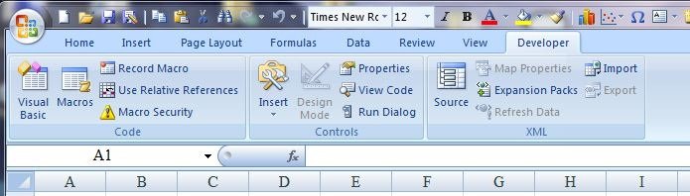

Figure 2

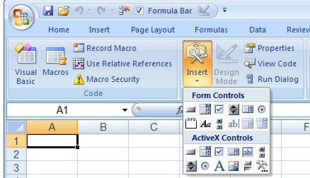

Figure 3

For now, create two horizontal sliders, one for the number of coins and the other for the number of random samples, as discussed in [2]. Position them one below the other, say about three rows apart, at the left of the screen. Suppose the upper slider is in Row 8 and the lower slider is in Row 11. In the row above the first slider (Row 7), enter some instructions such as: “How many fair coins (1 - 3)? ”. In the row above the second slider (Row 10), similarly enter something like “How many flips (100 - 1000)? ”.
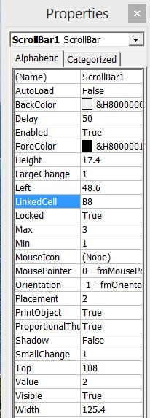
At the left of the Controls panel of the Developer ribbon shown in Figure 3, click on the Design Mode button (the tool set) to edit the underlying features of each slider. You will have to click on the Design Mode button again to exit Design Mode when you are done setting up the sliders, so that you can actually use them. To start, temporarily move both sliders off toward the right to expose one or two of the cells that will eventually be covered by the sliders. In Design Mode, click on the Properties button about to bring up the menu shown in Figure 4. The primary features you have to be concerned with are the items titled LinkedCell, Max, and Min. The last two determine the range of values for the slider; they must be non-negative integers. For the slider associated with the number of coins, the values should be 1 for Min and 3 for Max. For the slider associated with the number of random samples, the values should be 100 for Min and 1000 for Max.
The LinkedCell feature gives the cell in the spreadsheet where the current value of the associated variable is, based on the position in the slider; this value will be an integer between Min and Max. Eventually, we recommend that the slider be moved to cover that cell. For now, we suggest that you enter the cell address B8 for the first slider and B11 for the second slider. It will be convenient to name these two cells, as described in [1]. For instance, you may want to call cell B8 “coins” and cell B11 “flips”. Also, as discussed in [1], both of these cells, B8 and B11, should be left unprotected; press Home-Font-DownArrow-Protection and uncheck Locked for each. If you then exit Design Mode, you can experiment with using the sliders and seeing how the value displayed in B8 varies from 1 to 3 and how the value in B11 varies between 100 and 1000.
Figure 4
It is also convenient to have the current values associated with each slider displayed. In cell D7, enter the formula “=B8” or “= coins”, say, followed by the text “coins” in cell E7. Similarly, in cell D10, enter the formula “=B11” or “= flips” followed by the text “samples” in cell E10.
Next, we use a different control to generate new sets of random samples. From the display in Figure 3, select the first choice under ActiveX Controls to create a command button. Place the cursor several rows below the two sliders and drag it to the right to form a bar that looks similar to a slider, but has the words CommandButton1 on it. When you right-click on it and bring up the Properties list, as shown in Figure 5, the important entry is Caption, where it initially reads “CommandButton1”. Replace that text with something like “Run a New Set of Samples”. Be sure that the bar for the button is long enough for all the text to fit; if not, while in Design Mode, just extend the bar.
One difference between Command Buttons and the other controls is that such a button has an associated short program in Visual Basic (VBA). When you right-click on the button, the choice below “Properties” is “View Code”, which brings up the window shown in Figure 6. In the blank space between the two lines of code, either enter the following three lines or copy and paste them from Word or a similar program:

Range("C16").Select
ActiveCell.FormulaR1C1 = -ActiveCell.Value
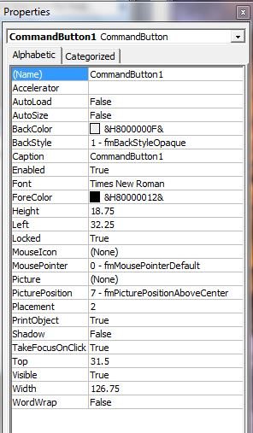
Calculate
Figure 5

When you have done this, click on Debug at the top, then Compile VBAProject, and finally close the VBA window to save this program. Notice that the program refers to cell C16 and the second line multiplies the value in that cell by -1; it is this change in the value of a cell that initiates recalculation of the cells that hold the sample values. Make sure that the protection setting for cell C16 is Unlocked and then move the command button so that it covers cell C16. Then exit Design Mode. Thereafter, each time you click on this button, the value in cell C16 changes and Excel automatically recalculates all cells and so generates a new random sample with the same parameters.

Generating the Random Samples
We now turn to the issue of generating the random samples to simulate flipping sets of n fair coins a total of k times. Since this involves a very large number of cells, we set up all the calculations on a separate sheet of the spreadsheet. In particular, click on the tab at the bottom marked “Sheet2” to shift to the second page.
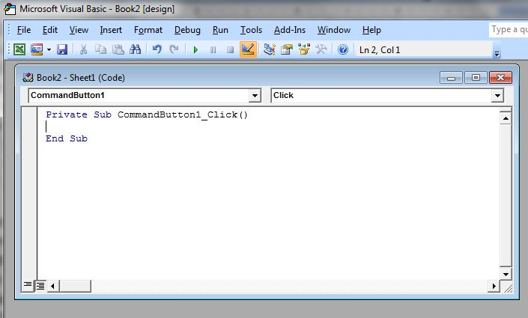
To start, in Column A, enter the numbers 1 through 1000 in cells A2 through A1001. The simplest way to do this is to enter 1, 2, and 3 in cells A2, A3, and A4, respectively, then highlight those cells, and copy them down the column all the way through row 1001. Then, in cells B1, C1, and D1, enter the values 1, 2, and 3 to represent the possible numbers of coins in the simulation. That is, column B will contain the sample results for the first coin, column C those for the second coin, and column D the results for the third coin.
Figure 6

Next, in cell B2, enter the formula
=IF(B$1<=coins, INT(2*RAND()), ""),
including the leading equal sign. Alternatively, if you don’t use the name feature, then this formula would be
=IF(B$1<=A$8, INT(2*RAND()), "").
The Excel function RAND() generates a random number between 0 and 1, excluding the 1. When it is multiplied by 2, it generates a random number between 0 and 2, excluding the 2. The Excel function INT( ) is essentially the greatest integer function, so that INT(2*RAND()) returns either a 0 or a 1. The IF command says that if the number B1 at the top of column B is less than or equal to the number of coins, then the function returns either a 0 for Tails or a 1 for Heads. Alternatively, if B1 is greater than the number of coins, the IF function returns a blank. The $ in B$1 is included to guarantee that the cell B2 always refers to B1, even when it is copied elsewhere. Now copy this cell B2 all the way down the column into cells B3 through B1001. The first flips cells will then contain only 0’s and 1’s and all the remaining cells will be blank.
Next, do the same things in columns C and D to generate the random results on the second and third coins. The corresponding commands are
=IF(C$1<=coins, INT(2*RAND()), "") in cells C2 through C1001
=IF(D$1<=coins, INT(2*RAND()), "") in cells D2 through D1001.
We next total the number of times each of the possible outcomes occurs in each row of columns B, C, and D. In column E, let cell E1 be a header such as “sum”. Then, in cell E2, enter the formula =IF(A1<=flips,SUM(B2:D2), "") and copy this down into cells E3 through E1001. The IF command is used to generate a value only up to the number of flips and a blank cell thereafter. An entry of 0 means that all the coins came up “tails”; an entry of 1 means that there was a single “head” and the other outcomes were “tails”; and so forth.
We then summarize the results of these random flips. Label columns F and G “frequency” and “percentage”, respectively. In cell F2, enter the formula
= COUNTIF(E2:E1001,"=0") .
This command counts the number of occurrences of the value “0” in column E; that tells us how many times the random outcomes consisted of only “tails”. In cell F3, enter the formula
= IF(A2<=coins+1,COUNTIF(E$1:E$1001,"=1"),"").
This command similarly counts the number of occurrences of the value “1”, the number of outcomes consisting of only one “head”, in column 3. The IF command is used to get this total provided that the counter in column A is less than one more than the number of coins; otherwise, it returns a blank cell. Then, copy this command into cells F4 and F5, but change the “1” near the end of the command in cell F3 to a “2” in F4 and a “3” in F5.
To calculate the associated percentages, simply enter the formula
= 100*F2/flips
into cell G2 and copy it into cells G3 through G5.

Creating the Histogram
We next turn to creating a histogram displaying the results of the simulation, as shown in Figure 7, that shows the simulated results of flipping three coins a total of 400 times. Start by inserting a column chart on the first page of your spreadsheet. Click on the Insert tab and then select the first entry, Column, in the Chart panel. Then select the first entry at the left under 2-D Column.
Next, right click on the blank chart that comes up and click on Select Data. Then select Add Data. In the window that comes up called Edit Series, you can enter a name for the series, say frequencies. Then, under Series values, click on the icon at the right, go to the second sheet of the spreadsheet where all the calculations are done, highlight the cells in F2 through F5, and press Enter. You will get a display much like Figure 7.
Figure 7

Figure 8

You may want to streamline the chart that appears to get something more like the image in Figure 8. First, you probably do not want the identifier reading "Series 1" that appears automatically at the far right, so right click on it and press the Delete button. Second, you probably do not want the grid lines that also appear automatically; just right click on any one of them and press Delete. Third, the darkish gray background that appears automatically may also detract from the image; to change it, right click anywhere around the periphery of the chart (so that the entire chart is highlighted), select Format Chart Area, and select a white background for the area. More importantly, the bars drawn are usually very widely spaced and you will likely want to change that appearance. Right click on any of the bars and select the last option, Format Data Series. The second option shown is Gap Width and you will likely want to reduce this to close to 0%, say 5%. Either use the slider or enter the value you want in the box below the slider. Finally, you may want to change the color of the display. If so, click on the second option, Fill, then select the second option, Solid fill, click on the down arrow beside Color:, and choose the color you like, probably a reasonably dark color that contrasts well with the white background for classroom display.

Generating the Numerical Output
We next consider how to generate the printed display of the results. To do this, below the chart, you can enter the commard:
="Out of "&TEXT(flips,"0")&" flips of a set of "&TEXT(coins,"0")&" fair coins," .
The & symbol is used to combine (concatenate) different text features. The TEXT command is an instruction to print the value of the indicated cell or variable (in this case, flips and coins) with the associated formatting. The “0” formatting calls for integers; in comparison, the formatting “0.0” calls for integers and one decimal place and “0.00” calls for integers and two decimal places. In this example, what appears is “Out of 400 flips of a set of 3 fair coins,”.
On the following line, enter the command:
=" "&TEXT(Sheet2!F2,"0")&", or "&TEXT(Sheet2!G2,"0.0")&"%, came up 0 heads",
which produces the text
“ 43, or 10.8%, came up 0 heads”
On the following line, enter
=" "&TEXT(Sheet2!F3,"0")&", or "&TEXT(Sheet2!G3,"0.0")&"%, came up 1 head"
and so forth.
At this point, you have a simple-to-use dynamic spreadsheet that allows students to visualize the results of flipping large numbers of random coins repeatedly and to compare and contrast the results of different samples. You could add a few lines of printed output to provide the theoretical predictions for the expected number of results for each outcome, if you desire, but we will not include that here.

Some Simple Extensions
Once you have created this spreadsheet, there are a fantastic array of fairly simple extensions you can create. For starters, you might want to extend this spreadsheet to allow for more than three fair coins. To do so, just change the Properties on the first slider, add the extra columns for the 4th, 5th, etc. coins, extend the table on the second sheet to include columns F and G for the additional summary values, and modify the data source in the chart.
As another extension that is very effective in the classroom, you can produce a comparable simulation on the sum of the faces of two fair dice. Just allow for values between 1 and 6 and most everything follows quite easily. Or, you can create a simulation for a more general binomial experiment. To do this, add an extra slider in which the user can select the desired likelihood of success, p, and just think of the variable coins as representing the number n of repetitions, and the variable flips as being the number of experiments. Note, though, that you will have to change the values for Min and Max in the Properties window to, say, 1 and 99, respectively and the formula in the associated cell, say D14, should now read “=A14/100” to produce a decimal value for p between 0.01 and 0.99 for the probability of success.
Or, you can create a simulation on the gender distribution in a family of n children.
Or, …. Just use your imagination for what you would like to demonstrate to your statistics or probability class.

A Final Note When a spreadsheet uses macros or some other sophisticated features such as the controls discussed earlier, Excel treats it differently after you have saved it and then subsequently open it for use. Whenever you open such a spreadsheet, a new bar appears near the top of the window that says "Security Warning: Active content has been disabled". Essentially, you have to tell Excel to accept macros. To do so, click on Options, then click on "Enable the Content" and finally click OK.

References
1. Gordon, Sheldon P. Functioning in Excel, Mathematics and Computer Education, vol. 50, No. 2, 2016.
2. Gordon, Sheldon P. Taking Control of Excel, Mathematics and Computer Education, vol. 50, No. 3, 2016.
3. Author, URL for Excel spreadsheets (to be added)

