Time, Tides, and Temps Are Waiting for All Students
Sheldon P. Gordon
Farmingdale State College

When introducing sinusoidal behavior in a modeling-based college algebra or precalculus course, the usual right-angle trigonometry problems are not particularly appropriate or interesting to the students. Instead, I have found that some of the real-world applications that literally are on all sides of us definitely connect with the students and show them the value of the mathematics while simultaneously providing some wonderful opportunities for very substantial problems. The following three examples represent (1) a sinusoidal function
(1)
that closely models the number of hours H of daylight in Jacksonville, FL on the t^{th} day of the year (t = 1 is January 1, t = 2 is January 2, etc.); (2) the tide cycle at the beach in Jacksonville over a particular 48 hour period, as shown in the chart in Figure 1; and (3) the historical average high and low temperatures in Jacksonville over the course of a year, as displayed in Figure 2. Each of these examples can easily be changed based on comparable data on almost any other location, but these were specifically chosen in connection with the 2012 annual AMATYC conference.
Each situation presents a wonderful collection of problems that test whether students have a very firm grasp of the concepts – like the practical significance of the parameters and the ability to solve predictive questions that are meaningful. For instance, with the hour of daylight function (1), students can either be asked: What does the 365 represent in practice? What does the 12 represent in practice? What does the 1.48 represent in practice? What does the 80 represent in practice? Or, given a different location (New York, Denver, or Honolulu, for instance), construct a sinusoidal function to model the number of hours of daylight there. How many hours of daylight would you predict on July 4th? On your birthday? On what days would you expect there to be, say, 13 hours of daylight? Furthermore, with any other location, students can be asked to create a sinusoidal function that models the situation and use it to answer similar predictive questions. All is takes is a little data and a lot of understanding, a rather perfect balance in what we should expect of our students.
In case any reader wonders how students at this level deal with these questions, all I do is present them with the above formula (or an equivalent one) after having introduced the basic sine and cosine, including radian measure, but without any discussion whatsoever of terminology like amplitude, frequency, phase shift, etc. I then ask them to pick one of the numbers in the formula and give a realistic interpretation to it. Invariably, several jump at the 365 as the number of days of the year. I then ask them to pick another number and usually someone picks the 12. Occasionally, the interpretation suggested is the number of months, but I redirect them away from that by pointing out that the formula is dealing with hours of daylight. Invariably, students will suggest that the 12 hours may represent the average number of hours of daylight over the course of an entire year. As for the 1.48, I point out that its position in the formula is to multiply the sine function and then ask them rhetorically what they know about the behavior of the sine, getting them to recall that it oscillates between -1 and +1 and asking what happens when you multiply any function by a constant. Last, and certainly not least, is the role of the 80. I point out that it is subtracted from the t-variable and usually some students begin conjecturing that it might have something to do with the 80th day of the year. When I point out that the 80th day (at least in the northern hemisphere) is March 21, several students always recall something to the effect that “isn’t that the spring equinox?”, even though that doesn’t seem to be connected to what’s happening here. A little discussion of what the word “equinox” means (maybe connecting it to noche in Spanish) and students suddenly realize that that is the day on which there are 12 hours of daylight and 12 of darkness.
At that point, I ask them to write out a comparable formula for a different location given no additional information other than the length of the longest day there. This is followed by several totally different situations where the students have to create a comparable formula, such as, for example, a scenario in which the temperature in a house in winter with the furnace turning on and off every 20 minutes and the temperature oscillating between 66° and 70°. At this point, I introduce the formal names for the parameters and cite the rules for the phase shift for both the sine and cosine. Incidentally (and perhaps a little surprisingly), most students end up opting to use the cosine rather than the sine for most of these modeling situations because it is considerably easier to determine the phase shift for the sine.
Let’s next look at the second example on the tide levels at the Jacksonville beach from Figure 1 (or some other coastal location). While not a perfect sinusoidal function, it certainly is roughly sinusoidal, and so is a good candidate for being modeled by such a function. The challenge is to estimate the values of the parameters from the graph and so write out an appropriate expression. Once such a formula is created, students can clearly be asked the comparable kinds of questions suggested above in this context.
Similarly, the chart in Figure 2 provides a slightly different take on a sinusoidal function that also requires understanding the meaning of the different parameters. And, of course, once a function has been created to model the historic average temperatures (or rainfall), it is simple to generate interesting and meaningful questions in the context.

Where to Find Data
Perhaps the easiest place to find data on which to base a sinusoidal function for the hours of daylight in a given location is at weather.com. Enter the location you want (anywhere in the country or around the world), click on Monthly at the left, and then scroll down and click on Averages. The usual display is for Monthly Averages, but you can also select Daily Averages. Then, for each day of each month, you will find all kinds of data and, in particular, the time of sunrise and sunset for that date. Specifically, if you go to June 21 (the summer solstice), you can easily calculate the length of the longest day of the year and thus have all the information needed for a cosine model. If you want a sine model, you have to make some adjustments, since the phase shift for a sine function occurs at the first point where the curve crosses the midline level while increasing.
An alternative, and somewhat older style, source for this kind of data is the annual Old Farmer’s Almanac that gives tables of sunrise and sunset for a huge variety of domestic locations.
Data on tide levels can be found at http://tides.mobilegeographics.com/, which provides tidal time charts such as the one in Figure 1 for over 7000 coastal locations around the world. At the webpage, simply entire the desired location (but caution your students that if they enter a non-coastal location, such as Chicago, or a local coastal location that is not part of the database, there will not be an entry). Alternatively, you can use the zone-option for a geographical list of locations or the master list to choose a site.
To locate charts such as the one in Figure 2 on the historic average temperatures each month, simply go to weather.com, enter the location you want (anywhere in the country or around the world), click on Monthly at the left, and then scroll down and click on Averages. You have the choice of seeing any of the historic high or low temperatures each month, as well as the record high or low temperatures. In addition, you have the option of seeing a bar chart showing the historic average monthly precipitation at that location, though the pattern is not always roughly sinusoidal.
The old adage says that time and tide wait for no man. However, with such easy availability of data to subjects that are certainly of interest to our students, we can instead say that time, tide, and temperatures are now waiting for all students.

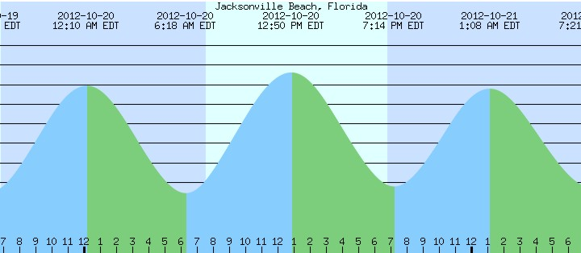
Figure 1: Tide Levels at the Jacksonville Beach

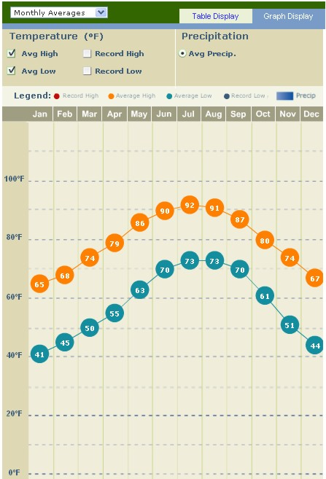
Figure 2: Historic Average Monthly High and
Low Temperatures in Jacksonville

