Using Secant Parabolas to Find Roots

Historical Background One of the most important and longest-standing problems in mathematics is that of finding the roots of equations. Solving any linear equations ax + b = 0 is trivial. Quadratic equations ax² + bx + c = 0 are more challenging, though the quadratic formula was essentially known to the ancient Babylonians, some 3000 years ago. It took about 1500 years until the Italian mathematician Niccolò Tartaglia discovered a formula (in the 1530’s) that takes about half of a printed page to display for finding the three roots of any cubic equation. Several years later, the Italian mathematician Lodovico Ferrari discovered a method for solving for the four roots of any quartic equation (this takes two full printed pages). In 1824, the Norwegian mathematician Niels Abel proved that it is not possible for any such formula to exist for every polynomial of degree five or higher; it became known as the Abel Impossibility Theorem.
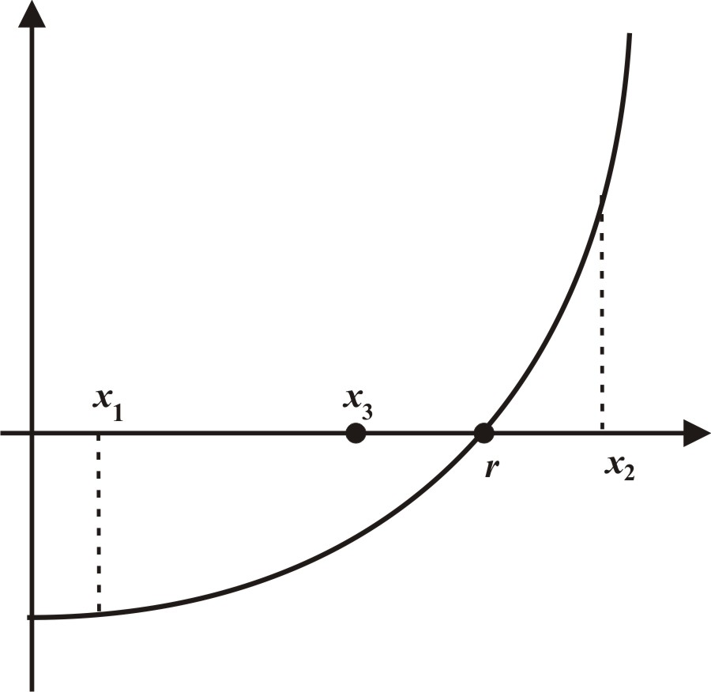
If the equation is not polynomial, then the chances of being able to find its roots algebraically become far less likely. For instance, the transcendental equation e^{-x} = sin x has infinitely many real roots (look at the graphs of the two functions), but it is impossible to solve for any of them in closed form (meaning, via an algebraic expression for x). Instead, over the last 200 years, mathematicians and other users developed various numerical techniques for approximating the roots of any polynomial or other equation to any desired degree of accuracy. Efforts to find more effective (meaning faster) methods are still a major on-going research effort.
Figure 1: The Bisection Method
Some Root-Finding Methods We look briefly at some of the simplest, most famous, and useful, methods for approximating roots of equations f(x) = 0, assuming f is continuous. Perhaps the simplest method is the bisection method that starts by finding two values x₁ and x₂, for which f(x₁) and f(x₂) have opposite signs. This bracketing interval [x₁, x₂] is then bisected at x₃ = (x₁ + x₂)/2 to create two subintervals [x₁, x₃] and [x₃, x₂], and the root r must lie in the one across which f(x) changes sign (see Figure 1). The process uses the new interval and is repeated until the distance between the bracketing points is as small as desired and hence the final approximation is as accurate as desired.
After the first iteration, both the root r and the approximation x₃ lie within the interval [x₁, x₂] and therefore the error with x₃ is at most x₂ – x₁. Since the next iteration bisects the interval, the associated error is at most (x₂ – x₁)/2; the error on the third iteration is at most (x₂ – x₁)/2²; and so on. In general, the error on the n^{th} iteration |r – x_{n+2} | < (x₂ – x₁)/2^{n-1}.
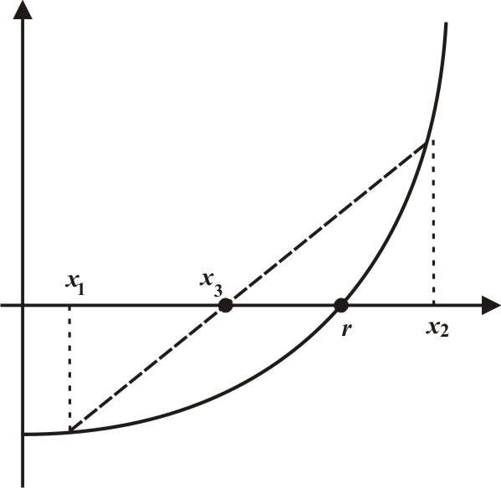
A second method for approximating roots is the secant method. This method first approximates the function y = f(x) using a secant line y = L(x) near the root r, then uses the root of the linear equation L(x) = 0 to approximate r. Specifically, using the initial bracketing interval [x₁, x₂], the line connecting the points (x₁, f(x₁)) and (x₂, f(x₂)) on the curve intersects the x-axis and its x-intercept is the following approximation x₃. See Figure 2. The process uses x₂ and x₃ to obtain x₄, then uses x₃ and x₄ to obtain x₅, and so on, until the difference between the two approximations is as small as desired and so the final approximation is as accurate as one wants.
Figure 2: The Secant Method
In general, the secant method converges more rapidly than the bisection method. However, the secant method may not always converge, whereas the bisection method always brackets the root in an interval of decreasing length and hence always works.
A third approach, the Regula Falsi (False Position) method, combines the secant and bisection methods. Using an initial interval [x₁, x₂], the next approximation, x₃, is the x-intercept of the line connecting (x₁, f(x₁)) and (x₂, f(x₂)) on the curve. Then, r must lie in either the left-hand subinterval [x₁, x₃] if f(x₁) and f(x₂) have opposite signs, or in the right-hand subinterval [x₃, x₂] otherwise. The process uses the new bracketing interval and is repeated iteratively until the length of the subinterval is as small as desired and the approximation is as accurate as one wants.
Unlike the secant method that may fail if we do not have a good initial interval, the Regula Falsi always works because it keeps the solution inside the shrinking bracketing intervals.
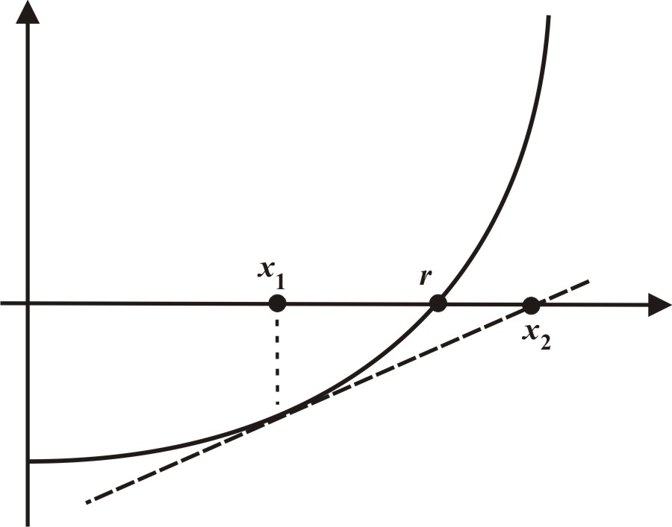
A fourth approach is Newton’s method that starts with a single initial approximation x₁ to the root r. The tangent line to the curve y = f(x) at the point (x₁, f(x₁)) is constructed and its x-intercept x₂ is taken as the subsequent approximation, as shown in Figure 3. The process continues until the desired level of accuracy is achieved.
Figure 3: Newton’s Method
If x₁ is sufficiently close to r, the process converges very rapidly; typically, once a sufficiently accurate approximation is determined, each subsequent approximation essentially doubles the number of correct digits and so converges considerably faster than the other methods.
Unfortunately, if x₁ is not close enough to r, the process could shoot off to a very distant intersection point and meander slowly back toward r, or it could converge to a different root, or it could even not converge at all.
The authors have developed a series of exploratory dynamic Excel spreadsheets that allow interested readers and their students to experiment with all of these methods by changing the function and the initial interval to see the convergence both graphically and numerically. They can be downloaded from ….
Comparing the Methods
To compare the four methods, we use an example -- finding the intersection of y = e^{-x} and y = x², which corresponds to the real root of f(x) = e^{-x} − x², as shown in Figure 4. Since f(0) = 1 > 0 and f(1) = e⁻¹ − 1 < 0, the root is in [0, 1], which we take as [x₁, x₂] for the bisection method. Its midpoint is x₃ = 0.5, where f(0.5) > 0. Consequently, the root is in the right half, so the next iteration uses [0.5, 1], whose midpoint is x₄ = 0.75. Since f(0.5) > 0 and f(0.75) < 0, the root must be in [0.5, 0.75] whose midpoint is x₅ = 0.625. The process continues to zero in on r ≈ 0.70346742, correct to eight decimal places. We use 8-place accuracy throughout to help observe the improvements in accuracy from one iteration to the next and to compare the relative accuracy with different methods. However, differences due to rounding resulting from different computational tools are possible in the right-most digits of some values throughout this article. After eleven iterations, we have x₁₃ = 0.70361328, which is accurate to only three decimal places, so the process is rather slow. We show the first eleven iterations in Table 1.
Figure 4: The graph of f(x) on [0,1]
The Number  of Iteration | Interval |  | Midpoint | |Error|
1 | 0 | 1 | 0.5 | 0.20346742
2 | 0.5 | 1 | 0.75 | 0.04653258
3 | 0.5 | 0.75 | 0.625 | 0.07846742
4 | 0.625 | 0.75 | 0.6875 | 0.01596742
5 | 0.6875 | 0.75 | 0.71875 | 0.01528258
6 | 0.6875 | 0.71875 | 0.703125 | 0.00034242
7 | 0.703125 | 0.71875 | 0.7109375 | 0.00747008
8 | 0.703125 | 0.7109375 | 0.70703125 | 0.00356383
9 | 0.703125 | 0.70703125 | 0.70507813 | 0.00161071
10 | 0.703125 | 0.70507813 | 0.70410156 | 0.00063414
11 | 0.703125 | 0.70401156 | 0.70361328 | 0.00014586
Table 1: Successive approximations using the bisection method

In the example, x₃ = 0.5 is off by at most 0.5 and x₄ = 0.75 is off by at most 0.25, which is half of the preceding maximum error, and so forth. Therefore, after any three successive estimates, the maximum error is reduced by a factor of 1/8, which means that, roughly, every three iterations reduce the error by about 1/10, so that we essentially obtain an extra decimal place. This is reinforced from the errors in the last column of Table 1.
To illustrate the secant method, we again start with [0, 1]. The secant line through (0, 1) and (1, −0.63212056) is y = −1.63212056x + 1, whose x-intercept is x₃ = 0.61269984, as shown in Figure 4. The secant line joining (1, −0.63212056) and (0.61269984, 0.16648480) is y = −2.06198043x + 1.42985987 and its x-intercept is x₄ = 0.69344008. A third iteration uses the secant line through (0.61269984, 0.16648480) and (0.69344008, 0.01899443), whose equation is y = −1.82672687x + 1.28572005; its x-intercept is x₄ = 0.70383815. Notice that after three iterations, we already have the first three decimal places of r, compared to the bisection method that required five iterations to achieve one decimal place accuracy.
We show the x-coordinates of the two points for the secant line, the x-intercept of the secant line and the corresponding error in Table 2. Notice how rapidly the error values decrease to zero; it is much faster than with the bisection method.
The number  of Iterations | The x-Coordinates of  Two Points for the Secant Line |  | Intercept | |Error|
1 | 0 | 1 | 0.61269984 | 0.09076758
2 | 1 | 0.61270084 | 0.69344008 | 0.01002734
3 | 0.61269984 | 0.69344008 | 0.70383815 | 0.00037073
4 | 0.69344008 | 0.70383815 | 0.70346595 | 0.00000147
5 | 0.70383815 | 0.70346595 | 0.70346742 | 2.28E-09
Table 2: Successive approximations using the secant method

To illustrate the regula falsi, we again use the initial interval [0, 1]. The line through the points (0, 1) and (1, −0.63212056) is y = −1.63212056x + 1 and its x-intercept is x₃ = 0.61269984, as with the secant method. Since f(0.61269984) > 0, the root is between 0.61269984 and 1. We then construct the line from (0.61269984, 0.16648480) to (1, −0.63212056); its equation is y = −2.06198043x + 1.42985987 and its x-intercept is x₄ = 0.69344008, where f(0.69344008) > 0. A third iteration uses the line through (0.69344008, 0.01899443) and (1, −0.63212056), which intersects the x-axis at x₅ = 0.70238309. We show the x-coordinates of the two points for the secant line, its x-intercept and the corresponding error in Table 3, which demonstrates that the method is clearly converging to the root. Notice how rapidly the error values decrease; it is faster than with the bisection method, but slower than with the secant method.

The number  of Iterations | Two Points for  the Secant Line |  | Intercept | Height at Intercept | |Error|
1 | 0 | 1 | 0.612700 | 0.166485 | 0.090768
2 | 0.612700 | 1 | 0.693440 | 0.018994 | 0.010027
3 | 0.693440 | 1 | 0.702383 | 0.002061 | 0.001084
4 | 0.702383 | 1 | 0.703350 | 0.000222 | 0.000117
5 | 0.703350 | 1 | 0.703455 | 0.000024 | 0.000013
6 | 0.703455 | 1 | 0.703466 | 0.000003 | 0.000001
7 | 0.703466 | 1 | 0.703467 | 2.79E-07 | 1.44E-07
Table 3: Successive approximations using the false position method

We suggest that interested readers apply Newton's Method to the same example f(x) = e^{-x} − x² to compare the rate of convergence.

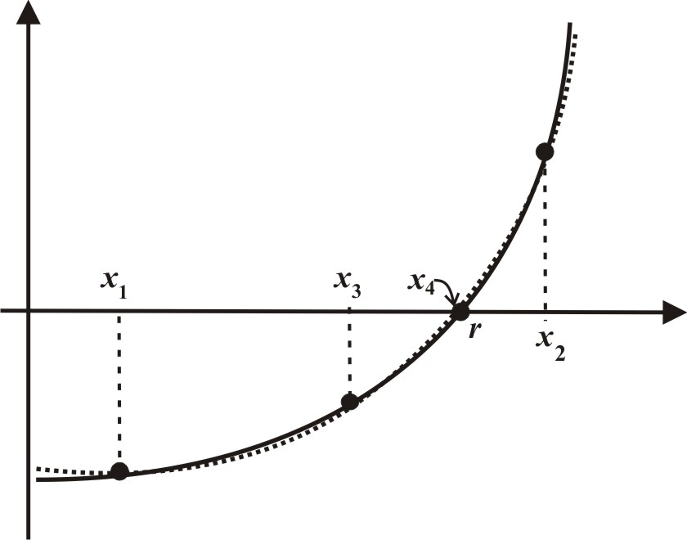
A Root-Finding Method Using Quadratic Interpolation We now consider a slightly more sophisticated approach that extends the secant method by using the secant parabola to the curve determined by three points in the interpolation sense. Any three non-collinear points (points that do not lie on a line) uniquely determine a quadratic polynomial. Suppose that the root, r, of the equation f(x) = 0 is bracketed between x₁ and x₂. For x₃, choose the midpoint of the interval [x₁, x₂], which is x₃ = (x₁ + x₂)/2. If the two initial points are reasonably close to r, the parabola determined by the points (x₁, f(x₁)), (x₂, f(x₂)), and (x₃, f(x₃)) will lie extremely close to the curve of the function. The approximating parabola has two real zeros and one of them should be very close to r, as seen in Figure 5. We use the quadratic formula to determine the zeros of this parabola; and select whichever of the two zeros lies within the interval [x₁, x₂], call it x₄, and then determine the parabola through the three points (x₁, f(x₁)), (x₄, f(x₄)), and (x₂, f(x₂)). The following set of points will be (x₁, f(x₁)), (x₅, f(x₅)), and (x₂, f(x₂)), and so on.
Figure 5: A Root-Finding Method
Using the Secant Parabola

We can actually anticipate which of the two zeros should be used if the portion of the curve being bracketed is either strictly increasing or decreasing with fixed concavity. If it is increasing and concave up, then the larger root will be inside the interval and close to r; if it is increasing and concave down, then the smaller root will be inside the interval and close to r. If the curve is decreasing and concave up, we should use the smaller root and if it is decreasing and concave down, then the larger root works best. However, if the direction and/or the concavity change, we cannot anticipate in advance; instead, we should zoom in more closely about r.
We again use the same example as before to illustrate the convergence of this method. The initial interval is [x₁, x₂] = [0, 1], so that x₃ = 0.5 and the three points are (0,1) (0.5, 0.35653066), and (1, −0.63212056). The parabola through these points is y = −0.69036376x² – 0.94175680x + 1 (you can use a graphing calculator to find this) and its roots are x = −2.06545106 and x = 0.70130528, both correct to eight decimal places (from the quadratic formula or various methods on a graphing calculator). Since x = 0.70130528 is within the interval [0, 1], we take x₄ = 0.70130528. In comparison, the actual root is roughly r ≈ 0.70346742, so this single iteration has produced an approximation that is accurate to two decimal places. We do not show the actual graphs because they are so close to one another that they are indistinguishable.
For the next iteration, we use the values x = 0, x = 0.70130528, and x = 1, so that the three points are (0,1), (0.70130528, 0.00410845), and (1, −0.63212056). Notice how close to 0 we are (0.00410845) at the middle point. The parabola through these points is y = −0.70997672x² – 0.92214384x + 1 and its roots are x = −2.00228241 and x = 0.70344567, so we use x₅ = 0.70344567 as the next approximation. Note that this approximation is correct to four decimal places, so we have effectively increased the number of correct digits by 2. Also, the associated value of y is 0.00004137, which is extremely close to 0. We show the results of the first three iterations of the method in Table 4, which shows just how quickly the successive approximations converge to the root r, how fast the associated heights at these points converge to 0, and how rapidly the error approaches 0. In fact, after three iterations, we effectively have determined the solution correctly to six decimal places, a gain of two more correct digits. We can expect that the next iteration adds at least two additional correct digits.

The number  of Iterations | Three Points for  the Secant Parabola |  |  | Intercept | Height at Intercept | |Error|
1 | 0 | 1 | 0.5 | 0.70130528 | 0.00410845 | 0.00216214
2 | 0 | 1 | 0.70130528 | 0.70344567 | 0.00004137 | 0.00002175
3 | 0 | 1 | 0.70344567 | 0.70346720 | 0.00000042 | 0.00000022
4 | 0 | 1 | 0.70346720 | 0.70346742 | 0.00000000 | 0.00000000
Table 4: Successive approximations using the secant parabola method

A dynamic spreadsheet for experimenting with this method is also available at …
We note that we could actually improve on the accuracy by using “better” values for and at each stage instead of sticking with 0 and 1. But, that tends to make the calculations more complicated if students are asked to do them. Moreover, the method also converges to a root r if the three points chosen initially do not bracket the root, but we do not go into that here because the choice of the root of the quadratic to use for the subsequent approximation becomes more complicated. In addition, we note that the method also works to approximate complex roots, particularly of higher degree polynomials, but we likewise do not go into that here.
Classroom Suggestions The use of numerical methods for solving mathematics problems has become increasingly important in all quantitative areas in our ever-more digital age. As such, it is important for students to be exposed as much as possible to the use of such methods, especially if that introduction has additional pedagogical benefits. In terms of the ideas in this article, the development of root-finding techniques in algebra or precalculus classes help on many fronts. For one, they provide a wonderful opportunity to reinforce key ideas on polynomials, their roots, and their behavior at subsequent points in a course when one is treating some of the fundamental families of nonlinear functions. In addition, as the famed futurist Arthur C. Clarke put it, “Sufficiently advanced technology is indistinguishable from magic” and this is, unfortunately all too true of the sophisticated techniques built into graphing calculators; when students push buttons without any understanding of the kinds of underlying methods used, the results are no different from magic.
In addition to reminding students about the basic ideas and methods they have previously seen, the techniques used here also provide the opportunity to work with more complicated examples and exercises. Thus, instead of solving quadratic equations with the usual integer coefficients, the students now have to face coefficients that are definitely not integers, but these equations arise in the process of calculating something significant, not merely as exercises designed to practice skills, and students react very well to this kind of challenge. Thus, rather than just reminding them of the previous techniques, they now can expand their skill sets, which is reasonable in the sense that it is later in the course when one would expect them to have a more highly developed set of algebraic skills.
As one classroom activity, we suggest the following for either individual students or small groups working together. The functions y = sin x and y = 1/x intersect at infinitely many points (because 1/x decays to zero very slowly), and so f(x) = sin x − 1/x has infinitely many roots. Thus, each student or group could be challenged with the task of approximating one of those roots to a given level of accuracy, say 8 decimal places. Each individual or group has a unique problem, but all require roughly the same amount of effort.
Incidentally, y = e^{-x} decays extremely rapidly, so that it becomes far more difficult to “see” the graphs near the x-axis. As such, we recommend using a function such as y = 1/x, for x > 1, or even y = 1/log x for x > 10.
Finally, the secant parabola method is a variation on a technique known as Muller’s method that was developed in the 1950’s [1, 2]. We believe that it is desirable to point out to students that mathematics is not just something that was developed centuries and millennia ago, but is still a vital and developing subject needed to solve important problems in many different fields.

References
- Antia, H. M., Numerical Analysis for Scientists and Engineers, 2nd Ed., 2002, Birkhauser, ISBN: 3764367156.
- Burden, Richard L. and Douglas Faires, Numerical Analysis, 9th Ed., 2012, Brooks Cole, ISBN: 0538733519.
- Yang, Yajun and Sheldon P. Gordon, Interpolation and Polynomial Curve Fitting, The Mathematics Teacher, Vol. 108 No. 2, 132-141, ISSN 0025-5769, 2014.

