Visualizing and Understanding Confidence Intervals Using Dynamic Software

One of the standard topics in any introductory statistics course is confidence intervals for estimating the value of some population parameter. In particular, consider the notion of estimating the unknown mean μ for a population based on the data obtained from a random sample drawn from that population. The confidence interval so constructed is centered at the sample mean and extends sufficiently far in each direction so as to have a pre-determined probability of containing μ. To construct a 95% confidence interval for the mean, the interval should have a 95% chance of containing μ. Equivalently, in 95% of the confidence intervals so constructed, the resulting interval should contain the true mean μ.
For most students in introductory statistics, the above statements represent little more than acts of faith. They do not fully appreciate the fact that the confidence interval constructed will correctly contain μ with probability 0.95. There is simply no effective way to construct, in class, a large variety of different confidence intervals based on different sample data to see whether or not the theoretical considerations actually make sense. Instead, the students just perform the appropriate manipulations to calculate the correct answer to such problem in a purely mechanical fashion or have the calculations done for them with either a calculator routine or some statistical software package.
Unfortunately, this is a topic that all too often reduces to rote memorization of formulas and procedures, in large measure because there are so many variations considered. For instance, there are:
■ confidence intervals for the population mean µ when you have a large sample and when you have a small sample;
■ confidence intervals for the population proportion π when you have a large sample and when you have a small sample;
■ confidence intervals for the difference in population means when you have two samples drawn from similar populations, and
■ confidence intervals for the difference in population proportions.
It is not in the least surprising that many students find their heads reeling and so come out of the course with little understanding of what confidence intervals are all about.
Technology has much to offer to reduce the tendency for the topic to be treated as a variety of exercises in rote memorization. Most graphing calculators contain a full menu of statistical functions that include most variations on constructing confidence intervals, as do statistical software packages and spreadsheets such as Excel. Some older calculator models only operated on a set of data entered in one or more lists to calculate the summary statistical measures and the corresponding confidence interval. Newer calculators give the option to work either with the raw data or the statistical measures, which more closely mirrors the typical kind of problems found in most textbooks in which students are asked to construct the confidence interval based on a sample of size n = 36 where the sample mean is 24 and the sample standard deviation is 9, say.
Even when students utilize technology to construct confidence intervals, the majority still tend to come away with very little in the way of basic understanding of the underlying fundamental concepts. In particular, they don’t understand the significance of:
 the variation in the results due to the variations between different samples;
 the effects of sample size on the results;
- the effects of changes in the sample data or the sample statistics on the results;
- the effects of the choice of confidence level on the length of the confidence interval.
Gaining a solid understanding of all of these ideas requires the use of dynamic software to bring the ideas to life and so make a far stronger impact on the students.

Dynamic Programs in Excel
The authors have developed a collection of dynamic modules in Excel that are intended to enhance student understanding of the fundamental concepts related to confidence intervals (as well as virtually every other topic in introductory statistics). All of these modules are available at the authors' websites [1, 2] for free download and can be used either by instructors for in-class demonstrations of these ideas or by students for individual or small-group investigations and/or projects. As will be illustrated later in the article, these spreadsheets, all use sliders and other Excel controls to provide dynamic effects in which parameters and statistical measures can be changed and the resulting effects can be seen virtually instantaneously. Some utilize random simulations to illustrate the variations that occur in the results due to different samples.
In this article, we will discuss the various aspects of confidence interval construction that can be enhanced using such software.

Constructing Confidence Intervals for the Population Mean µ
We begin with the ideas associated with creating a confidence interval for the population mean μ. First, we have a spreadsheet that is essentially a computational tool for constructing a confidence interval based on the statistics associated with the sample data, but with a dynamic visual component, as shown in Figure 1. The spreadsheet lets the user choose from among a 90%, 95%, 98% and a 99% confidence interval. It displays all four confidence intervals with the chosen one highlighted for emphasis, as well as numerical results showing the actual confidence interval and the associated z- or t-value to point out the number of standards deviations the interval extends about the sample mean. The primary conceptual value of this program for student understanding is to demonstrate how the length of a confidence interval varies with the level of confidence.

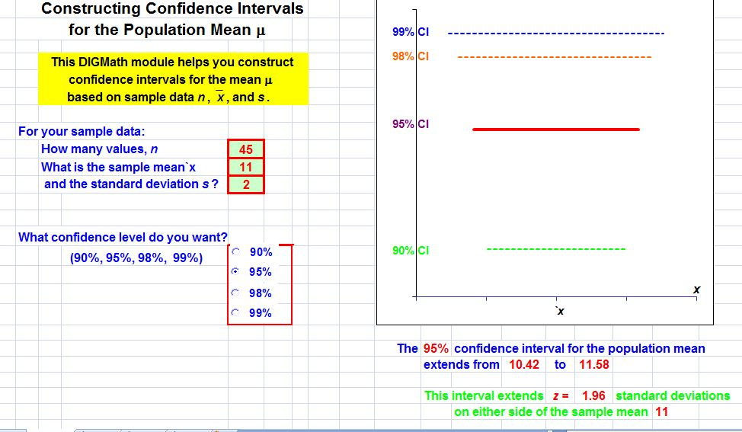

Figure 1

A more dynamic version of this program uses sliders to vary the parameters for n, , and s so that students can see the effects of changing each of them virtually instantaneously. The output from this program is shown in Figure 2. Thus,
1. as the sample mean changes with the middle slider, students see the four confidence intervals shifting to the right and the left without any other changes.
2. as the sample size n increases, students see that the length of the lines representing the confidence intervals shorten. Hence, this allows an instructor to emphasize that one can achieve a given level of confidence with less of a spread in the predictive range. On the other hand, when n decreases, the lengths of the confidence intervals increase. In turn, this allows an instructor to point that smaller samples provide less certainty and so one needs a longer confidence interval to achieve a given level of confidence.
3. as the standard deviation s increases, students observe that the length of the confidence intervals increase. In turn, this means that when the data has greater variation, one needs a longer interval to achieve a given level of confidence in the prediction. On the other hand, when s is smaller and there is greater consistency in the data, then one needs a shorter interval to achieve that level of confidence.

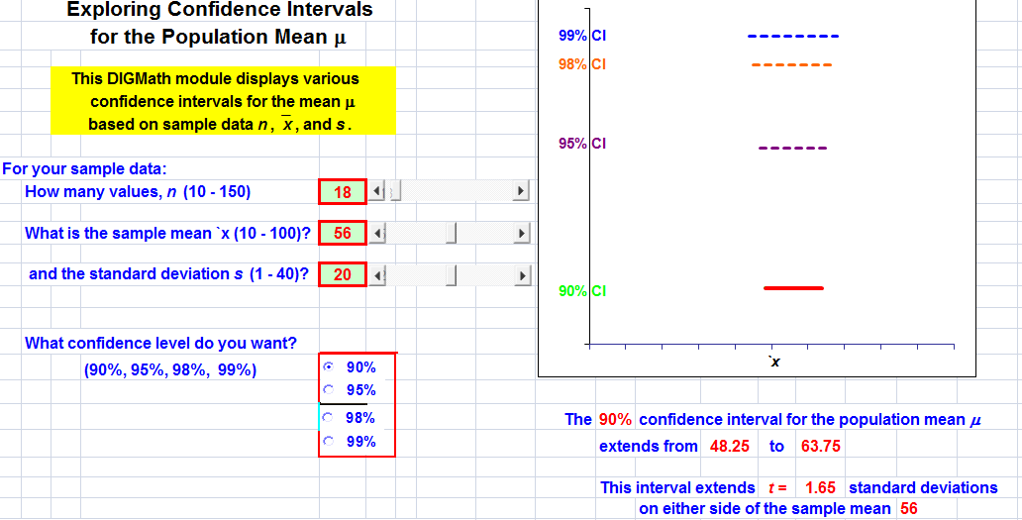

Figure 2

However, none of these previous programs address one of the biggest issues that students face – being able to assess the variation in the results from one sample to another. Typical problems all focus on the results of one sample, but students never have the opportunity to see how results can vary if there is more than that single sample. To address this, the authors have developed a third Excel program that generates repeated random samples from a given underlying population, constructs the corresponding confidence intervals, and displays the results visually. This graphical simulation provides an especially powerful tool to translate the statistical theory and predictions into ideas that the students can visualize and hence comprehend.
This Excel routine allows the user (either the instructor while conducting a live classroom demonstration or individual students working with the software in a computer laboratory setting or at home on their own) to select from among four underlying populations – one is roughly normally distributed, another is roughly uniformly distributed, a third is roughly U-shaped, and the fourth is skewed in one direction. The user selects the desired confidence level, from among 90%, 95%, 98% and 99. Finally, the user can select the desired sample size, from n = 10 to n = 50, using a slider.
The program then generates repeated random samples of size n from the selected population, calculates the sample mean and sample standard deviation for each, and then calculates and plots the corresponding confidence interval. A typical example of the graphical output is shown in Figure 3 for 99% confidence intervals. Each successive confidence interval is drawn horizontally, so that the program constructs 80 such intervals on each run. The vertical line near the center indicates the location of the population mean μ of the underlying population. The numerical results corresponding to Figure 3 are based on 80 samples of size n = 50 drawn from the normal population; for these samples, 79 of the 80, or 98.75%, of these 99% confidence intervals, contain μ. A second run of the program involving 80 different samples is shown in Figure 4, where again 79 of the 80 confidence intervals contain μ. The patterns are similar, but there are distinct differences.
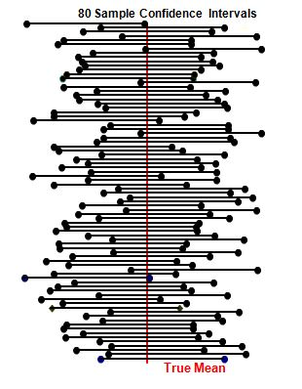
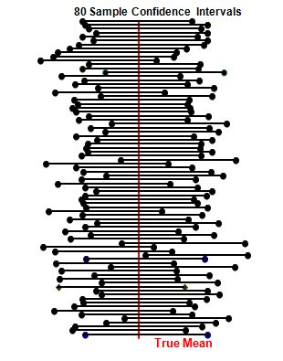
Figure 3 Figure 4
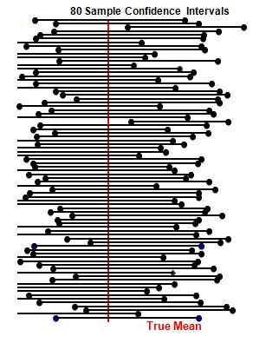
Figure 5
At the other extreme, Figure 5 shows the results of 80 samples of size n = 20 drawn from the same normal population to create 99% confidence intervals. Notice that the confidence intervals are considerably longer; as stated above, to achieve a given level of confidence, one should expect larger intervals to compensate for the smaller sample size. Also, in this set of samples, notice that 78 of the 80, or 97.5%, of the 99% confidence intervals included the population mean μ. However, the “cost” of achieving this is that the intervals are considerably wider; in fact, many extend off the screen.
A single image such as those in Figures 3 through Figure 5 appears in many statistics textbooks, but it is only a static image; the ability to generate repeated sets of samples, to change the underlying population, and most importantly, to change the confidence level and/or the sample size and see the immediate effects, are extremely powerful attributes to help students understand the underlying ideas. Repeated runs of this program can be used to demonstrate that, in the long run, the results will more or less average out to the predicted percentage of 99% (or whichever of the other confidence levels are chosen). In fact, a useful computer laboratory technique is to have each student run the program simultaneously and then average out the percentage of intervals which contain the true mean μ.
Moreover, it is useful to point out to the students that even when a confidence interval does not contain the population mean μ, it is usually a "near miss". It is a very rare occurrence for the sample mean to be so far away from μ that the corresponding confidence interval dramatically misses μ.
In addition, within each run of the program, the lines drawn for the individual confidence intervals have different lengths. This is because the length of each interval is based on the size of the sample standard deviation. Thus, the program provides a visual dimension for seeing the effects of the standard deviation on the outcome of an estimation problem. Similarly, if a different confidence level, say 98%, is used, then it is visually clear that most of the confidence intervals drawn are longer than those shown in Figure 3 or 4 for 99% confidence intervals. Moreover, very few of these 99% confidence intervals do not contain μ. Thus, the students see that, by increasing the confidence level, we achieve a much greater likelihood of the confidence interval containing μ.
Perhaps most importantly, such a program can be used to give students a greater appreciation of the nature of statistics: any statistical result is based on the data from one particular sample and the result likely change if a different sample is used.
Furthermore, it is also useful to demonstrate that totally similar results occur when we change the underlying population. Hence, the students see that the population from which the samples are drawn does not especially affect the results.

Other Confidence Intervals
Very comparable approaches can be used to enhance student understanding of other types of confidence intervals and the authors have developed similar programs for those situations. For instance, consider the problem of creating a confidence interval for the population proportion. The authors’ programs parallel those that produced Figures 1 and 2. The primary difference is that the user now must enter the sample size n and the number of successes x, as well as the desired confidence level. As with the programs for confidence intervals for means, students can see the effects of changing these parameter values on the resulting confidence interval for the proportion. In particular, as the sample proportion value p increases, the confidence intervals all shift toward the right and as p decreases, the intervals shift to the left. As the sample size n increases, the length of the confidence interval lines decrease and as n decreases, the length of these lines increases.
We next consider confidence intervals for the difference of means, where the authors have developed a similar pair of dynamic spreadsheets. First, as a visual tool, we have one spreadsheet that performs the calculations and displays the results visually. The user has to enter the statistical summary values for each of the two samples, n₁, , and s₁ for the first and n₂, , and s₂ for the second, as well as the choice of confidence level, 90%, 95%, 98% or 99%. The spreadsheet displays all four corresponding confidence intervals with the chosen one highlighted. It also displays the numerical results for that confidence interval.
As a more conceptual tool, we have also created a dynamic spreadsheet that simulates the distribution of the differences in sample means. The program allows the user either to have both samples drawn from the same underlying population or to have the samples drawn from two distinct populations. Either way, the user can select among the same four underlying populations – normal, uniform, U-shaped, and skewed – as before. Further, the user enters the desired sample size n₁, via a slider, for the first sample and the sample size n₂ for the second sample. Finally, the user selects the number of pairs of samples that will be randomly generated. The program then performs the simulation, plots the differences for each pair of sample means in a histogram, and displays the results numerically. The students can then see what happens with many different sets of samples, first with both samples drawn from the same underlying population and then with samples drawn from different populations.
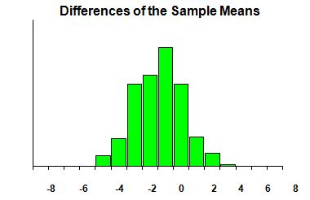
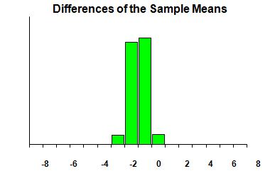
In the first case with samples drawn from the same population, one should expect that the difference in population means will be 0 and, in fact, the differences in sample means are clustered about 0. When the sample sizes n₁ and n₂ are both small, there is a rather wide spread in those differences, but as you increase the sample sizes, the differences are clustered ever more tightly about 0. In Figure 6a, we show the results of one run of the program where both samples are drawn from the normal population and the first sample consists of samples of size n = 7 and the second samples of size n = 9. In contrast, Figure 6b shows the results with samples of size n = 42 and n = 39.
Figure 6a
Figure 6b

Moreover, when sampling from the normal population, the shape of the histogram is reasonably normal, even for small sample sizes. Again, look at the two results in Figures 6a and 6b. However, when sampling from the other three populations, the shape of the histogram is definitely non-normal for small sample sizes, but becomes ever more normal-looking as the sample sizes increase. Figure 7a shows the results of drawing samples from the roughly uniformly distributed population with samples of size n = 8 and n = 10; the shape may not look particularly normal. On the other hand, the results with larger samples, say n = 40 and n = 43, from the same uniformly distributed population are shown in Figure 7b, which shows a much more normal distribution pattern.

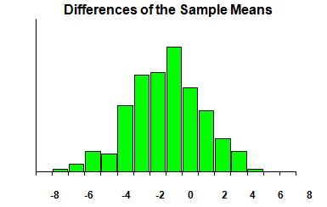
Figure 7a
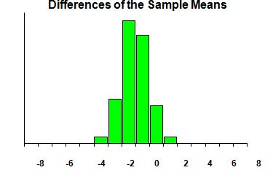
Figure 7a

Students can also be asked to perform comparable investigations when the samples are drawn from two different populations.
Finally, we consider confidence intervals for the difference in proportions in very similar ways with comparable dynamic spreadsheets. Again, one program is designed to perform the calculations based on two sets of sample data – the sample size n₁ and the number x₁ of successes for the first sample and the sample size n₂ and the number x₂ of successes for the second. As before, the user can select the desired confidence level, 90%, 95%, 98% or 99%. The spreadsheet displays the four corresponding confidence intervals with the chosen one highlighted. It also displays the numerical results for that confidence interval.
The last approach we discuss is a random simulation of the distribution of the difference of sample proportions. As with the differences of sample means, the user can select the probability of success π₁ and the sample size n₁ of the first sample and the probability of success π₂ and the sample size n₂ of the second sample via sliders, as well as the number of such pairs of samples. The program then randomly generates the desired samples, displays the results on the difference p₁ – p₂ of the sample proportions graphically in a histogram, and also displays the numerical results.

All of the dynamic spreadsheets mentioned here, as well as many others covering virtually every topic in introductory statistics and probability, can be downloaded from the authors’ websites, [1] and [2]. If interested readers have any suggestions for additional topics they would like to see treated, they are encouraged to contact the authors with their suggestions.

References
1. Author 1, Dynamic spreadsheets for statistics and probability, URL to be supplied
2. Author 2, Dynamic spreadsheets for statistics and probability, URL to be supplied

