Visualizing and Understanding Hypothesis Testing Using Dynamic Software

One of the standard topics in any introductory statistics course is hypothesis testing, in which we test the supposed value of some population parameter. In particular, consider the process of testing a statistical hypothesis regarding the mean μ for a population based on the sample data consisting of the sample size n, the sample mean , and the sample standard deviation, s, obtained from a random sample drawn from that population.
The supposed value for μ, known as the null hypothesis H₀, asserts that μ = μ₀, for some specific value μ₀. The alternate hypothesis H_{a} typically asserts that μ > μ₀, μ < μ₀, or simply μ ≠ μ₀. If the sample data indicate that is sufficiently far above, far below, or simply far away from μ₀, then we reject the null hypothesis; alternatively, if is reasonably close to μ₀, then we cannot reject the null hypothesis. Notice that in the latter instance, we are not able to “accept the null hypothesis”.
In any hypothesis test, whether for the mean or some other population parameter, there is always a possibility of coming to a wrong conclusion, and we attempt to minimize this by choosing a level of significance α, often 1%, 2.5%, or 5%, as the greatest acceptable chance of committing such an error. Essentially, α represents the probability of committing a Type I error -- incorrectly rejecting a true null hypothesis (a "false positive").
For most students in introductory statistics, the above statements represent little more than acts of faith. They do not fully appreciate the fact that the decision about whether to reject or fail to reject the null hypothesis is valid only 99% or 97.5%, or 95% of the time or the fact that the decision may change depending on the choice of α. They often don’t grasp the fact that the values of the sample statistics may change the decision. Finally, and perhaps most importantly, there is no effective way to conduct, in class, a large variety of different hypothesis tests based on different sample data to see whether or not the theoretical considerations actually make sense. Instead, the students just perform the appropriate manipulations to calculate the correct answer to such a problem in a purely mechanical fashion or have the calculations done for them with either a calculator routine or some statistical software package.
Unfortunately, this is an important topic that all too often reduces to rote memorization of formulas and procedures, in large measure because there are so many variations considered. For instance, there are:
■ hypothesis tests for the population mean µ when one has a large sample and when one has a small sample;
■ hypothesis tests for the population proportion π when one has a large sample and when one has a small sample;
■ hypothesis tests for the difference in population means when one has two samples drawn from similar populations, and
■ hypothesis tests for the difference in population proportions.
In addition, there are many other situations, such as chi-square analysis, that also entail hypothesis testing. It is not in the least surprising that many students find their heads spinning and so come out of the course with little understanding of what hypothesis testing is all about.
Technology has much to offer to reduce the tendency for the topic to be treated as a variety of exercises in rote memorization. Most graphing calculators and all statistical software packages and spreadsheets such as Excel contain a full menu of statistical functions that include most variations on conducting hypothesis tests. Some older calculator models only operated on a set of data entered in one or more lists to calculate the summary statistical measures and displayed the corresponding decision about whether or not to reject the null hypothesis. Newer calculators give the option to work with either the raw data or the statistical measures, which more closely mirrors the typical kind of problems found in most textbooks in which students are asked to test a hypothesis about the population mean μ with a given risk level based on a sample of size n = 36 where the sample mean is 24 and the sample standard deviation is 9, say.
Even when students utilize technology to conduct hypothesis tests, the majority still tend to come away with very little in the way of basic understanding of the underlying fundamental concepts. In particular, they don’t understand the significance of:
 the variation in the results due to the variations between different samples;
 the effects of sample size on the results;
- the effects of changes in the sample data or the sample statistics on the results;
- the effects of the choice of risk level on the conclusion drawn.
Perhaps the most effective way to help the majority of students gain a solid understanding of all of these ideas is to use dynamic software that brings the ideas to life and so makes a far stronger and hopefully longer lasting impact on the students.

Dynamic Software to the Rescue
Two key notions that underlie virtually every concept and method in statistics are randomness and variation among samples. Has the sample been collected in a truly random fashion that reflects the underlying population? How representative of that population is this one sample? How does this single sample compare to other possible samples drawn from the same population?
Fortunately, most of the critical topics in probability and statistical inference can be dramatically presented using computer graphics simulations to allow students to visualize the underlying statistical populations and so enhance their understanding of the statistical concepts and methods. Many years ago, the authors addressed the challenge of making these notions evident to students by developing a comprehensive package of computer graphics simulations using BASIC that addressed virtually every topic in introductory probability and statistics. BASIC routines have become outmoded over the years, especially in terms of being able to provide students (or even colleagues) with copies of the files to explore the statistical concepts on their own computers. We have lately returned to this challenge and have developed a much more extensive package of dynamic interactive graphical simulations of the mathematics (DIGMath) using Excel because it is available on almost all computers today. Moreover, Excel has the further advantages that it does not require any plug-ins or internet connections, as for example, using Flash, Java, or JavaScript, and it is the standard technology tool for virtually every discipline outside of mathematics. (The complete package can be downloaded from our websites [1] or [2] for use either by instructors for in-class demonstrations of these ideas or by students for individual or small-group investigations and/or projects, as discussed at the end of this article.)
In the intervening years, many other statistics educators have thought deeply about these issues and have developed specialized software tools to implement random simulations of many of the basic statistical ideas and techniques. These issues have been discussed in a variety of articles, primarily in the statistics literature, as summarized by Mills [6] for the early years, as well as in individual papers in the Journal of Statistics Education. All of the articles in volumes 1 through 24 of the latter from 1993 through 2014 can be accessed from the journal’s website, [4]; subsequent issues from 2015 (volume 25) on are now housed on the Taylor & Francis website at [5]. In addition, there are many applets available on the Web and many of the same kinds of simulations can be generated using statistical software packages such as Minitab. A summary of literally hundreds of such apps and links to them are compiled by DePaolo [3].
These efforts have had considerable impact on the teaching of statistics among professional statisticians, but probably much less impact on the teaching of statistics by mathematicians or by statistical users in other disciplines. In part, this may be due to the fact that mathematics faculty without statistical training are often uncomfortable with using such statistical packages in the classroom; others feel it is not appropriate to require students to purchase specialized software in addition to an expensive textbook and calculator; others feel that the one software tool that almost all of their students will someday use in other courses and on the job is Excel (and the majority of students today appear to arrive on campus already knowing how to use it). Furthermore, most quantitatively-oriented people today are familiar with Excel and many are able to modify or create their own spreadsheets without having to learn a new computer language. As such, existing Excel spreadsheets provide templates that can be adapted to create comparable simulations of other situations or to provide additional information and insights. As a consequence, there seem to be good reasons to have such simulations available in Excel, so that both faculty and students can have easy access to their use without needing to expend money or time in learning new programs.
The authors have developed a collection of dynamic modules in Excel that are intended to enhance student understanding of the fundamental concepts and procedures related to hypothesis testing (as well as virtually every other topic in introductory statistics and probability). All of these modules are available at the authors' websites [1] or [2] for free download and can be used either by instructors for in-class demonstrations of these ideas or by students for individual or small-group investigations and/or projects. As will be illustrated later in the article, these spreadsheets all use sliders (a feature to input or change values by moving, using a mouse, say, a square in a horizontal bar) and other Excel controls to provide dynamic effects in which parameters and statistical measures can be changed and the resulting effects can be seen virtually instantaneously. Perhaps the most powerful program is one that utilizes random simulations to illustrate the variations that occur in the results due to different samples.
In this article, we will discuss the various aspects of hypothesis testing that can be enhanced using such software.

Conducting Hypothesis Tests for the Population Mean µ
We begin with the ideas associated with conducting a hypothesis test for the population mean μ. First, we have a spreadsheet that is intended primarily as a visual tool to assist students in understanding the fundamental ideas associated with hypothesis testing, as shown in Figure 1. It can also be used as a computational tool for conducting a hypothesis test based on the statistics associated with the sample data, but with a dynamic visual component. The spreadsheet lets the user choose from among a two-tailed test and a one-tailed test with the tail on the right or the left. The user also can select a 10%, a 5%, a 2%, or a 1% significance level. The program displays all four critical values (for a one-tailed test) or all eight critical values (for a two-tailed test) as vertical lines with the chosen significance level highlighted for emphasis. It also displays the location of the associated sample mean (the tall vertical line with the arrowhead) to demonstrate that our conclusion to reject or not reject the null hypothesis depends on the choice of the significance level. In addition, the spreadsheet also displays what z- or t-value is required in order to reject the null hypothesis, as well as the particular z- or t-value associated with the actual test statistic to point out the number of standards deviations that the sample mean lies from the supposed null hypothesis value μ₀. Note that each of the vertical representations for the critical values are successively taller, to dramatize the fact that in order to reduce the likelihood of making an erroneous conclusion requires raising the hurdle that one must get over.
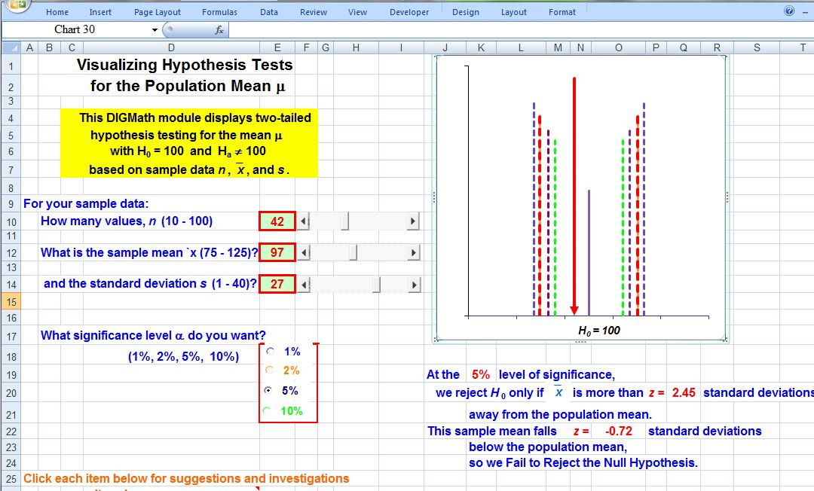
Figure 1
A more individualized version of this program can be used as both a way to increase conceptual understanding and a computational tool. It allows students to enter any value they want for the null hypothesis μ₀ and then select whether the alternate hypothesis is two-tailed, one-tailed on the right, or one-tailed on the left. The students then enter the values for the statistical measures n, , and s for any set of data. (Our previous program limits the values to those that are pre-determined by the allowable values for the sliders). Finally, the students can select among the values 10%, 5%, 2.5%, 1%, and 0.5% for the significance level α. The spreadsheet displays the corresponding normal or t-distribution, the location of the critical value(s), and the location of the sample mean. It also shows the associated z- or t-value, as well as the corresponding P-value, and the conclusion as to whether one Rejects or Fails to Reject the null hypothesis. The output from this program is shown in Figure 2.
In the process of using both of these programs, the students can see the effects of changing each of the choices virtually instantaneously. Thus, they see that:
1. The critical value(s) associated with the significance level separates the least likely outcomes from what one would expect and only a sample whose mean falls beyond the critical value provides evidence that the claimed value for H₀ is false, so that one would reject the null hypothesis. That is, the issue reduces to the location of relative to the critical value(s).
2. As the sample size n increases (and hence there is more certainty in the accuracy of as a predictor of the value of μ for the population, the graph of the sampling distribution becomes ever tighter (and hence taller) to reflect the reduction in the variability. In turn, this allows an instructor to point out that larger samples provide greater certainty while smaller samples provide less certainty and so one needs a sample mean that is further away from the center in order to conclude that one can reject the null hypothesis with confidence.
3. As the sample standard deviation s increases (so that there is greater variation in the sample data and hence less certainty in the accuracy of as a predictor of the value of μ), the sampling distribution becomes wider and shorter, indicating that there is more variation possible. In turn, the critical value moves further away from the center, suggesting that in order to reject the null hypothesis, one must have a sample mean that is farther away from the supposed value μ₀. On the other hand, when s is smaller and there is greater consistency in the data, then one needs a sample mean that is closer to the center in order to reject H₀.
All that remains is to tell the students that, based on the Central Limit Theorem for repeated samples drawn from an underlying population, the standard error is given by

.

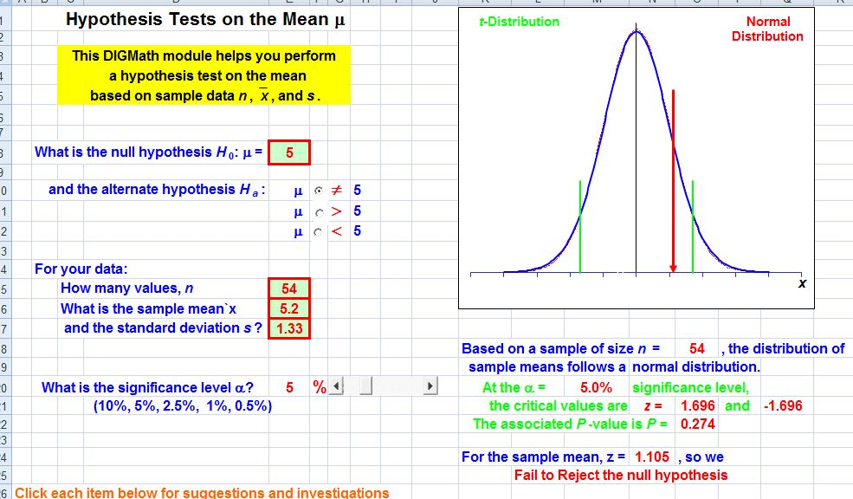
Figure 2

However, neither of these programs addresses one of the biggest issues that students face – being able to assess the variation in the results from one sample to another. Typical textbook problems all focus on the results of one sample, but students never have the opportunity to see how results can vary if there is more than that single sample. To address this, the authors have developed a third Excel program that generates repeated random samples from a given underlying population, draws a representation of each of the sample means, and displays the results both visually and numerically. This graphical simulation provides an especially powerful tool to translate the statistical theory and predictions into ideas that the students can visualize and hence comprehend.
This Excel routine allows the user (either the instructor while conducting a live classroom demonstration or individual students working with the software in a computer laboratory setting or at home on their own) to select from among four underlying populations – one is roughly normally distributed, another is roughly uniformly distributed, a third is roughly U-shaped, and the fourth is skewed in one direction. (Each of these underlying populations is composed of roughly 500 entries that fall into the indicated pattern and random samples are then drawn from the selected population.) The user selects the desired significance level α, from among 1%, 2%, 5% and 10%, for a two-sided hypothesis test with H₀: μ = μ₀.
The program generates 80 random samples of size 50 from the selected population, calculates the mean and standard deviation for each sample, and then plots the sample means as vertical lines. A typical example of the graphical output is shown in Figure 3 for a 5% significance level. The curve shown is the theoretical normal distribution for the sampling distribution of the mean (since n = 50 > 30) and the vertical line near the center indicates the location of the mean μ of the underlying population. The other two taller vertical lines represent the location of the critical values corresponding to α. The numerical results corresponding to Figure 3 are based on 80 samples of size n = 50 drawn from the normal population; for these samples, 5 of the 80, or 6.25%, of these sample means are far enough away from μ₀ to allow us to reject the null hypothesis. A second run of the program involving 80 different samples is shown in Figure 4, where 7 of the 80 sample means (or 8.75%) are far enough away from μ₀ to have us reject H₀.
The patterns in the two figures are similar, but there are distinct differences. In particular, notice that in both cases, the sample means are clustered very tightly about the population mean μ₀ and very few of them fall particularly far from μ₀. However, it is the relatively few sample means that actually fall far from the population mean that allow us to reject the null hypothesis. Also, note that trying to count the number of sample means that are in the rejection region(s) can be misleading on occasion – if two values are very close together, it is possible that they are shown superimposed over one another due to rounding, so the apparent count may be low compared to the actual count that is displayed on the screen.
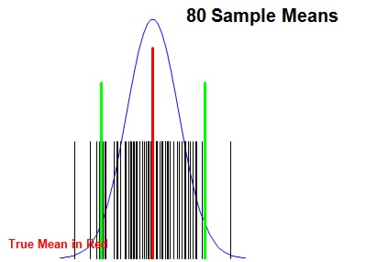
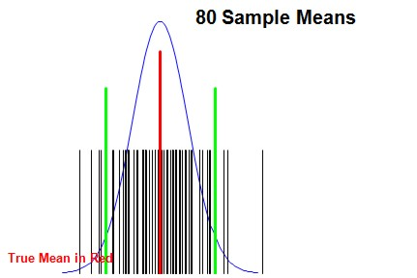

Figure 3 Figure 4

In contrast, Figure 5 shows the results of 80 samples drawn from the same normal population with α = 1%. In this set of samples, notice that 2 of the 80, or 2.5%, of the sample means are far enough away from the population mean μ to allow us to reject the null hypothesis.
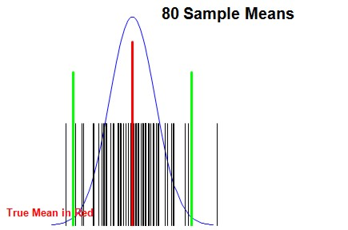

Figure 5

One important item to notice (and to point out to students) is the fact that, in each case, those sample means that allow us to reject the null hypothesis are typically “near misses”; they are usually quite close to the critical values and not wildly far away in either direction.
Comparable results occur with different significance levels α and for the other three populations. In the process of using this program, students come to realize that the percentage of sample means that lead to our rejecting the null hypothesis is typically fairly close to α. They also see that the fundamental ideas arise regardless of the underlying population chosen, which is an important notion for them to grasp.
A single image such as those in Figures 3 through Figure 5 appears in some statistics textbooks, but it is only a static image. The ability to generate repeated sets of samples, to change the underlying population, and most importantly, to change the confidence level α and see the immediate effects dynamically, are extremely powerful attributes that help students understand the underlying ideas. Repeated runs of this program can be used to demonstrate that, in the long run, the results will more or less average out to the predicted percentage for α. In fact, a useful computer laboratory technique is to have each student run the program simultaneously with the same value for α and then average out all of their percentages.
Perhaps most importantly, such a program can be used to give students a greater appreciation of the nature of statistics: any statistical result is based on the data from one particular sample and the conclusion drawn may possibly change if a different sample is used.

Other Hypothesis Testing Situations
Very comparable approaches can be used to enhance student understanding of other types of hypothesis tests and the authors have developed a variety of similar programs for many of those situations. For instance, consider the problem of conducting a hypothesis test for the population proportion π of a binomial population. The authors’ programs parallel those that produced Figures 1 and 2. The primary difference is that the user now must enter the supposed population proportion π and the choice of whether the test is two tailed, one-tailed with the tail on the right, or one-tailed with the tail on the left. In addition, the user must supply the sample size n and the number of successes x, as well as select the desired significance level α. As with the programs for hypothesis tests for the mean, students can see, both visually and numerically, the effects of changing these parameter and sample values on the resulting critical values associated with the hypothesis test for the proportion, as well as the decision as to whether to Reject or Fail to Reject the null hypothesis. In particular, as the sample proportion value p increases, the vertical line representing the location of the sample proportion shifts toward the right and as p decreases, the line shifts to the left. As the sample size n increases, the position of the sample proportion shifts to the left and as n decreases, the sample proportion shifts to the right.
We next consider hypothesis testing for the difference of means, where the authors have developed a similar pair of dynamic spreadsheets. First, as a visual and computational tool, we have one spreadsheet that performs the calculations and displays the results visually. The student selects whether the alternate hypothesis is two tailed or, if one-tailed, which tail. He or she also has to enter the statistical summary values n₁, , and s₁ for the first sample, and n₂, , and s₂ for the second sample, as well as the choice of the significance level, 10%, 5%, 2.5%, 1% or 0.5%. The spreadsheet displays the corresponding critical value(s) as well as a vertical line that corresponds to , the difference in the two sample means. It also displays the numerical results, including the associated z- or t- value and the P-value, as well as the decision to Reject or Fail to Reject the null hypothesis at the chosen level of significance.
As a more conceptual tool, we have also created a dynamic spreadsheet that simulates the distribution of the differences in sample means. The program allows the user either to have both samples drawn from the same underlying population or to have the samples drawn from two distinct populations. Either way, the user can select among the same four underlying populations – normal, uniform, U-shaped, and skewed – as before. Further, the user enters the desired sample size n₁, via a slider, for the first sample and the sample size n₂ for the second sample. Finally, the user selects the number of pairs of samples that will be randomly generated. The program then performs the simulation, plots the differences for each pair of sample means in a histogram, and displays the results numerically. The students can then see what happens with many different sets of samples, first with both samples drawn from the same underlying population and then with samples drawn from different populations.
In the first case with samples drawn from the same population, one should expect that the difference in population means will be 0 and, in fact, the differences in sample means are clustered about 0. When the sample sizes n₁ and n₂ are both small, there is a rather wide spread in those differences, but as you increase either or both of the sample sizes, the differences are clustered ever more tightly about 0. In Figure 6a, we show the results of one run of the program where both samples are drawn from the normal population and the first sample consists of samples of size n₁ = 7 and the second samples of size n₂ = 9. In contrast, Figure 6b shows the results with samples of size n₁ = 42 and n₂ = 39.

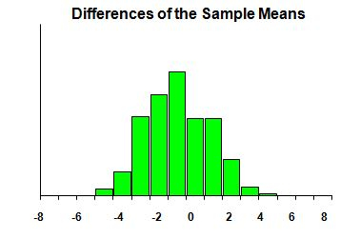
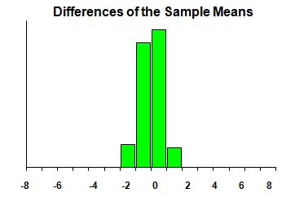 Figure 6a Figure 6b

Moreover, when sampling from the normal population, the shape of the histogram is close to normal, even for small sample sizes. Again, look at the two results in Figures 6a and 6b. However, when sampling from the other three populations, the shape of the histogram is definitely non-normal for small sample sizes, but becomes ever more normal-looking as the sample sizes increase. Figure 7a shows the results of drawing samples from the roughly uniformly distributed population with samples of size n₁ = 8 and n₂ = 10; the shape may not look particularly normal. On the other hand, the results with larger samples, say n₁ = 40 and n₂ = 43, from the same uniformly distributed population are shown in Figure 7b, which shows a much more normal distribution pattern.

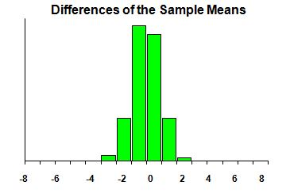
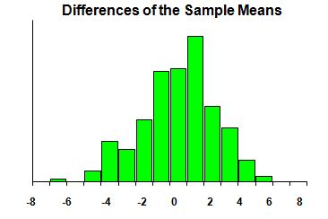

Figure 7a Figure 7b

Students can also be asked to perform comparable investigations when the samples are drawn from two different populations.
Finally, we consider hypothesis tests for the difference in proportions in very similar ways with comparable dynamic spreadsheets. Again, one program is designed to perform the calculations based on two sets of sample data – the sample size n₁ and the number x₁ of successes for the first sample and the sample size n₂ and the number x₂ of successes for the second. As before, the user can select the desired significance level, α, from among 10%, 5%, 2.5%, 1% or 0.5%. The spreadsheet displays the corresponding critical value(s), as well as the location of the difference of sample proportions, p₁ – p₂. The spreadsheet also displays the numerical results associated with the hypothesis test, including the z- or t- value, the P-value, and the decision of whether we can Reject the null hypothesis or Fail to Reject it.
The last topic we discuss is a random simulation of the distribution of the difference of sample proportions. As with the differences of sample means, the user can select the probability of success π₁ and the sample size n₁ of the first sample and the probability of success π₂ and the sample size n₂ of the second sample via sliders, as well as the number of such pairs of samples. The program then randomly generates the desired samples, displays the results on the difference p₁ – p₂ of the sample proportions graphically in a histogram, and also displays the numerical results.
All of the dynamic spreadsheets mentioned here, as well as many others covering virtually every topic in introductory statistics and probability, can be downloaded from the authors’ websites, [1] and [2]. If interested readers have any suggestions for additional topics they would like to see treated, they are encouraged to contact the authors with their suggestions.

Evidence of What Students Gain from Dynamic Software in Statistics
While the authors have no specific incidents to report of improvements in student understanding of hypothesis testing, we can certainly describe some extraordinary student insights into other sophisticated statistical concepts based on the use of dynamic software.
One of the standard, and certainly the most important, topics in any introductory statistics course is the Central Limit Theorem, which is the basis of all inferential statistics; it is also probably the most conceptually difficult topic in that course. The Central Limit Theorem provides insight into how any single sample drawn from an underlying population compares to all other possible samples of the same sample size drawn from that population. Unfortunately, if all students see is one sample, or perhaps a handful of samples, drawn from a population, it is not surprising that few, if any, of them understand what the Central Limit Theorem is all about.
In the authors’ implementation of a demonstration module for the Central Limit Theorem, the user (either the instructor while conducting a live classroom demonstration or individual students working with the software in a computer laboratory setting or at home on their own) can select from among four underlying populations – one is roughly normally distributed, another is roughly uniformly distributed, a third is roughly U-shaped, and the fourth is skewed in one direction. The user can select the sample size and number of samples using sliders and the results appear virtually instantaneously. In particular, the program randomly generates repeated samples of the given size, calculates, and then displays the mean of each sample in a bar chart. It also displays information on the average and standard deviation of all of the sample means generated and compares them to the mean and standard deviation of the underlying population. Specifically, the authors focus on samples of size n = 4, 9, 16, and 25. From theresulting images and the corresponding numerical results, as well as repeated runs with the same choices, the students quickly observe that:
- the overall shape of the sample means in each instance is also roughly normal;
- the average of the sample means in each instance is quite close to the mean of the underlying normal population;
- the spread in the sample means clearly decreases as the sample size n increases.
At this point, we would point out to the class that, with samples of size n = 4, the spread is roughly one-half the spread in the underlying distribution, the spread with samples of size n = 9 is roughly one-third the population’s spread, and so forth. These results can be seen both numerically based on the numbers given as well as graphically by estimating the horizontal spread in the bar chart for the sample means. Invariably, in every statistics class taught by the authors, several students have always hypothesized that the formula for the spread in the sample means is equal to . Thus, rather than having a set of rules to memorize and apply without understanding, the students are actually able to thoroughly understand the conclusions of the Central Limit Theorem and even to deduce the key formulas based on those observations.
As a second example, consider the notion of linear regression. Virtually every problem in statistics textbooks gives the students a single set of data and asks them to construct the regression line based on that data and perhaps use the equation to answer some predictive questions. Regression analysis also arises in all courses in the lab sciences, where students similarly collect one set of sample data and have to construct (possibly only graphically) a line that fits the data. Similarly, as mathematical modeling becomes ever more prominent in high school algebra, college algebra, and precalculus courses, students are likewise expected to fit a line (or other non-linear function) to a set of data, assess how good the fit is, and use the function so constructed as a model to answer predictive questions. In all of these settings, most students rarely appreciate the fact that the set of data they have is just one possible set of bivariate data for the two variables under consideration. Rather, they get so involved in finding the line (or curve) that fits the data, either graphically or using technology or, worst yet, by performing the actual calculations, that they lose sight of the underlying statistical ideas.
Dynamic software can change this paradigm so that, in the process of discussing the regression line to fit a set of data, particularly laboratory data, it becomes natural to emphasize that there could be many different sets of data, each leading to a different regression line. A simple computer graphics simulation provides the visual support to make these different lines come to life and provides the means for an investigation on the effects of using different sample sizes. We have developed a very effective version of such a simulation in Excel that is available to any interested reader. It allows the user to select the sample size n (between 2 and 40) and the number of such samples (between 5 and 20). It then generates repeated random samples of size n from an underlying bivariate population that falls into a roughly linear pattern. The program then calculates the regression line for each random sample and displays the graph of the lines. It also displays the means of the sample regression lines.
The first time that one of us used a BASIC version of this demonstration in introductory statistics almost 40 years ago, several students noticed that typically most of the sample regression lines all seemed to intersect close to one another. They also observed that this is ever more pronounced as the sample size increased. (This is something that the authors had not happened to notice during development of the module.) Let’s see why this is in fact typical. Any regression line always passes through the point (,) corresponding to the mean of the x’s and the mean of the y’s in that sample. When the sample size n is reasonably large, we should expect that ≈ μ_{x}, the mean of the x-values in the underlying population, and ≈ μ_{y}. Consequently, it is reasonable to expect that, on most of the sample regression lines, the points (,) should be close to the point (μ_{x}, μ_{y}) and that this result should be more pronounced the larger the sample size n is. However, this is a rather sophisticated line of reasoning that is needed to answer a question raised by several students in such a low-level course.
Note that that evening, the authors highlighted the point (μ_{x}, μ_{y}) in the graphical display of the simulation and added some explanatory notes to explain why most of the sample regression lines pass close to that point.
Incidentally, we make it a point to use this simulation in every statistics course we have since taught, as well as in every college algebra/precalculus course we have taught that incorporates regression and curve fitting.

Summary
Introductory statistics courses tend to be filled to overflowing with a vast array of concepts and methods that students with relatively weak mathematical backgrounds are expected to understand, apply to large numbers of problems (often via rote memorization of the methods), and retain so as to be able to recognize, interpret, and perhaps apply in successor courses in many different fields. However, if they don’t understand those concepts and methods in the first place, they likely will not have any understanding of the methods they do by rote, and will almost certainly carry little of value on to those other courses.
Dynamic software that brings the concepts to life with visual images can go a long way toward significantly enhancing student understanding of the statistical ideas and, in turn, may help in keeping those ideas alive after the course is over. Although virtually every topic in introductory statistics can be explored this way, the present article has only focused on hypothesis testing, which is one of the more fundamental concepts in the first course in statistics and which often is one of the most intellectually challenging topics in that course.

References
1. Author 1, Dynamic spreadsheets for statistics and probability, URL to be supplied
2. Author 2, Dynamic spreadsheets for statistics and probability, URL to be supplied

3. DePaolo, Concetta A., The STAT-ATTIC Website: Links to Statistics Applets for Introductory Courses, Journal of Statistics Education, vol 18, 2010.
4. Journal of Statistics Education, (1993-2015), vols 1-24, American Statistical Association, URL: http://ww2.amstat.org/publications/jse/jse_archive.htm
5. Journal of Statistics Education, (2016 - ), vols 25- , Taylor & Francis, URL: http://tandfonline.com/toc/ujse20/current
6. Mills, Jamie D., Using Computer Simulation Methods to Teach Statistics: A Review of the Literature, Journal of Statistics Education, vol 10, 2002.

