Visualizing and Understanding Sampling Distributions Using Dynamic Software

By Sheldon P. Gordon¹ and Florence S. Gordon²

¹ Farmingdale State College of SUNY, Farmingdale, NY 11731, USA
gordonsp@farmingdale.edu
² New York Institute of Technology, Old Westbury, NY, 11568, USA
fgordon@nyit.edu

Received: 17 October 2018 Revised: 28 January 2019 DOI: 10.1564/tme_v26.1.xx

This article illustrates ways that dynamic software using some sophisticated techniques in Excel can be used to demonstrate fundamental ideas related to sampling distributions and their properties to increase student understanding of the concepts and methods in elementary statistics courses. The article considers such sampling distributions as the distributions of sample means, sample medians, sample modes, sample midranges, sample proportions, and differences of sample means and examines how they depend on the underlying population and on the sample size of the repeated random samples drawn from the population.

- INTRODUCTION

Students in introductory statistics courses are often asked to accept many statements and procedures on faith since the mathematical justifications are often much too sophisticated for them to comprehend. In many traditional courses, the emphasis all too often is still on the mechanics of performing a hypothesis test or constructing a confidence interval (or worse, on calculating means and standard deviations, or even correlation coefficients and chi-square values by hand). The students are typically given the summary statistics for a set of data (rarely the actual data values themselves) and asked to perform an inferential procedure. At best, some preliminary theoretical discussion may be covered in class, but that is usually quickly forgotten in the rush to complete the mechanical solutions to a great many problems. When students do work with the actual data, even data they have personally collected, it is still just one possible sample to which they apply the appropriate (we hope) procedures. It is therefore not surprising that many students come out of an introductory statistics course having, at best, mastered a series of computational procedures, but with relatively little statistical understanding.

Even when students utilize technology (graphing calculators or statistical software) to perform statistical calculations such as finding the statistical measures for a set of data, constructing a confidence interval, or conducting a hypothesis test, the majority still tend to come away with very little in the way of basic understanding of the underlying fundamental concepts. In particular, they don’t understand the significance of:
- the variation in the results due to different samples (the variations between samples);
- the effects of changes in the sample data or the sample statistics (the variation within sample) on the results;
- the effects of sample size on the results.

Yet these concepts underlie virtually every statistical decision, such as estimating a population parameter (creating a confidence interval) or testing a hypothesis or conducting a regression/correlation analysis. Gaining a solid understanding of these ideas requires the use of dynamic software to bring the ideas to life and so make a far stronger and hopefully longer lasting impact on the students.

- SOME BACKGROUND

Typically, the students who take introductory statistics courses, either in high school or in post-secondary institutions, have had considerably less mathematics than those who take calculus. In U.S. colleges and universities, the usual mathematical prerequisite for introductory statistics is either intermediate algebra or a rather low-level college algebra course, though at many schools, particularly two year colleges, the prerequisite can be elementary algebra. Similarly, in U.S. high schools, the AP (Advanced Placement) statistics course is usually either the second, if not the third, track in terms of mathematical sophistication; the top track is designed to prepare students for AP calculus; often, the secondary track has a goal of precalculus; and the third track leads to AP statistics, if not a non-AP statistics course.

While in most mathematicians’ minds, calculus instruction tends to dominate the undergraduate curriculum, this may be a somewhat misleading perception. According to the 2015 survey of undergraduate programs in the mathematical sciences in the U.S. conducted by the Conference Board on the Mathematical Sciences (Blair et al., 2012), the total enrollment in calculus level courses was 959,000. In comparison, the total enrollment in probability and statistics courses offered in mathematics departments (almost all of which are introductory statistics) was 693,000. This does not include statistics courses offered within a department of statistics (very common in the universities, rather uncommon in the four-year colleges, and non-existent in two year colleges), where the total enrollment was 144,000. However, “calculus level” encompasses Calculus I, Calculus II, Calculus III, Differential Equations, Linear Algebra, Discrete Mathematics, and a variety of other calculus courses including those for students in business, or in the social sciences, and so on. As a consequence, many students may be counted two or even three times in the total for calculus level while the students in statistics are counted only once.

Moreover, the growth rate in enrollment in the calculus level courses was about 8% over the previous five year period 2010 to 2015; in comparison, the growth rate for statistics enrollment over the previous 15 year period 2000 to 2015 was 10% in colleges and universities and an astounding 104% in two year colleges. It is obvious that statistics is having a very rapidly increasing impact on undergraduate enrollment and deserves far more in the way of attention (and respect) from mathematicians. It is likely that statistics enrollment in other countries is similarly growing extremely rapidly.

Historically, introductory statistics courses offered through collegiate mathematics departments in the U.S. have focused on computational procedures and the probabilistic underpinnings of statistics. For the last quarter century, leading statistics educators (Gordon & Gordon, 1992) have complained about such courses, pointing out that they are too "mathematical" in the sense of focusing heavily on probability and probability distributions (binomial, geometric, Poisson, hypergeometric, etc.), probably because mathematicians are more comfortable with such topics. Instead, they have urged that introductory statistics should focus almost exclusively on data analysis and applications arising from real-world data. Statistics educators have also called for a significantly increased emphasis on fundamental statistical concepts, since those are considerably more important than statistical computations for the students. (Clearly, this mirrors the debate in the mathematics community over what the appropriate emphasis in calculus and related courses should be.) These points are made very strongly in the articles in the MAA Notes volume Statistics for the Twenty First Century (Gordon and Gordon, 1992).

Over the years, more and more data-driven ideas have been incorporated into many introductory statistics offerings and somewhat greater emphasis on the fundamental concepts has been introduced. However, most textbook authors have merely added additional sections and examples to reflect the emphasis on data without eliminating the more traditional topics, so that the current courses present a hodge-podge of topics and emphases across a wide spectrum that reflect the interests and backgrounds of all individual instructors and departments.

- DYNAMIC SOFTWARE TO THE RESCUE

Two key notions that underlie virtually every concept and method in inferential statistics are randomness and variation among samples. Has the sample been collected in a truly random fashion that reflects the underlying population? How representative of that population is this one sample? How does this single sample compare to other possible samples drawn from the same population? How much does that single sample influence the accuracy of the results?

Fortunately, most of the central topics in probability and statistical inference can be dramatically presented using computer graphics simulations to allow students to visualize the underlying statistical populations and the variation that exists among many different samples, and so enhance their understanding of the statistical concepts and methods. Many years ago, the authors (Gordon & Gordon, 1994) addressed the challenge of making these notions evident to students by developing a comprehensive package of computer graphics simulations using BASIC that addressed virtually every topic in introductory probability and statistics. BASIC routines have become outmoded over the years, especially in terms of being able to provide students (or even colleagues) with copies of the files to explore the statistical concepts on their own computers. We have lately returned to this challenge and have developed a much more extensive package of dynamic interactive graphical simulations using Excel because it is available on almost all computers today. Moreover, Excel has the further advantages that it does not require any plug-ins or internet connections, as when using Flash, Java, or JavaScript, and it is the standard technology tool for virtually every discipline outside of mathematics. (The authors’ complete package can be downloaded from our websites (S.P. Gordon and F.S. Gordon, 2018) or (F.S. Gordon and S.P. Gordon, 2018) for use either by instructors for in-class demonstrations of these ideas or by students for individual or small-group investigations and/or projects, as discussed at the end of this article.)

In the intervening years, many other statistics educators have thought deeply about these issues and have developed specialized software tools to implement random simulations of many of the basic statistical ideas and techniques. These issues have been discussed in a variety of articles, primarily in the statistics literature, as summarized in (Mills, 2002), for the early years, as well as in individual papers in the Journal of Statistics Education. All of the articles in volumes 1 through 24 of the latter from 1993 through 2014 can be accessed from the journal’s website, The Journal of Statistics Education (1993-2015); subsequent issues from 2015 (volume 25) on can be found at The Journal of Statistics Education, (2016 -). However, as the editor of the IJTME (Fujita, 2018) points out in an article giving an overview of the articles published in the past 15 years, “other important areas of mathematical study like statistics and probability do not feature on the most commonly used list, and have substantially less attention.” A number of articles (Kostadinov, 2013; Lipson, 2003; Novak, 2014; Ozmen and Guven, 2018) address the specific impacts of use of simulations on student learning and performance regarding sampling distributions. A recent article (Ruggieri, 2016) discusses the use of simulations to improve student understanding of sampling distributions. A series of related articles on ways to improve statistics education using simulations of other major topics in introductory statistics using dynamic software to increase student understanding of regression/correlation (Gordon and Gordon, 2018a), constructing confidence intervals (Gordon and Gordon, 2017), and hypothesis testing (Gordon and Gordon, 2018b). In addition, there are many applets available on the Web and many of the same kinds of simulations can be generated using statistical software packages such as Minitab. A summary of literally hundreds of such apps and links to them are compiled by (DePaolo, 2010).

These efforts have had considerable impact on the teaching of statistics among professional statisticians, but probably much less impact on the teaching of statistics by mathematicians or by statistical users in other disciplines. In part, this may be due to the fact that mathematics faculty without extensive statistical training are often uncomfortable with using such statistical packages in the classroom; some feel it is not appropriate to require students to purchase specialized software in addition to an expensive textbook and calculator; others feel that the one software tool that almost all of their students will someday use in other courses and on the job is Excel (and the majority of students now arrive on campus already knowing how to use it). Furthermore, most quantitatively-oriented people are familiar with Excel and many are able to modify or create their own spreadsheets without having to learn a new computer language. As such, existing Excel spreadsheets provide templates that can be adapted to create comparable simulations of other situations or to provide additional information and insights. As a consequence, there seem to be good reasons to have such simulations available in Excel, so that both faculty and students can have easy access to their use without needing to expend money or time in learning new programs.

As will be illustrated later in the article, the authors’ spreadsheets all use sliders (a feature to input or change values by moving, using a mouse, say, a square in a horizontal bar) and other Excel controls to provide dynamic effects in which parameters and statistical measures can be changed and the resulting effects can be seen virtually instantaneously. Perhaps the most powerful programs are those that utilize random simulations to illustrate the variations that occur in the results due to different samples.

In this article, we will discuss a variety of sampling distributions, most notably the distribution of sample means and hence the Central Limit Theorem, that can be enhanced using such software. Other sampling distributions include those for the median, the mode, the midrange, the variance, the proportion, the standard deviation, and differences of means and proportions.

- THE CENTRAL LIMIT THEOREM AND THE DISTRIBUTION OF SAMPLE MEANS

One of the standard, and certainly the most important, topics in any introductory statistics course is the Central Limit Theorem, which summarizes the most important properties of the distribution of sample means (also known as the sampling distribution of the mean). It consists of the means of every possible sample of a given size n drawn from some underlying population and is the basis of virtually all inferential statistics. (Actually, there is a different central limit theorem for every other sampling distribution, such as the distribution of sample medians, the distribution of sample proportions, the distribution of sample differences of means, and so forth.) Among other things, the Central Limit Theorem provides insight into how any single sample drawn from an underlying population compares to all other possible samples of the same sample size drawn from that population. Unfortunately, if all students see is one sample, or perhaps a handful of samples, drawn from a population, it is not surprising that few, if any, of them understand what the Central Limit Theorem is all about.

To gain an understanding of the underlying concepts behind the Central Limit Theorem, as well as other sampling distributions that arise in introductory statistics courses, it is necessary for students to see many different samples and thus see the effects on the associated sampling distribution. However, it is just too difficult and time-consuming to do this live in class. And, in the few cases where it can be done, it is likely that the class becomes bogged down in the details of enumerating and analyzing all possible samples, so that the students do not see any overall pattern. Fortunately, all the core topics in statistical inference can be dramatically presented using computer graphics simulations that let the students visualize the underlying statistical distributions and so enhance their understanding of the statistical concepts and methods.

In the authors’ implementation of a demonstration module for the Central Limit Theorem, the user (either the instructor while conducting a live classroom demonstration or individual students working with the software in a computer laboratory setting or at home on their own) can select from among four underlying populations – one is roughly normally distributed, another is roughly uniformly distributed, a third is roughly U-shaped, and the fourth is skewed in one direction. (Each of these underlying populations is composed of roughly 500 entries that fall into the indicated pattern and random samples are then drawn from the selected population.) The user can select the sample size and number of samples using sliders and the results appear virtually instantaneously. In particular, the program randomly generates repeated samples of the given size, calculates, and then displays the means of all the samples in a bar chart. It also displays information on the average and standard deviation of all the sample means generated and compares them to the mean and standard deviation of the underlying population. In Figure 1, we show the complete screen image to illustrate the controls and the format for all the displayed information.

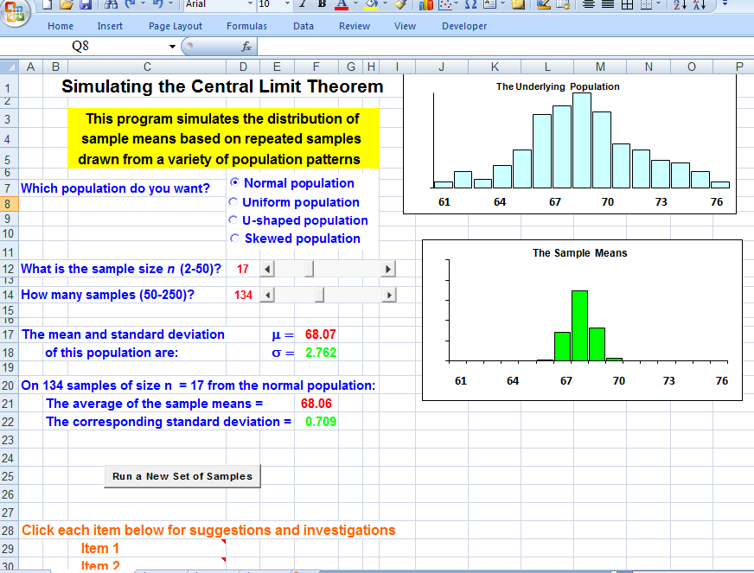

Figure 1 The Central Limit Theorem Simulation Spreadsheet.

In Figures 2-5, we show results based on 250 samples of sizes n = 4, n = 9, n = 15, and n = 25, respectively, drawn from the roughly normal population. Note that in these and subsequent images, we only display the graphical results of the simulations since it is much easier to compare the results from such displays.

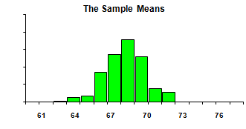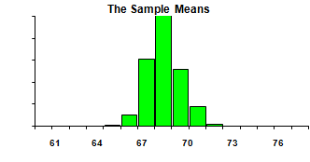
Figure 2 250 Sample means with n = 4. Figure 3 250 Sample means with n = 9.

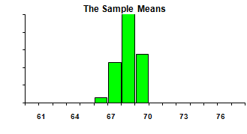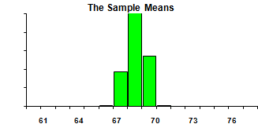
Figure 4 250 Sample means with n = 16. Figure 5 250 Sample means with n = 25.

Note that the underlying normal population has a mean µ = 68.07 with a standard deviation of σ = 2.762. For the 250 samples of size n = 4 shown in Figure 2, the mean of the sample means is 67.93 with a standard deviation of 1.471. Similarly, for the results in Figure 3 with n = 9, the mean is 68.00 and the standard deviation is 0.942; for the results in Figure 4 with n = 16, the mean is 68.01 and the standard deviation is 0.654; and for the results in Figure 5 with n = 25, the mean is 68.09 and the standard deviation is 0.581. From these images and the corresponding numerical results, as well as repeated runs with the same choices, the students quickly observe, without being told, that:

- the overall shape of the sample means in each instance is also roughly normal;
- the average of the sample means in each instance is quite close to the mean of the underlying normal population;
- the spread in the sample means clearly decreases as the sample size n increases.

At this point, we would point out to the class that, with samples of size n = 4, the spread is roughly one-half the spread in the underlying distribution. This can be seen either numerically or graphically. First, comparing the standard deviation of the 250 sample means shown in Figure 2, which is 1.471, to the standard deviation of the underlying population (2.762), it is fairly clear that the sample means have roughly half the spread. Alternatively, from a graphical perspective, the bar chart for the underlying normal population is shown in Figure 6. Notice that the values shown extend from a minimum of about 61 to a maximum of 76, a spread of 15. In contrast, the spread for the bulk of the sample means shown in Figure 2 based on n = 4 extends from about 65 to 72, which is roughly half as extensive.

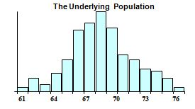
Figure 6 The Underlying Roughly Normal Population.

Totally comparable results arise with other runs of the program or with other sample sizes. For example, the spread (0.942) with samples of size n = 9 is roughly one-third the population’s spread (2.762); this can also be seen graphically by estimating the horizontal spread in the bar chart for the sample means. Invariably, in every introductory statistics course the authors have taught using this module, (both introductory statistics and college algebra courses with an emphasis on data analysis and applications), at least several students in each class have hypothesized that the formula for the spread in the sample means is equal to . Thus, rather than having a set of rules to memorize and apply without understanding, the students are actually able to thoroughly understand the conclusions of the Central Limit Theorem and even to deduce the key formulas based on those observations.

We would then repeat the investigation with a different underlying population, say the U-shaped population, which has mean µ = 68.61 and standard deviation σ = 4.801. We show typical results in Figures 7-10 for 250 random samples of size n = 4, 9, 16, and 25, respectively. Clearly, with small samples, the pattern does not appear to be normal, but does seem to become more and more normal as n increases. In particular, for the samples of size n = 4 shown in Figure 7, the mean of the sample means is 68.62 with a standard deviation of 2.634; for the samples in Figure 8 with n = 9, the mean is 68.58 and the standard deviation is 1.546; for the results in Figure 9 with n = 16, the mean is 68.50 and the standard deviation is 1.295; and for the results in Figure 10 with n = 25, the mean is 68.66 and the standard deviation is 0.906. Obviously, the means of the sample means are invariably very close to the mean of the underlying population, no matter what the sample size. And, the spread of the sample means clearly decreases as the sample size increases; further, both numerically and graphically, the spread is roughly ½, ⅓, ¼, and 1/5 of the population’s standard deviation, respectively, again reinforcing the conjecture that it is seemingly equal to σ divided by the square root of n.

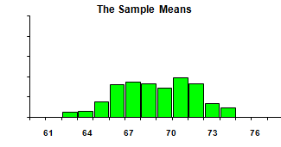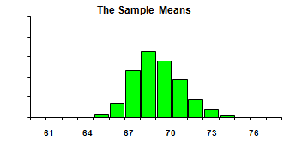
Figure 7 250 Sample means with n = 4. Figure 8 250 Sample means with n = 9.
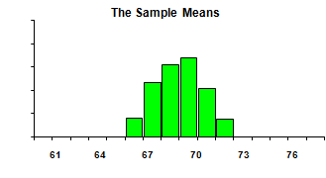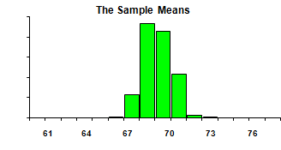
Figure 9 250 Sample means with n = 16. Figure 10 250 Sample means with n = 25.

From such explorations and the accompanying geometric displays, the students in an introductory statistics course are able to predict the conclusions of the Central Limit Theorem and the properties of the sampling distribution of the mean based exclusively on the visual displays. The only thing that they need to be told is that n = 31 has been found empirically as the minimum sample size needed to be assured of normality for most underlying populations. Of course, how large n must be depends strongly on the shape of the underlying distribution. Computer graphics present an ideal tool for experimenting with different values of n and different populations. For instance, students can see that n = 1 or n = 2 seems adequate if the population is normal; that n = 12 is usually accepted as large enough if the population is uniform; and that n = 100 may be needed if the population is highly skewed as with the exponential distribution.

- SIMULATING THE SAMPLING DISTRIBUTIONS OF THE MEDIAN, MODE AND MIDRANGE

Comparable investigations can be conducted to investigate the properties of other sampling distributions such as the distribution of sample medians (consisting of the medians of every possible sample of a given size drawn from an underlying population), the distribution of sample modes, or the distribution of sample midranges. Although not ideas that are ever presented in introductory statistics, there is some value in introducing at least one of these situations to reinforce the ideas with the distribution of sample means without explicitly repeating the previous exploration and boring the students; and it only takes perhaps an additional ten minutes of class time to explore a different sampling distribution using dynamic spreadsheets.

In Figures 11 and 12, we show the results, respectively, of 250 samples of size n = 4 and n = 25 for sample medians drawn from the roughly normal distribution; Figures 13 and 14 show the comparable results for sample medians drawn from the roughly U-shaped population.

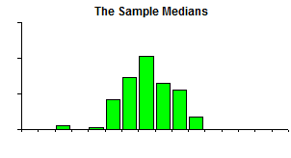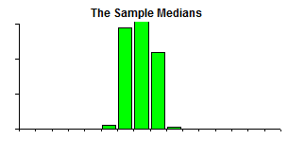
Figure 11 250 Sample medians with n = 4 Figure 12 250 Sample medians with n = 25
from normal population. from normal population.

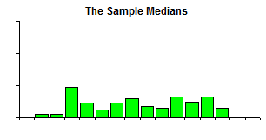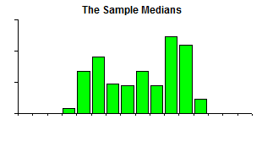
Figure 13 250 Sample medians with n = 4 Figure 14 250 Sample medians with n = 25
from U-shaped population. from U-shaped population.

From the images, it is reasonably apparent that the distribution of sample medians seems to become more normal-shaped when the samples are drawn from the normal population as the sample size increases. However, this is definitely not apparent with the distribution of sample medians when the samples are drawn from the U-shaped population. In fact, even with samples of size n = 50 (the largest value allowed in the simulation), the resulting bar chart in Figure 15 clearly does not appear to fall into a normal pattern, but rather continues to suggest a U-shaped pattern that is similar to the previous results with smaller samples, but ever less widely spread, as n increases, as well as to the underlying U-shaped distribution.

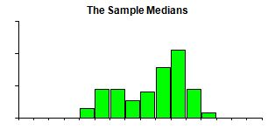
Figure 15 250 Sample medians with n = 50.

Moreover, for the 250 sample medians based on samples of size of size n = 4 drawn from the normal population shown in Figure 11, the mean of the sample medians is 68.99 with a standard deviation of 1.489 and a median of 68, compared to the values of µ = 68.07, σ = 2.762, and a median of 68 for the underlying population. The numerical results corresponding to Figure 12 with samples of size n = 25 drawn from the normal population are a mean of 67.94, a standard deviation of 0.674, and a median of 68.

Similarly, the U-shaped population has a mean of µ = 68.61, a standard deviation of σ = 4.801, and a median of 69. For the 250 sample medians of size of size n = 4 drawn from that population shown in Figure 13, the mean of the sample medians is 68.79 with a standard deviation of 3.329 and a median of 69. Also, for the samples in Figure 14 with n = 25, the mean is 68.99 with a standard deviation of 2.597 and a median of 69. Clearly, the means of the sample medians are invariably very close to the mean of the underlying population, no matter what the sample size. And, the spread of the sample medians clearly decreases as the sample size increases; however, both numerically and graphically, there does not seem to be a clear pattern suggesting a simple relationship between the standard deviation of the sampling distribution for the median and the standard deviations of the sample medians.

We note that comparable spreadsheets are available for investigating the properties of the distribution of sample modes and the distribution of sample midranges, though we will not discuss them here.

A particularly effective use of any of these programs is to have the students conduct their own investigations of these (and related) sampling distributions on an individual or small group basis. Having seen how such an analysis proceeds with the distribution of sample means, they can be asked the comparable questions about the sampling distribution: What is its shape and how does it change with the sample size? What is its mean? and, What is its standard deviation? The students are then able to make some conjectures based on the visual and accompanying numerical displays. In fact, individual students can be assigned different projects of this nature using a variety of underlying populations and a variety of sampling distributions such as those for the median, the mode, the midrange or even the variance or the standard deviation. This type of activity is extremely desirable for giving students a feel for discovering and developing a mathematical theory on their own. More importantly, by repeating the procedure used to develop the key ideas for the distribution of sample means in or more parallel contexts, the students achieve a far better understanding of the ideas presented on the Central Limit Theorem to make a deeper impression on all students.

- SIMULATING OTHER SAMPLING DISTRIBUTIONS

Comparable investigations can be conducted to examine the properties of other sampling distributions that often arise in an introductory statistics course. This includes the distribution of sample proportions, the distribution of the difference of sample means, the distribution of the difference of sample proportions, the distribution of sample variances, and the distribution of sample standard deviations.

For instance, consider the sampling distribution of the proportion. Our dynamic spreadsheet allows the user to select the population proportion π, the sample size n, and the number of samples. In Figure 16, we show the results of 575 samples of size n = 20 with π = 0.20, while Figure 17 shows the results of 575 samples of size n = 40 also with π = 0.20. The pattern in Figure 16 is too skewed to suggest a roughly normal pattern, although the one in Figure 17 does seem to reflect normality. This allows an instructor to reinforce the criteria for normality, namely that nπ > 5 and n(1 - π) > 5 need to hold to be assured of approximate normality. For the values used to produce Figure 16, nπ = 4 and n(1 - π) = 16, while those used to produce Figure 17 yield nπ = 8 and n(1 - π) = 32. Moreover, the output from the program also demonstrates quite dramatically that the mean and the standard deviation of the sample proportion values typically are extremely close to the values μ = nπ and predicted by statistical theory.

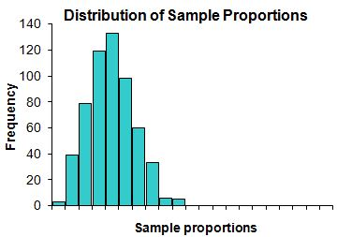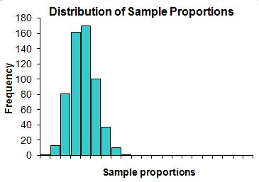
Figure 16 250 Sample proportions with Figure 17 250 Sample proportions with
n = 20 and π = 0.20. n = 40 and π = 0.20.

Next, consider the distribution of the differences of sample means that arises when one is constructing a confidence interval for the differences or testing a hypothesis regarding the difference of means. We have also created a dynamic spreadsheet that simulates the distribution of the differences in sample means. The program allows the user either to have both samples drawn from the same underlying population or to have the samples drawn from two distinct populations. Either way, the user can select from among the same four underlying populations – normal, uniform, U-shaped, and skewed – as before. Further, the user selects the desired sample size n₁, via a slider, for the first sample and the sample size n₂ for the second sample. Finally, the user selects the number of pairs of samples that will be randomly generated. The program then performs the simulation, plots the differences for each pair of sample means in a bar chart, and displays the results numerically. The students can then see what happens with many different sets of samples, first with both samples drawn from the same underlying population and then with samples drawn from different populations.

In the first case with samples drawn from the same population, one should expect that the difference in population means will be 0 and, in fact, the differences in sample means are clustered about 0. When the sample sizes n₁ and n₂ are both small, there is a rather wide spread in those differences, but as you increase the sample sizes, the differences are clustered ever more tightly about 0. In Figure 18, we show the results of one run of the program where both samples are drawn from the normal population and the first sample consists of samples of size n₁ = 7 and the second samples of size n₂ = 9. In contrast, Figure 19 shows the results with samples of size n₁ = 42 and n₂ = 39.

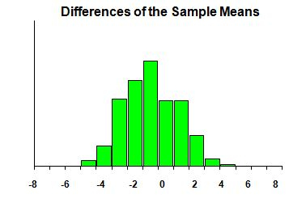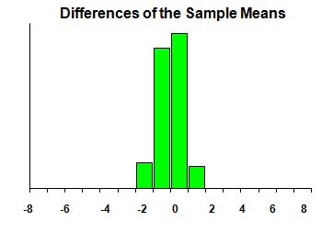
Figure 18 250 Sample differences of means Figure 19 250 Sample differences of means
with n₁ = 7 and n₂ = 9. with n₁ = 42 and n₂ = 39.

Moreover, when sampling from the normal population, the shape of the histogram is close to normal, even for small sample sizes. Again, look at the two results in Figures 18 and 19. However, when sampling from the other three populations, the shape of the histogram is definitely non-normal for small sample sizes, but becomes ever more normal-looking as the sample sizes increase. Figure 20 shows the results of drawing samples from the roughly uniformly distributed population with samples of size n₁ = 8 and n₂ = 10; the shape may not look particularly normal. On the other hand, the results with larger samples, say n₁ = 40 and n₂ = 43, from the same uniformly distributed population are shown in Figure 21, which shows a much more normal distribution pattern.

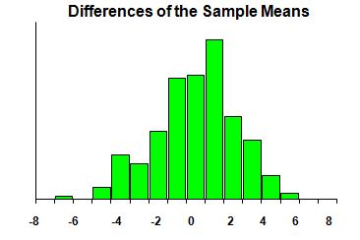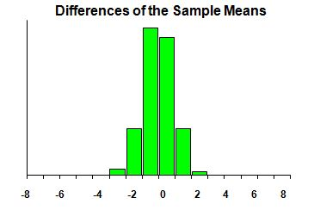
Figure 20 250 Sample differences of means Figure 21 250 Sample differences of means
with n₁ = 8 and n₂ = 10. with n₁ = 40 and n₂ = 43.

Students can also be asked to perform comparable investigations when the samples are drawn from two different populations, in which case the differences in means are not centered about 0, but rather about μ₁ - μ₂, where μ₁ is the mean of the first population and μ₂ is the mean of the second population.

Finally, we consider the sampling distribution for the difference in sample proportions. As with the differences of sample means, the user can select the probability of success ₁ and the sample size n₁ of the first sample and the probability of success ₂ and the sample size n₂ of the second sample via sliders, as well as the number of such pairs of samples. The program then randomly generates the desired samples, displays the results on the difference p₁ – p₂ of the sample proportions graphically in a bar chart, and also displays the numerical results.

We note that the authors have Excel spreadsheets for exploring other sampling distributions, including the distribution of sample skewness (the third order moment where the mean is the first order and the standard deviation is the second order), the distribution of sample kurtosis (the fourth order moment), and the distribution of sample IQR (the InterQuartile Range – the spread between the first and the third quartiles) values.

- IMPLEMENTATION

The authors use the programs described here (though certainly not all of them) primarily on an in-class demonstration basis to motivate and explain statistical ideas. The first demonstration we would do is for the Central Limit Theorem based on the distribution of sample means that essentially follows the development in this article. We would begin with the normal population and have repeated random samples of sizes n = 4, 9, 16, and 25 drawn and displayed. We likely would have the program generate two or three different sets of samples, particularly with the smaller sample sizes, to demonstrate that the results obtained are fairly consistent. We would ask the students at each step to think through how the mean of all the sample means compares to the mean of the underlying population. We also ask how the spread of the sample means varies depending on the sample size – first in a very general way, so that they observe that it seems to get smaller as n increases. We then follow up in a more mathematical way, first graphically pointing out how the spread in the sample means extends roughly halfway across the underlying population with n = 4, roughly one-third of the way with n = 9, and so on. We then look at the values for the summary to verify that this also works numerically. We find that this takes perhaps 15 to 20 minutes of class time, a rather small investment considering the gain in understanding of an otherwise very sophisticated topic.

A subsequent investigation a week or two later with one of the other sampling distributions (say sample medians or sample proportions) usually takes considerably less time, but is valuable in terms of reinforcing the ideas on the Central Limit Theorem. Perhaps a third investigation with the distribution of differences of means, which also take only a few minutes, would be all that we would cover. With the use of a projector, the graphical output is easily visible to all students in the class.

In addition, we have used several of the programs as the basis for individual investigation projects; students are required to conduct a study of the properties of a sampling distribution and write a formal report containing graphical output and their conclusions based on it. Alternatively, some of the programs have tutorial routines that lead the students through the steps involved in mastering the corresponding statistical procedures, so that they simultaneously gain understanding of the ideas and facility with the techniques.

The authors have also found that the visual images generated by the computer tend to "stick" in students' minds. They often refer back to the computer pictures of a simulation. Therefore it is possible to capitalize on these solid visual images by referring back to them on an on-going basis in class when discussing subsequent ideas or going over particular problems.

As mentioned above, all of the dynamic spreadsheets discussed here, as well as many others covering virtually every topic in introductory statistics and probability, can be downloaded for free from the authors’ websites. If interested readers have any suggestions for additional topics they would like to see treated, they are encouraged to contact the authors with their suggestions.

REFERENCES

Blair, Richelle, Ellen E. Kirkman, and James W. Maxwell, Eds., (2018), Statistical Abstract of Undergraduate Programs in the Mathematical Sciences in the United States, The Fall 2015 CBMS Survey, American Mathematical Society, Providence, RI. ISBN 9781470442514.

DePaolo, Concetta A., (2010), The STAT-ATTIC Website: Links to Statistics Applets for Introductory Courses, Journal of Statistics Education, 18.

Fujita, Taro (2018), “That Journal has a History”: Overview of the Technological Tools and Theories Studied in the International Journal For Technology In Mathematics Education, 2004-2018, IJTME, 25.

Gordon, Sheldon P. and Florence S. Gordon, (1994), Contemporary Statistics: A Computer Approach, McGraw-Hill Publishing Company, New York, NY, ISBN-10: 0078343704.

Gordon, Sheldon P. and Florence S. Gordon, (December, 2018), Dynamic spreadsheets for statistics and probability, Farmingdale State College of SUNY, URL: http://www.farmingdale.edu/faculty/sheldon-gordon/dynamicstatistics.shtml

Gordon, Florence S. and Sheldon P. Gordon, (December, 2018), Dynamic spreadsheets for statistics and probability, New York Institute of Technology, URL: http://iris.nyit.edu/~fgordon/StatisticalSimulations.htm.

Gordon, Sheldon P. and Florence S. Gordon (2018a), Visualizing and Understanding Regression and Correlation Using Dynamic Software, International Journal For Technology In Mathematics Education, 25.

Gordon, Sheldon P. and Florence S. Gordon, (2018b), Visualizing and Understanding Hypothesis Testing Using Dynamic Software, PRIMUS, 28.

Gordon, Sheldon P. and Florence S. Gordon, (2017), Visualizing and Understanding Confidence Intervals Using Dynamic Software, Computer and Mathematics Education, 50.

Gordon, Sheldon and Florence Gordon, Eds., (1992), Statistics for the Twenty First Century, MAA Notes #26, Mathematical Association of America, Washington, DC.

Journal of Statistics Education, (1993-2015), vols. 1-24, American Statistical Association, URL: http://ww2.amstat.org/publications/jse/jse_archive.htm.

Journal of Statistics Education, (2016 - ), vols. 25- present , Taylor & Francis, URL: http://tandfonline.com/toc/ujse20/current.

Kostadinov, Boyan (2013), Simulation Insights Using R, PRIMUS, 23.

Lipson, Kay (2003), The Role of the Sampling Distribution in Understanding Statistical Inference, Mathematics Education Research Journal, 15.

Mills, Jamie D., (2002), Using Computer Simulation Methods to Teach Statistics: A Review of the Literature, Journal of Statistics Education, 10.

Novak, Elena, (2014), Effects of Simulation‐Based Learning on Students' Statistical Factual, Conceptual and Application Knowledge, Journal of Computer Assisted Learning, 30.

Ozmen, Zeynep Medine and Bulent Guven (2018), Evaluating Students’ Conceptual and Procedural Understanding of Sampling Distributions, International Journal of Mathematics Education in Science and Technology, 49.

Ruggieri, Eric (2016), Visualizing the Central Limit Theorem Through Simulation, PRIMUS, 26.

BIOGRAPHICAL NOTES

Sheldon Gordon is SUNY Distinguished Teaching Professor of Mathematics (retired) at Farmingdale State College in New York, USA. Throughout his career, he has been deeply involved in efforts to revitalize the undergraduate mathematics curriculum, particularly from the perspective of the use of technology to enhance student understanding of mathematical concepts and methods. Shelly has authored more than 200 papers, a dozen textbooks and monograph volumes, and hundreds of software programs for mathematics education.

Florence S. Gordon is a retired Professor of Mathematics at New York Institute of Technology in New York, USA. She is a co-author of Functioning in the Real World, co-author of Contemporary Statistics: A Computer Approach and co-editor of two MAA Notes volumes, Statistics for the Twenty First Century and A Fresh Start for Collegiate Mathematics: Rethinking the Courses Below Calculus. She has published extensively in mathematics and statistics education.

