Visualizing and Understanding l’Hopital’s Rule

One of the guiding principles of the calculus reform movement over the past two decades has been the notion of approaching all concepts and techniques from graphical and numerical as well as symbolic points of view. However, the implementation of this principle invariably hits a brick wall when first year calculus courses reach certain topics where algebraic techniques appear to be the only possible approach. When this happens, the presentation typically devolves to exercises in symbolic manipulation exclusively. One of these topics is the use of l’Hopital’s Rule to evaluate the limits of a variety of indeterminate forms, most notably 0/0, ∞/∞, 1∞, and ∞ - ∞.
Typically, we prove the Rule in class, then present several direct examples involving 0/0 followed by several others where we have to apply the Rule repeatedly, then extend it to several cases where f and g approach ∞ as x → a (or, more usually, as x → ∞), and then illustrate with several additional examples how some logarithmic and exponential manipulations allow us to extend the Rule still further to apply to other indeterminate forms such as 1∞ and ∞ - ∞. And, this is invariably accompanied by one (or more) of those traditional homework assignments with a page full of problems that require lots and lots of algebraic manipulation, but little, if any, conceptual understanding.
In this article, we look at several ways in which graphical and numerical approaches can be introduced both to enhance student understanding of l’Hopital’s Rule and to explain why the Rule actually works to give the “right” answers.

The Indeterminate Form 0/0 when x → a If f and g are two differentiable functions such that for some finite point x = a, then l’Hopital’s Rule asserts that
If both f ′(x) and g′(x) approach 0 as x → a, then l’Hopital’s Rule would be applied again, and so forth, assuming that both functions are sufficiently differentiable.
But, what is actually happening when we say that
To answer that question in an investigatory manner, the author has developed a series of dynamic interactive spreadsheets in Excel [2] (they are available for download from the author’s website for use either by instructors for in-class demonstrations and explorations or by students for independent or small-group investigations involving different cases with l’Hopital’s Rule). Suppose we consider the limit

which is an indeterminate form of the type 0/0. Applying l’Hopital’s Rule, we find that
To visualize what is actually happening here, consider Figure 1, which shows the graphs of the original ratio, sin (3x)/x, and the ratio produced via l’Hopital’s Rule, 3cos(3x)/1, on the interval from x = -0.3 to x = 0.3. Notice how the two curves have similar shapes and that, as you approach the limit point at x = a = 0, the two intersect. This behavior appears to be typical of what happens with any limit of the form where both f and g approach 0 as x → a; the curves for both f(x)/g(x) and f ′(x)/g′(x) always appear to intersect at x = a. (This can be further verified, both graphically and numerically, using a slider built into the spreadsheet that allows the user to trace along both curves and see the coordinates of the two tracing points shown in the Figure.) As a consequence, it becomes apparent that the two limits in the formula for l’Hopital’s Rule are indeed equal.
Figure 1 might also suggest that the two curves are tangent to one another at the point of intersection. However, this is not the case, but merely the effect of looking at too large a scale. If one considers the approximate slope of each of the two ratio curves very close to x = 0, it is apparent that the slopes are clearly different. Alternatively, if one zooms in sufficiently close to x = 0, it also becomes evident that the ratio curves merely intersect, but are not tangent there.

In retrospect, it should be apparent, given the statement of l’Hopital’s Rule, that the two ratio curves must intersect, providing that the limits exist; if they did not intersect, one could not have the equality guaranteed by the Rule.
Moreover, most of the cases that the author has considered have typically resulted in graphs similar to that in Figure 1 – a pair of curves that are either both concave up or concave down (at least in the neighborhood of the intersection point, which is the turning point for both curves). However, it is possible to construct examples where there is a different behavior pattern – one suggestive of a pair of cubic curves. For instance, one such case arises with
While the above visualization helps explain why l’Hopital’s Rule works, it does not particularly explain why the value in the limit is 3, as in the primary example above, or whatever other value arises in different examples. To understand why a particular value is the limit of the quotient, we follow the ideas in [1] and approximate both the numerator and the denominator with their Taylor polynomial approximations. In this case, sin (3x) ≈ 3x – (3x)³/3! = 3x – 27x³/6; there is no need to approximate the denominator g(x) = x. Therefore,
and, in the limit as x → 0, we find that
That is, when x is small, the approximation reduces to a polynomial that eventually behaves more and more like the constant function h(x) = 3. More generally, using the Taylor approximations eliminates the transcendental functions and so typically reduces the ratio to a rational function or perhaps a ratio involving power functions that often can be reduced algebraically. Either way, one can then estimate the limit directly without recourse to l’Hopital’s Rule.

The Indeterminate Form 0/0 when x → ∞
We next consider the case where the indeterminate form 0/0 arises as x → ±∞. For example, if f(x) = e^{-x} and g(x) = x⁻¹⁰, then both approach 0 as x increases. Using one of the other dynamic Excel spreadsheets mentioned above, we get the graph shown in Figure 2, which seems to be typical for this kind of situation. The two curves have shapes that are similar to that of a surge function – an early sharp surge followed by a relatively slow decay toward zero. In this case, the decay is rather rapid due to the two functions used. As one traces along the two ratio curves, it quickly becomes apparent that the tracing points soon converge and so it becomes evident, both from the graphical display and the accompanying numerical values, that the limits of the two ratios eventually equal one another and hence provide verification that l’Hopital’s Rule is indeed correct in this situation.
We note that, if we depended entirely on the graphical display, then it might suggest that the two ratio curves both converge to 0 as x → ∞. While that is the result with this pair of functions, it certainly is not necessarily the case in general, but only a matter of the scales used in the Figure. In all probability, whenever there is a finite limit L as x → ∞, the graphical display will likely suggest an incorrect limiting value. If anything, this indicates the importance of balancing a graphical display with numerical and algebraic approaches.
As in the previous case, in retrospect, it should not be surprising that the two ratio curves converge toward one another and that, in the limit, they would intersect; otherwise, l’Hopital’s Rule would not work. We should expect the comparable situation if the limits are taken as x → -∞.

The Indeterminate Form ∞/∞ when x → a We next consider the indeterminate form ∞/∞ in the case where the limit arises at some finite point x = a. For instance, consider
When we apply l’Hopital’s Rule, we find that

To see why this works, we use another of the dynamic Excel spreadsheets to investigate the behavior of indeterminate forms ∞/∞ as x approaches some finite point a. Corresponding to this pair of functions, we obtain the graph shown in Figure 3 on the interval [-0.5, 0.5]. Observe that we now have a pair of cusps corresponding to the limit point, and that both curves intersect at the point where the two cusps occur. In retrospect, this behavior should not be overly surprising, since both derivatives f ′ and g′ become infinite as x → 0 and hence their slopes are undefined there.
The spreadsheet also allows the user to trace along the two curves and it becomes clear from the numerical results that are produced that both ratios f /g and f ′/g′ increase in magnitude as one approaches the limit point, but that both ratios approach the same value and that this value is 0.
The investigation with this example certainly suggests that the limit of the ratio is very small, though it would not be possible to conclude definitively from the graphical display that the limit is precisely 0, nor would it explain why 0 is the limit. Our experience above might suggest that we again utilize Taylor approximations to visualize what is happening. Thus, for x > 0, we have
so that
and, using the derivative of the approximation to ln x, we obtain
Therefore, for x > 0,

Unfortunately, as x → 0⁺, none of the terms in either the numerator or the denominator approach 0. In fact, since (x – 1) → -1, the numerator approaches 1 –(-1) + 1 – (-1) = 4 and, were more than four terms included in the “approximation”, it would approach n for any n. Similarly, the numerator approaches
2(-1)[1 – (-1)/2 + 1/3 – (-1)/4] = -2[1 + 1/2 + 1/3 + 1/4]
and, as more terms are included in the “approximation”, this becomes ever closer to a multiple of the divergent harmonic series. Thus, both the numerator and denominator diverge in the limit and hence provide no insight into the limiting value of the original ratio. Moreover, this also illustrates how the use of Taylor approximations, as described in [1], breaks down in terms of explaining why a limit value occurs in the case of the indeterminate form ∞/∞ when x approaches a finite value a.

The Indeterminate Form ∞/∞ when x → ∞
Next, we look at the case where the indeterminate form ∞/∞ arises as x → ±∞. For instance, consider the example

which is an indeterminate form of the type ∞/∞. Applying l’Hopital’s Rule, we find that
To visualize what is actually happening here, we use still another dynamic Excel spreadsheet to investigate the behavior of indeterminate forms ∞/∞ as x → ∞. Figure 4 shows the graphs of the two ratios on the interval x = 0 to x = 60. Notice how the two curves have similar shapes reminiscent of logistic curves and that the two appear to converge as x increases. In particular, at the tracing point shown in the Figure at x = 45, the value along the ratio f(x)/ g(x) is 0.980 and the value along the ratio f ′(x)/g′(x) is 0.992, both correct to three decimal places. If we extend the display somewhat, it turns out that at x = 100, the respective values are 0.995 and 0.998, although the two points overlap too closely for the graphical display to be informative. Continuing this farther, say to x = 1000, we obtain 0.9999500025 and 0.9999833669, respectively, both correct to ten decimal places.
Again, in retrospect, if there is to be a finite limit as x → ∞, then both ratio curves must converge toward that common height. As such, we should expect a pattern such as the one in Figure 4 or a comparable pattern where both curves decay toward a common height or possibly one where they oscillate about each other as they converge as x → ∞.

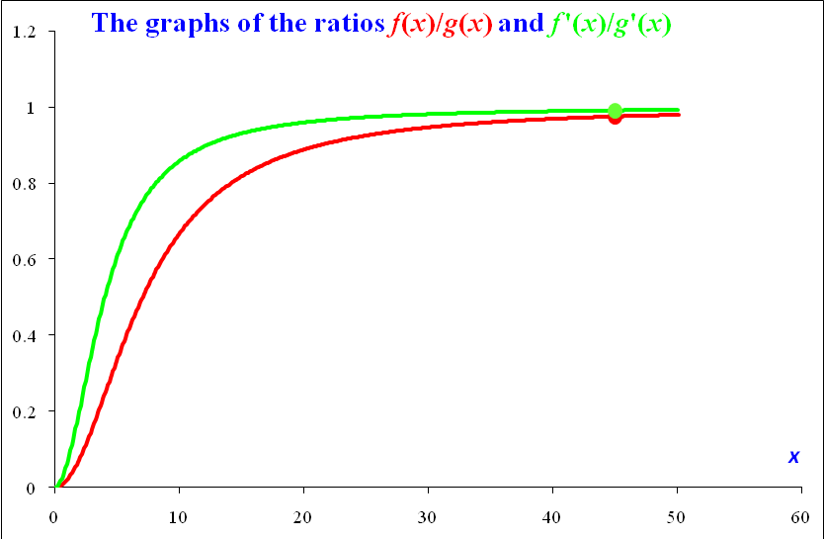

The Indeterminate Form 1∞
Finally, we consider one example of the indeterminate form 1∞. Consider the limit
,
which approaches 1∞. If we write , then we can take logarithms of both sides to obtain
. (1)
In the limit as x → ∞, this approaches 0/0 and hence can be evaluated by l’Hopital’s Rule to produce an answer of 0. Therefore, since ln y → 0 as x → 0, it follows that y → e ⁰ = 1 as x → 0.
To see why this answer is correct, we expand the numerator in Equation (1) using the Taylor expansion for the log function to get
Other than the first term in the first numerator, all other terms will be quartic or higher and so, as x → 0, the term –x² will dominate and hence, eventually, the final expression will behave as if it is
which approaches 0 as x → 0. Since ln y → 0 as x → 0, it follows that y → e⁰ = 1 in the limit.

References
1. Gordon, Sheldon P. l’Hopital’s Rule and Taylor Polynomials, International Journal of Mathematics Education in Science and Technology, 1992.
2. Author, Dynamic spreadsheets for l’Hopital’s Rule, URL to be supplied.

Dedication This article is dedicated to the memory of Joe Roitberg, a wonderful friend and brilliant mathematician, who will be missed.

